

Performing Arts

Name: _____________________________________

THE PURPOSE OF THIS TRANSITION BOOKLET IS TO
BOOST YOUR READINESS FOR BTEC LEVEL 3 PERFORMING ARTS.
Through these activities, you will begin to explore the process of creating and developing a performance, including researching and performing believable characters. You will develop an understanding of how performers use acting, movement and vocal skills to communicate meaning to an audience, whilst exploring the context of the whole play and the intentions behind the performance.
You will also develop independent learning, creativity, reflection and analytical skills that will support your success on the course and prepare you for further study and future careers within the Performing Arts industry.
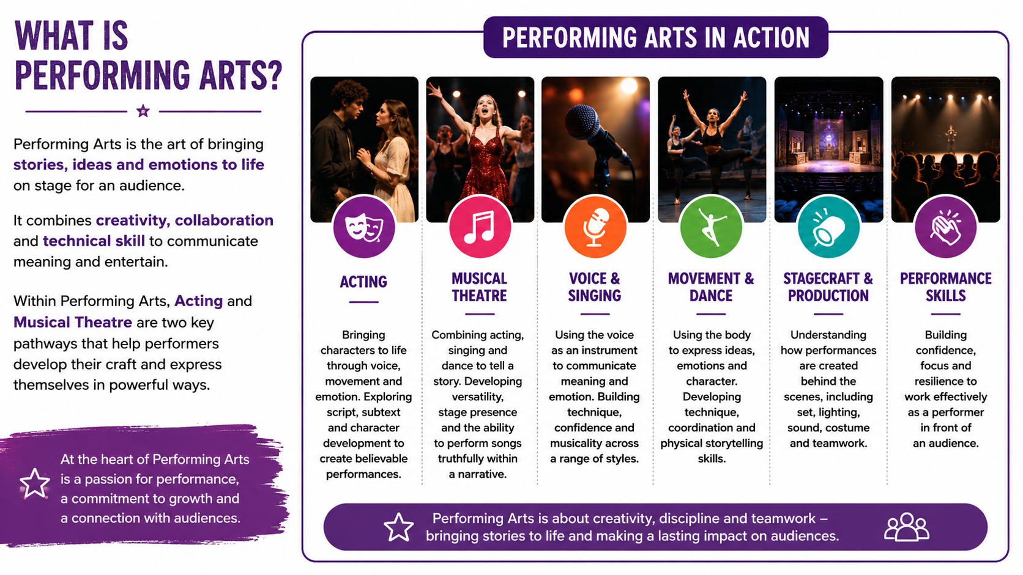


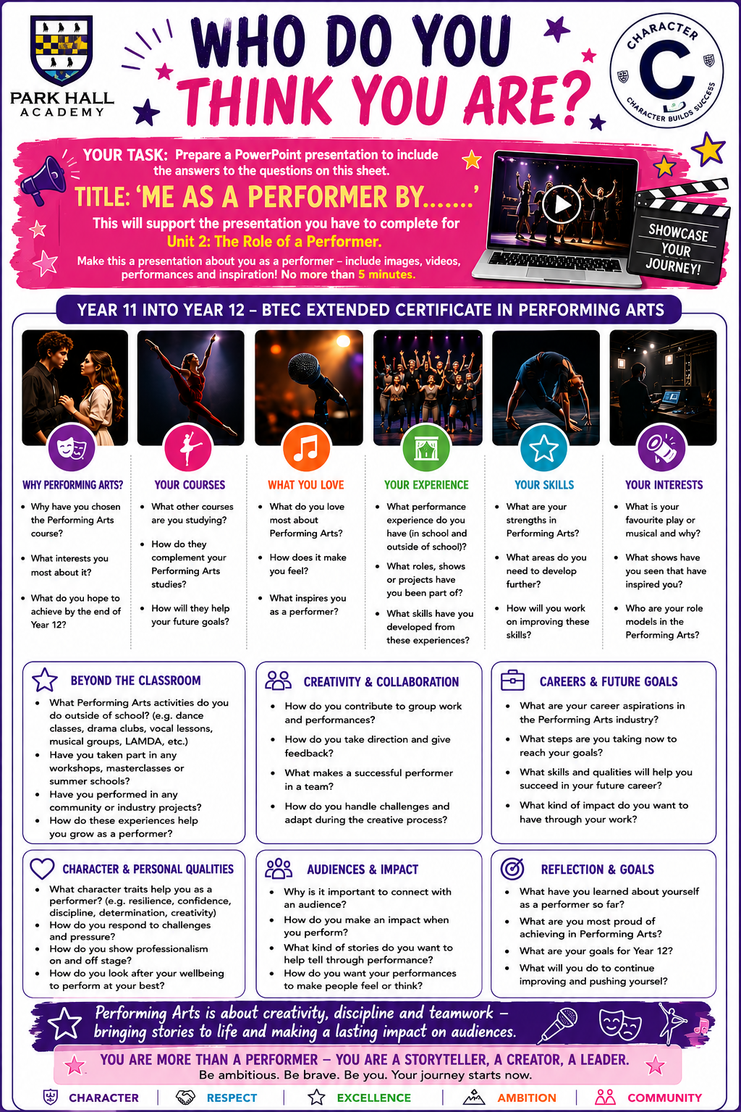

PERFORMANCE TASK: MONOLOGUE PROJECT

Your Challenge
You are to select, learn, and perform a monologue from a:
- 🎭 Play
- 🎶 Musical Theatre Production
- 🎬 Film
This performance will be showcased at our September Open Evening 2026, so aim to deliver a confident and polished piece that represents your very best work.

Performance Requirements
✅ Your monologue must be:
- At least 1 minute 30 seconds long
✅ You must include:
- A short introduction (30 seconds) explaining:
  - Who your character is
  - What is happening in the scene (given circumstances)
  - Why this moment matters
  - The performance the monologue is from
✅ Your performance should demonstrate:
- Strong vocal skills (clarity, projection, tone, expression)
- Effective physical acting (movement, posture, gestures, facial expression)

Extension Opportunity (Optional but encouraged)
To showcase your full range as a performer, you can also include:
- 🎤 A short section of singing and/or
- 💃 Movement or dance
⭐ Remember: Acting is the main focus—these elements should enhance your performance, not replace it.

What you should aim to show
- Clear understanding of your character
- Emotional connection and commitment
- Confidence performing in front of an audience
- Creativity and individuality
- Strong stage presence

Preparation Tasks
Before performing, make sure you have:
✔ Researched your character and context
✔ Identified your objective (what your character wants)
✔ Explored changes in emotion or thought
✔ Rehearsed your voice and movement choices
✔ Practised your introduction so it is clear and confident

Performance Date
📅 September Open Evening 2026
(Exact date to be confirmed)

Top Tip
A great monologue is not just memorised—it is lived. Make bold choices and bring your character to life!

