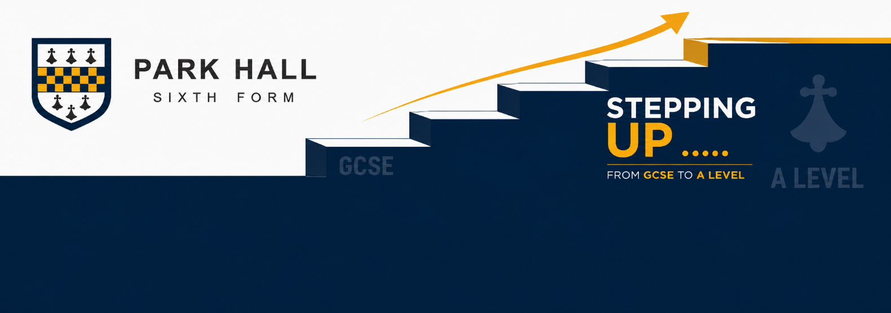
A level English Literature
The purpose of this transition booklet is to boost your readiness for A level English Literature by ….
- Encouraging you to embrace the world of literary texts
- Encouraging you to be inquisitive about the factors that influence human behaviour and society’s norms
- Developing your skills in analysis and critical reflection. Are you able to consider different interpretations, weigh up critics’ arguments and argue in defence of your own interpretation of texts?

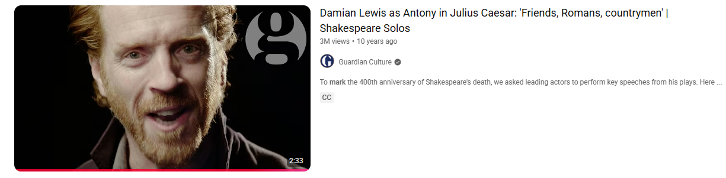 | Task 1) Watch and Respond:  Act 3, Scene 2 - Julius Caesar by William Shakespeare
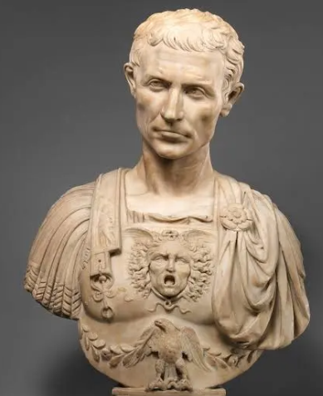
Step 1) Before watching, write down 3 things you could say make someone a villain

- _____________________________________
- _____________________________________
- _____________________________________

Explain how one current world leader may present at least one of those qualities
________________________________________________________________________________________________________________________________________________________________________________________________

During this pivotal scene, Mark Antony has been invited to speak at the funeral of Julius Caesar. Caesar was murdered by leaders who said they did it for the good of Rome.

Step 2) After watching: answer the following questions

- What is Anthony’s true purpose in speaking to the crowd at the funeral. Include at least two pieces of evidence
____________________________________________________________________________________________________________________________________________________________________________________________________________________________________________________________________________________________________________________________________________________________________________________________
- What is the impact of Anthony repeating “Brutus is an honourable man?”
_____________________________________________________________________________________________________________________________________________________________________________________________________________________________________________________________________________________________
- How does Anthony use structural features to move the crowd?
_____________________________________________________________________________________________________________________________________________________________________________________________________________________________________________________________________________________________
______________________________________________________________________________________________________________________________________________________________________________________________
- How does the actor use the drama form to move the crowd?
_____________________________________________________________________________________________________________________________________________________________________________________________________________________________________________________________________________________________
- Craft am analytical paragraph on the most memorable phrase designed to manipulate the crowd. You may wish to PEZEL:
______________________________________________________________________________________________________________________________________________________________________________________________________________________________________________________________________________________________________________________________________________________________________________________________________________________________________________________________________________________________________________________________________________________________________________________________________________________________________________________________________________________________________________________________________________________________________________________________________________________________________________________________________________________________________________________________________________________________________________________

Task 2) Read and Respond:

Read the following extract from a novel. It is an example of an unseen prose text you may see in the exam. Answer the questions at the end of the extract.
Kate Chopin (1851-1904)
Chopin was an American author of short stories and novels, mainly based in Louisiana. She is now considered by some to have been a forerunner of the feminist authors of the 20th century of Southern or Catholic background, such as Zelda Fitzgerald.
The Awakening, originally titled A Solitary Soul, was first published in 1899. Set on the Louisiana Gulf coast at the end of the 19th century, the plot centers on Edna Pontellier and her struggle to reconcile her increasingly unorthodox views on femininity and motherhood with the prevailing social attitudes of the turn-of-the-century American South. Edna is married with two sons, Raoul and Etienne. The extract is from the end of the novel, when Edna learns that Robert, the man she truly loves, has left forever as he is unwilling to enter into a relationship with a married woman.
Edna walked on down to the beach rather mechanically, not noticing anything special except that the sun was hot. She was not dwelling upon any particular train of thought. She had done all the thinking, which was necessary after Robert went away, when she lay awake upon the sofa till morning.
She had said over and over to herself: "To-day it is Arobin; to-morrow it will be someone else. It makes no difference to me; it doesn't matter about Leonce Pontellier—but Raoul and Etienne!" She understood now clearly what she had meant long ago when she said to Adele Ratignolle that she would give up the unessential, but she would never sacrifice herself for her children.
Despondency had come upon her there in the wakeful night and had never lifted. There was no one thing in the world that she desired. There was no human being whom she wanted near her except Robert; and she even realized that the day would come when he, too, and the thought of him would melt out of her existence, leaving her alone. The children appeared before her like antagonists who had overcome her, who had overpowered and sought to drag her into the soul's slavery for the rest of her days. But she knew a way to elude them. She was not thinking of these things when she walked down to the beach.
The water of the Gulf stretched out before her, gleaming with the million lights of the sun. The voice of the sea is seductive, never ceasing, whispering, clamoring, murmuring, inviting the soul to wander in abysses of solitude. All along the white beach, up and down, there was no living thing in sight. A bird with a broken wing was beating the air above, reeling, fluttering, circling disabled down, down to the water.
Edna had found her old bathing suit still hanging, faded, upon its accustomed peg.
She put it on, leaving her clothing in the bath-house. But when she was there beside the sea, absolutely alone, she cast the unpleasant, pricking garments from her, and for the first time in her life she stood naked in the open air, at the mercy of the sun, the breeze that beat upon her, and the waves that invited her.
How strange and awful it seemed to stand naked under the sky! how delicious! She felt like some new-born creature, opening its eyes in a familiar world that it had never known.
The foamy wavelets curled up to her white feet and coiled like serpents about her ankles. She walked out. The water was chill, but she walked on. The water was deep, but she lifted her white body and reached out with a long, sweeping stroke. The touch of the sea is sensuous, enfolding the body in its soft, close embrace.
She went on and on. She remembered the night she swam far out and recalled the terror that seized her at the fear of being unable to regain the shore. She did not look back now, but went on and on, thinking of the blue-grass meadow that she had traversed when a little child, believing that it had no beginning and no end.
Her arms and legs were growing tired.
She thought of Leonce and the children. They were a part of her life. But they need not have thought that they could possess her, body and soul. How Mademoiselle Reisz would have laughed, perhaps sneered, if she knew! "And you call yourself an artist! What pretensions, Madame! The artist must possess the courageous soul that dares and defies."
Exhaustion was pressing upon and overpowering her.
"Good-by—because I love you." He did not know; he did not understand. He would never understand. Perhaps Doctor Mandelet would have understood if she had seen him—but it was too late; the shore was far behind her, and her strength was gone.

- Sum up your reaction to this extract as the end of the novel. What questions and thoughts do you have?

- Explore the ways Chopin uses language in this extract and effects she achieves.
- Compare the female experience of love in this story with your wider reading. Sum up your ideas.

- Explore the view that Chopin presents Edna as achieving freedom in this extract. Make close reference to the writer’s methods in your response.
Extension Task
Look at the Watch/Listen/Read list. Select one of the Podcasts to listen to or the RSC version of the play to watch. Make notes as you take part in your chosen media.

Studying as an A Level Student
During the A level course, we will look at the themes of identity, love, ethnicity and betrayal as they are played out in literature in different historical times. It is vital that as we endeavour to research and analyse as a class, the emphasis and impetus of the learning must shift from the teacher to the student.
• Don’t be afraid to include your own opinion
• Always link your points back to the text
• Make sure you discuss other interpretations

The watch/listen/read list
. Series One Channel 4 series “A Handmaid’s Tale
https://www.bing.com/videos/search?q=podcasts+free++a+streetcar+named+desire&qpvt=podcasts+free++a+streetcar+named+desire&FORM=VDRE “A Streetcar Named Desire”
. https://www.youtube.com/watch?v=LY31t8rXIQ0 Feminine Gospels
. https://www.bbc.co.uk/programmes/p07mvypf “The Yellow Wallpaper”
. https://youtu.be/_836WhwmoNQ “If I Were A Man” Charlotte Perkins-Gilman
https://www.youtube.com/watch?v=lleHC2zeLDQ Ibsen
Any Shakespeare
Any Rossetti
Any Hughes
Any Dickens
Anything from this list https://www.theguardian.com/books/ng-interactive/2026/may/12/the-100-best-novels-of-all-time


