
A level Psychology

The purpose of this transition booklet is to boost your readiness for A level Psychology by ….
- Encouraging you to be inquisitive about the factors that influence human behaviour
- Learning to see Psychology as the ‘science of human behaviour’
- Developing your skills in ‘Evaluation’. Are you able to consider the strengths and weaknesses of a theory or a piece of research?

 | Task 1) Watch and Respond:  The Science of Happiness  Dan Gilbert
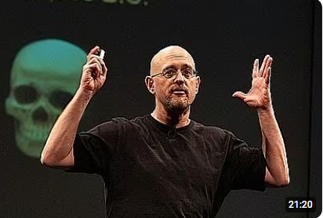
Step 1) Before watching, write down 3 things that make people happy

- _____________________________________
- _____________________________________
- _____________________________________

Step 2) While watching: answer the following questions

- What is ‘synthetic happiness’?

________________________________________________________________________________________________________________________________________________________________________________________________________________________________________________________________________________________________________________________________________________________________________________

- How does choice affect happiness?

____________________________________________________________________________________________________________________________________________________________________________________________________________________________________________________________________________________

- What psychological evidence does Gilbert refer to? (Describe at least one experiment)

____________________________________________________________________________________________________________________________________________________________________________________________________________________________________________________________________________________

Step 3) After watching: Explain in your own words why humans are poor at predicting happiness

____________________________________________________________________________________________________________________________________________________________________________________________________________________________________________________________________________________

Step 4) Application task: Give one real-life example where someone might experience ‘synthetic happiness’

____________________________________________________________________________________________________________________________________________________________________________________________________________________________________________________________________________________

Step 5) Stretch yourself: Answer these questions

- Is the evidence presented convincing? (Justify your answer)

____________________________________________________________________________________________________________________________________________________________________________________________________________________________________________________________________________________

- Are there any limitations? (eg the sample, realism, are other factors ignored?)

____________________________________________________________________________________________________________________________________________________________________________________________________________________________________________________________________________________

 | Task 2) Watch and Respond:  Depression: the secret we share Andrew Soloman
Step 1) Before watching, consider what you already know about depression. Write down 3 symptoms

- _______________________________

- _______________________________

- _______________________________

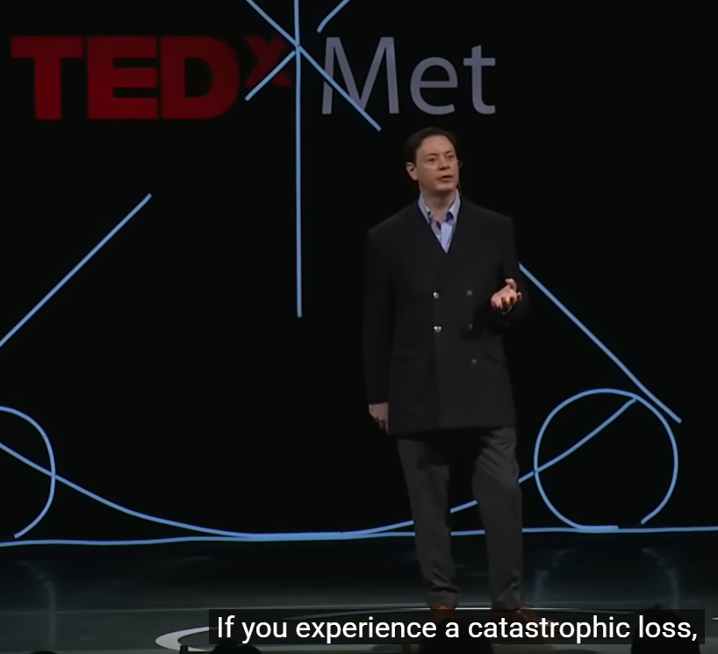

Step 2) While watching: answer the following questions

1. How does Solomon describe depression?

____________________________________________________________________________________________________________________________________________________________________________________________________________________________________________________________________________________

2. What causes of depression are discussed?

____________________________________________________________________________________________________________________________________________________________________________________________________________________________________________________________________________________

- What treatments or coping strategies are discussed

________________________________________________________________________________________________________________________________________________________________________________________________________________________________________________________________________________________________________________________________________________________________________________

Step 3) After watching: Summarise the key message of the talk in 3-4 sentences

________________________________________________________________________________________________________________________________________________________________________________________________________________________________________________________________________________________________________________________________________________________________________________
____________________________________________________________________________________________________________________________________________________________________________________________________________________________________________________________________________________

Step 4) Is depression best explained biologically (based on our biology), psychologically (based on our thoughts) or socially (based on our social circumstances). Explain your answer

________________________________________________________________________________________________________________________________________________________________________________________________________________________________________________________________________________________________________________________________________________________________________________

Step 5) Stretch yourself: Identify one strength and one limitation of using people’s personal experiences as evidence.  One strength _____________________________________________________________________________________________________________________________________________________________________  One weakness  _____________________________________________________________________________________________________________________________________________________________________ | 

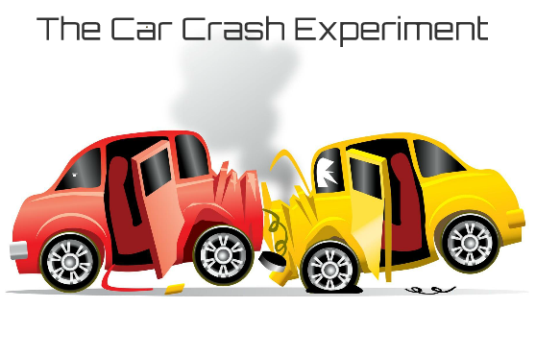 | Loftus and Palmer (1974) carried out a well-known psychology experiment to investigate how reliable human memory is, particularly in eyewitness situations. Their main aim was to see whether the wording of questions (known as leading questions) could influence how people remember an event. A leading question is one that suggests a particular answer or contains information that may shape a person’s response.
In the first part of the study, participants watched short video clips of car accidents. After viewing the clips, they were asked to estimate how fast the cars were going. The crucial detail was that the question was phrased differently for each group. For example, some participants were asked how fast the cars were going when they “hit” each other, while others heard stronger words like “smashed or collided” and others heard softer words such as “bumped or contacted.” This type of experiment is called a laboratory experiment, meaning it took place in a controlled environment where variables could be carefully managed.
The results showed that participants gave different speed estimates depending on the word used. Those who heard “smashed” tended to give higher speed estimates (40.8 mph on average) than those who heard milder words like “contacted” (31.8mph). This suggests that memory is not a perfect recording of events but can be influenced by the language used in questions after the event.
In a second part of the study, participants were later asked whether they saw broken glass in the crash (even though there was none). Participants who had heard the word “smashed” were more likely to say they remembered broken glass. This is called a false memory. Loftus and Palmer concluded that memory is reconstructive, meaning it can be changed by new information after the event. This has important implications, especially in legal settings, where eyewitness testimonies may not always be fully reliable.
Check your understanding
- Which of the verbs mentioned resulted in the lowest estimates of speed?
____________________________________________________________________________________________
- Which of the verbs mentioned resulted in the highest estimates of speed?
____________________________________________________________________________________________
- What implications to Loftus and Planners findings have for …
 | Police Officers conducting interviews | Judges deciding whether to convict someone | 
Despite limited physical evidence, the confidence of the eyewitness testimony was highly persuasive. Steve Titus was found guilty by a jury and sentenced to prison. This highlights a key issue in psychology: juries often trust confident eyewitnesses, even though confidence does not equal accuracy.
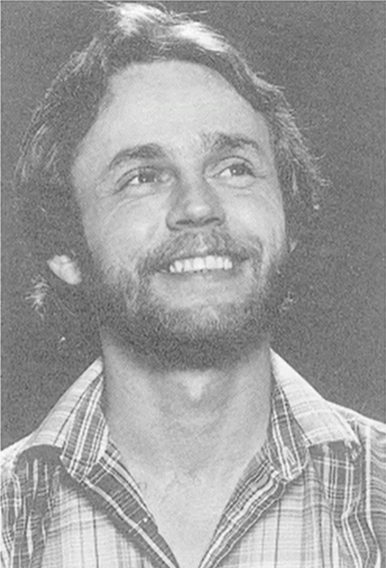
A real world example of False Eyewitness memory

The Case of Steve Titus (A False Memory Case Discussed by Elizabeth Loftus)
In 1980, a woman in Washington State reported being attacked by a man driving a car similar to one owned by Steve Titus. The police identified Titus as a possible suspect based on his car matching the description and his general appearance fitting the attacker’s description. A photo of Titus was then included in a photo lineup shown to the victim.
Initially, the victim said that Steve Titus looked similar to the attacker but was not completely certain. However, during the investigation the police focused heavily on Titus as the suspect. As the investigation proceeded the identification process became increasingly biased and subtle suggestions implied that Titus was the “correct” choice. Over time, the victim’s memory became stronger and more confident. Eventually, she testified in court that Titus was definitely the attacker

In her TED Talk, Loftus uses this case to illustrate how memory can be distorted through suggestion and expectation. She explains that memory is reconstructive and the victim likely experienced a source monitoring error, confusing her memory of the attacker with the repeated exposure to Titus’ image. The police procedures further introduced post-event information, shaping the memory over time.
Later, evidence emerged identifying another man as the true attacker. Steve Titus was eventually cleared, but the damage was severe: His life was ruined, his business collapsed and he suffered significant emotional consequences. Since Elizabeth Loftus published her original research more than 700 wrongful convictions have been overturned in the US where false eyewitness testimony played a role.
This case of Steve Titus clearly demonstrates:
- False memories can feel completely real
- Leading procedures and suggestions distort recall
- Eyewitness confidence is not a reliable indicator of accuracy
Check your understanding: What factors contributed to the creation of a ‘false memory’ in this case?
________________________________________________________________________________________________________________________________________________________________________________________________________________________________________________________________________________________________________________________________________________________________________________
Why are criminal convictions no longer made based on eyewitness testimony alone?
____________________________________________________________________________________________________________________________________________________________________________________________________________________________________________________________________________________
Does this mean that eyewitness accounts of crimes have no value? (Justify your answer)
____________________________________________________________________________________________________________________________________________________________________________________________________________________________________________________________________________________
Watch Elizabeth Loftus’ TED talk (How reliable is your memory?) on the Steve Titus case
Evaluating the Loftus and Palmer car crash Experiment

✅ Advantages

1. High control (strong internal validity): The study was a laboratory experiment, meaning variables were carefully controlled (e.g. same film clips, only wording changed). This makes it clear that the independent variable (verb) caused the change in speed estimates. This supports cause-and-effect (the idea that the leading information directly influenced the speed that was estimated)

2. Easy to replicate (reliable): The study used a standardised procedure (same clips, same question format). This means other researchers can repeat the study to check consistency. This increases reliability of findings.

3. Important real-world applications: The study showed that leading questions can distort memory. This influenced police interview techniques, courtroom procedures and led to the development of a new form of interview (known as cognitive interviews). This demonstrates a strong practical use of this theory in society.

❌ Disadvantages

1. Low ecological validity: Watching video clips of car crashes is not the same as witnessing a real accident. In real life witnesses experience fear, anxiety and emotional arousal. Also, the participants knew they were in an experiment and therefore their speed estimates held very little importance. This questions the validity of Loftus’ research as real eyewitnesses experiences may be less effected by leading information. Research by Yuille and Cutshall (1986) found that eyewitness memories of a real-life bank robbery were much less affected by leading questions.

2. Lack of population validity: The sample was made up of mainly university students. They are not representative of the wider population (e.g. in terms of age or experience). This limits generalisability. The speed estimates of more experienced drivers may have been less affected by leading information.

3. Ethical issue: deception: Participants were misled about the true aim of the study (memory distortion). They were not initially aware their memory was being tested and therefore were not able to give fully informed consent. This raises minor ethical concerns (although low levels of actual harm).

Step 2) Conclusion: Do you think Elizabeth Loftus’ conclusions about the effects of leading questions are valid based on her research? Justify your response based on what you think is the most compelling argument from those given above.
________________________________________________________________________________________________________________________________________________________________________________________________________________________________________________________________________________________________________________________________________________________________________________________________________________________________________________________________________________________________________________________________________________________________________________________________________________________________________________________________________________________________________________________________________________________________________________________________________________________________________________________________________________________________________________________________________________________________________________________________________________________________________________________________________________________________________________________________________________________________________________________________________________________________________________________________________________________________________________________________________________________________________________________________________________________________________________________

Task 4) Reflection: Think about the work of the psychologists above (Gilbert, Soloman and Loftus).

Write one sentence to describe what a psychologist does

____________________________________________________________________________________________________________________________________________________________________________________________________________________________________________________________________________________________________________________________________________________________________________________________________________________

Write one sentence to explain how psychologists contribute to the betterment of society

____________________________________________________________________________________________________________________________________________________________________________________________________________________________________________________________________________________________________________________________________________________________________________________________________________________

Optional Extension task)

Enrol for free with Tutor2u and complete the ‘Introduction to AQA A-level Psychology’

https://ondemand.tutor2u.net/courses/208449ee-f35c-4399-b635-8fbd875fdf30

Give yourself a big head start in A level Psychology by completing this course.

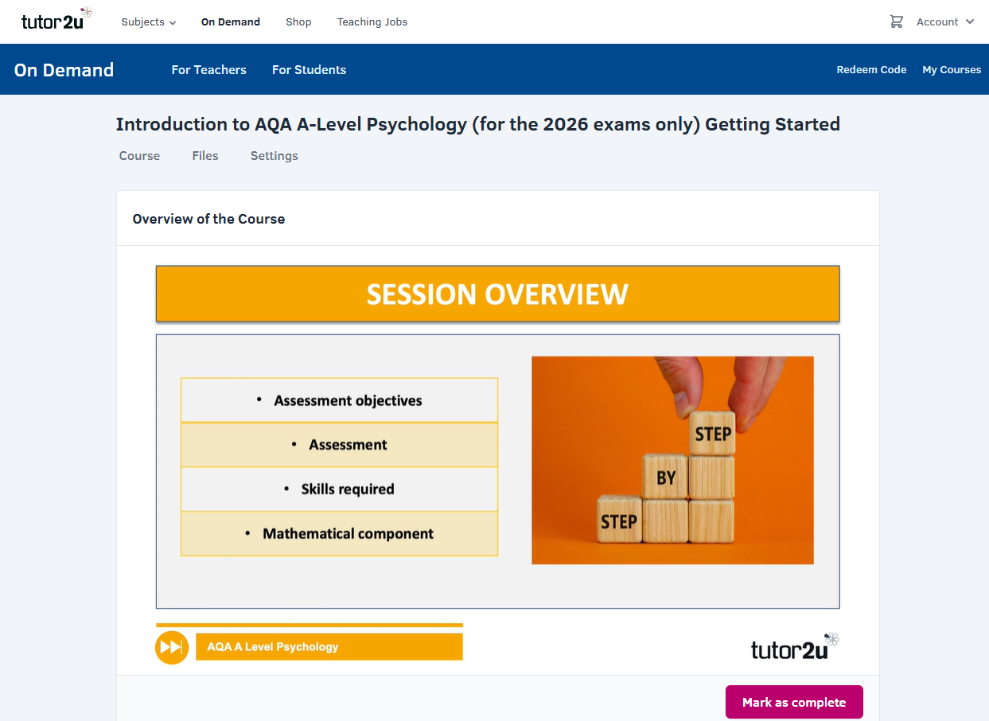
Introduction
- Overview of the course
- Assessment Objectives
- Course assessment
- Skills required
- Mathematical Component

Extension Task

What are the three main skills (Assessment objectives) that are you required to demonstrate in AQA A level Psychology?

- _____________________________________________________________________________
- _____________________________________________________________________________
- _____________________________________________________________________________



