
GEOGRAPHY A LEVEL
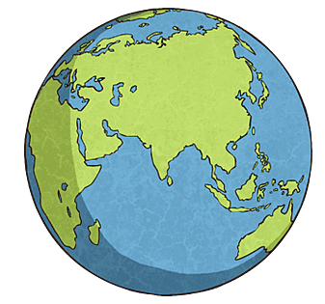

Name:

Class:

Teachers: Mrs Ahmed and Mr Adams

The purpose of this transition booklet is to boost your readiness for A Level Geography by…

- Encouraging you to be geographically curious about the physical and human processes shaping our world, from volcanic eruptions and climate change to globalisation and international governance.
- Understanding that Geography is about debate and evaluation. There is rarely a single correct answer; geographers weigh evidence, consider different perspectives, and assess the extent to which factors influence outcomes.
- Developing your ‘geographical voice’ – your ability to communicate ideas using accurate geographical terminology, apply concepts to real-world issues, and construct evidence-based arguments.

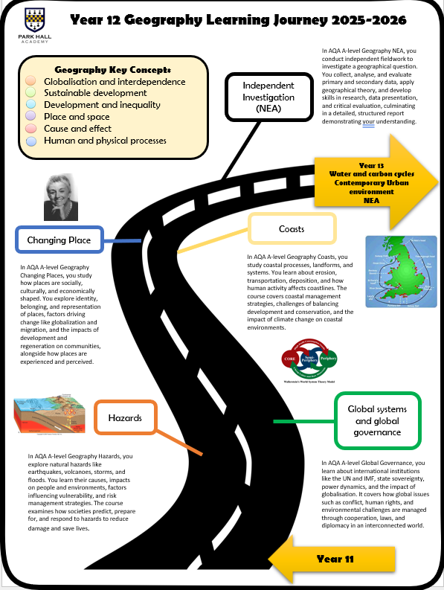
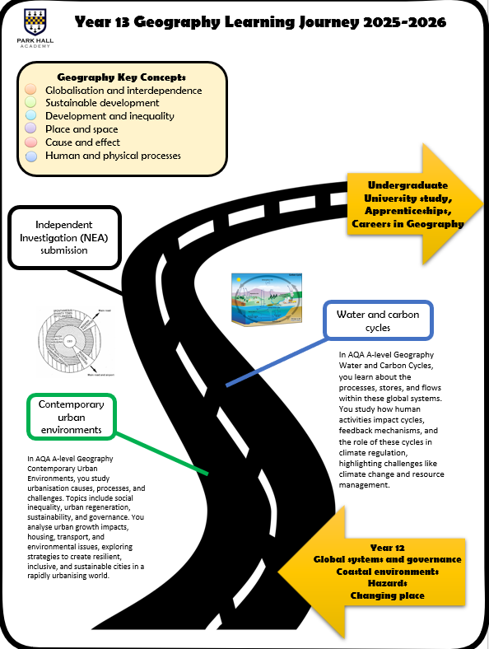
Below highlights the topics you will be studying for A Level Geography:

Mrs Ahmed = Human Geography
Mr Adams = Physical Geography

Task 1:
As part of your first physical geography topic, you will be looking at ‘Natural Hazards’. Use the information below to fill in the corresponding tasks.
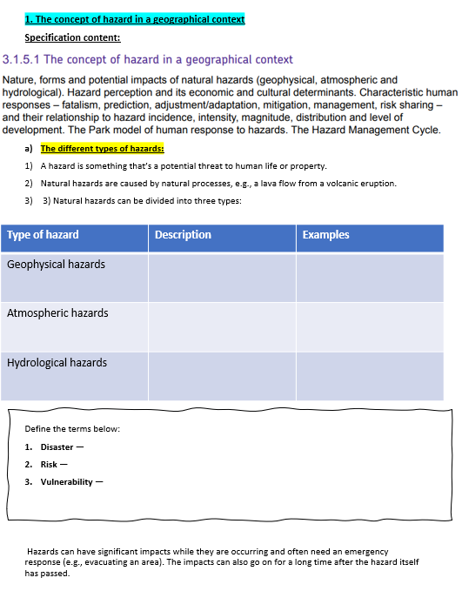
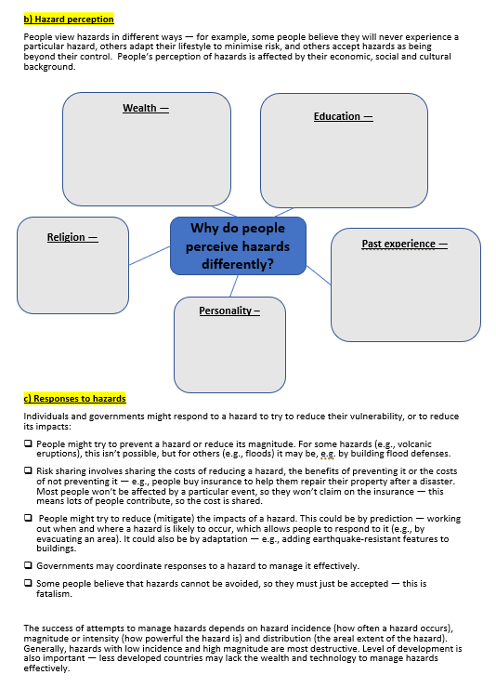

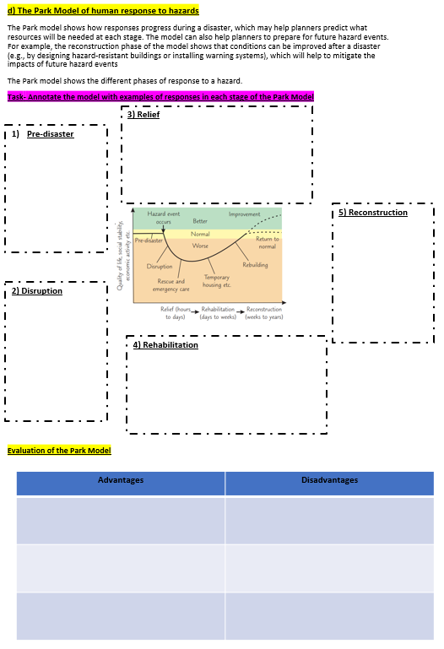
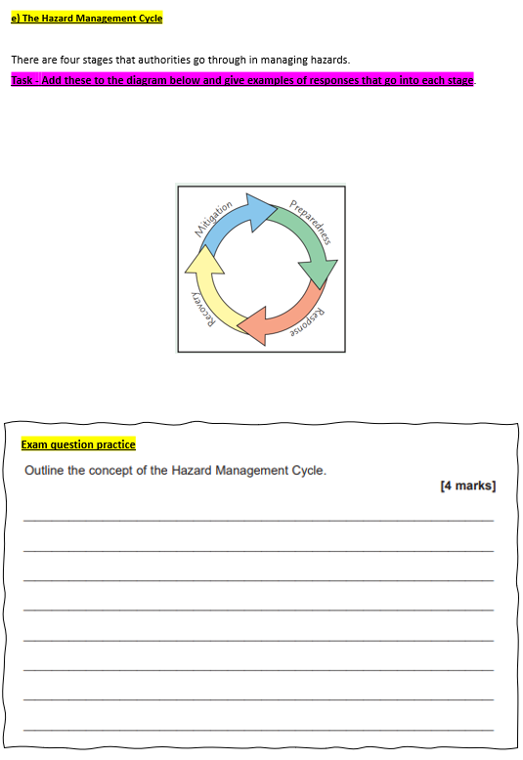
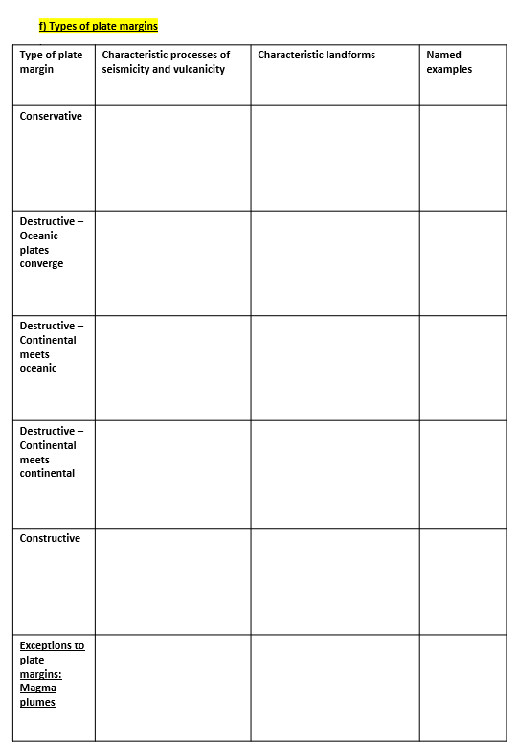
Task 2:
As part of your first human geography topic, you will be looking at ‘Global governance and systems’. Use the information below to fill in the corresponding tasks.
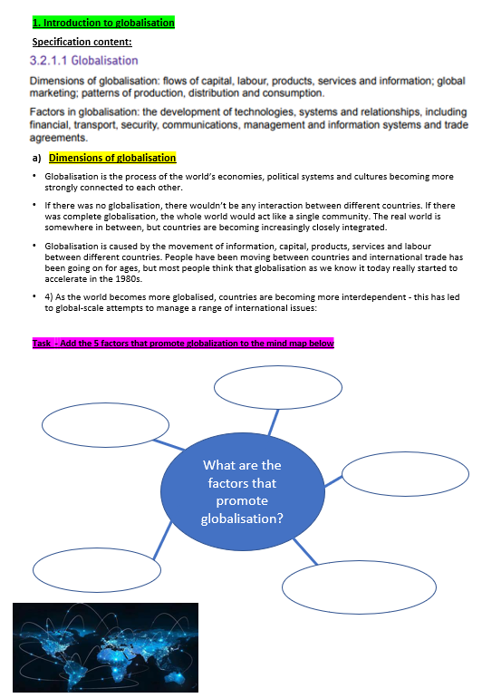
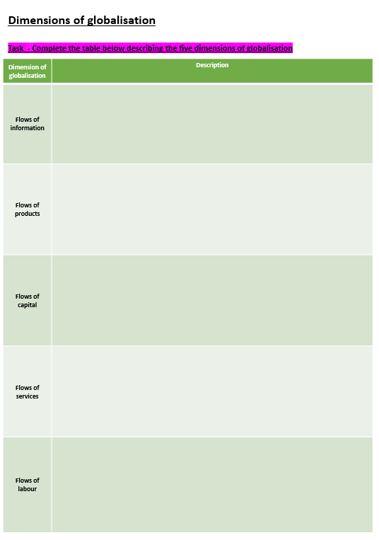
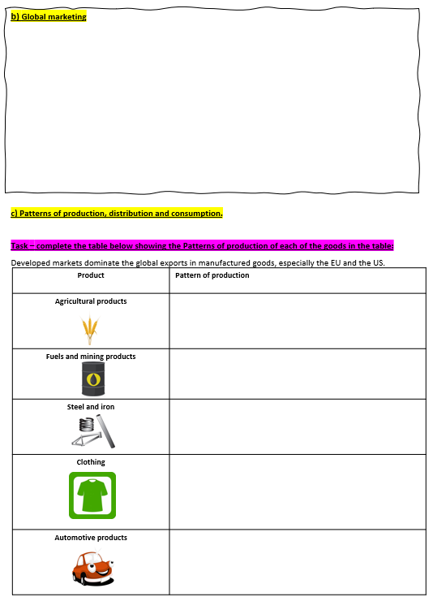
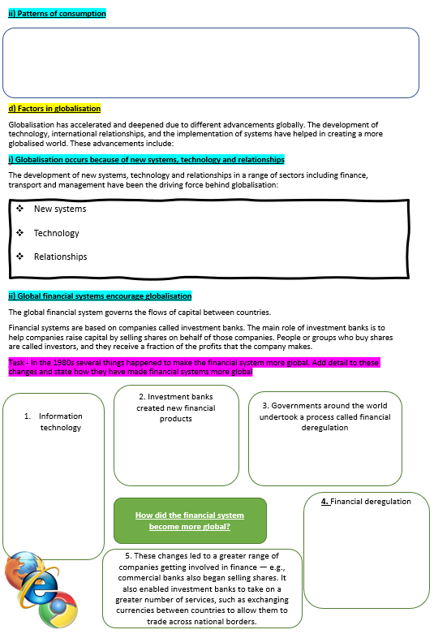
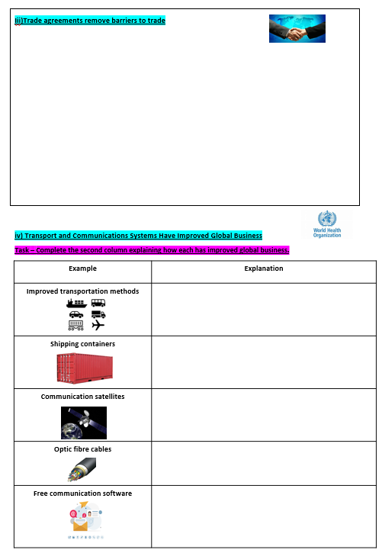
Understanding AQA A-Level Geography Command Words
Success in A-Level Geography is not just about what you know; it is also about understanding exactly what the examiner is asking you to do. Different command words require different types of responses. Learning these command words will help you structure your answers more effectively and maximise your marks.
Analyse
To analyse means to break a topic, issue, process or set of data into its component parts and examine the relationships between them. You should identify patterns, connections and causes rather than simply describing what you see.
Annotate
To annotate means to add notes, labels and explanations to a diagram, photograph, map or graphic. Good annotations go beyond identifying features and explain their significance.
Assess
To assess means to consider different viewpoints, arguments or factors and weigh them up before reaching a reasoned judgement about their importance, effectiveness or validity.
Calculate
To calculate means to work out a numerical value using the information provided. Make sure you show your working where appropriate and include units.
Critically Assess / Critically Evaluate
When a question includes the word critically, you are expected to examine strengths, weaknesses, limitations and alternative viewpoints. Your answer should be balanced and analytical, leading to a well-supported judgement.
Define
To define means to give the precise meaning of a geographical term or concept. Definitions are usually concise and require accurate geographical terminology.
Describe
To describe means to provide a detailed account of a feature, pattern, process, distribution or event. Focus on what is happening rather than why it is happening.
Discuss
To discuss means to consider different sides of an argument and explore contrasting viewpoints. A discussion should demonstrate balance and conclude with a reasoned judgement.
Evaluate
To evaluate means to judge the importance, success, effectiveness or value of something. This requires consideration of both strengths and weaknesses before reaching a conclusion.
Examine
To examine means to investigate a topic carefully and in detail. You should explore evidence and explain its significance.
Explain
To explain means to give reasons for why something occurs. This usually involves demonstrating an understanding of geographical processes and showing clear chains of cause and effect.
Interpret
To interpret means to identify and explain the meaning of information presented in a graph, map, photograph, table or other resource. You should explain what the evidence suggests rather than simply describing it.
Justify
To justify means to provide reasons why a particular view, decision or course of action is valid. You should demonstrate why one option is preferable to alternatives.
Outline
To outline means to provide a summary of the key points or main features of a topic. Avoid unnecessary detail.
To What Extent
This command word requires you to consider how far you agree with a statement. You should explore evidence supporting different viewpoints before reaching an overall judgement about the validity of the statement.

Understanding the Assessment Objectives (AOs)
All AQA A-Level Geography questions assess one or more of three Assessment Objectives (AOs). Understanding these will help you recognise what examiners are looking for in your answers.
AO1: Knowledge and Understanding
AO1 is about what you know. It requires you to demonstrate accurate geographical knowledge, understanding of concepts, theories and processes, and the use of appropriate geographical terminology.
For example, in Natural Hazards, AO1 might involve explaining how plate tectonics causes earthquakes and volcanic eruptions. In Global Systems and Global Governance, it could involve understanding the role of global institutions such as the United Nations or the World Trade Organisation.
Key words associated with AO1: Define, Describe, Outline, State.

AO2: Application and Analysis
AO2 is about using your geographical knowledge to interpret information, apply concepts to unfamiliar situations and analyse patterns, relationships and processes.
This often involves using resources such as maps, graphs, photographs or case study information. You must move beyond describing what you see and explain what the evidence means.
For example, you may be asked to analyse why the impacts of an earthquake differ between countries or explain how patterns of trade demonstrate global interdependence.
Key words associated with AO2: Explain, Analyse, Interpret, Examine.

AO3: Evaluation
AO3 is the highest-level skill in A-Level Geography. It requires you to make judgements by weighing up evidence, considering different viewpoints and reaching supported conclusions.
There is rarely a single correct answer. Instead, you are expected to assess the relative importance of different factors and justify your opinions using geographical evidence.
For example, you might evaluate whether governance is the most important factor in reducing hazard risk, or assess the extent to which globalisation benefits developing countries.
Key words associated with AO3: Assess, Evaluate, Discuss, Justify, To What Extent.

The Geography Success Formula
- AO1 = What do I know?
Knowledge and understanding.
- AO2 = How can I apply and analyse what I know?
Using geographical knowledge to interpret evidence and explain relationships.
- AO3 = What judgement can I make?
Evaluating evidence and reaching a reasoned conclusion.
TASK 3:
1. Which Assessment Objective (AO) is primarily focused on making judgements and reaching conclusions?
A. AO1 – Knowledge and Understanding
B. AO2 – Application and Analysis
C. AO3 – Evaluation
D. AO4 – Investigation
2. Which command word requires you to consider different viewpoints before reaching a reasoned judgement?
A. Describe
B. Define
C. Evaluate
D. Outline
3. A question asks you to "Explain how governance can reduce the impacts of natural hazards." Which Assessment Objective is being assessed most directly?
A. AO1 – Knowledge and Understanding
B. AO2 – Application and Analysis
C. AO3 – Evaluation
D. AO1 and AO3 equally

Task 4:
Highlight where the four AO1 marks were given in the 2 model answers below:

- Outline the role of containerisation in globalisation. (4 marks)
Containerisation has contributed to globalisation by making the transportation of goods faster, cheaper and more efficient. Standardised shipping containers can be easily transferred between ships, trains and lorries, reducing handling costs and delays. This has encouraged the growth of international trade and allowed businesses to source materials and manufacture products across different countries. As a result, containerisation has increased global interconnectedness and the movement of goods between economies.

- Outline the characteristics of a conservative plate boundary. (4 marks)
A conservative plate boundary occurs where two tectonic plates move past each other horizontally. No crust is created or destroyed because the plates do not move towards or away from each other. Friction causes the plates to become locked together, leading to a build-up of pressure. When this pressure is released, earthquakes occur, but volcanoes are not usually found at conservative plate boundaries.

