Name: ​ ​ Date: ​

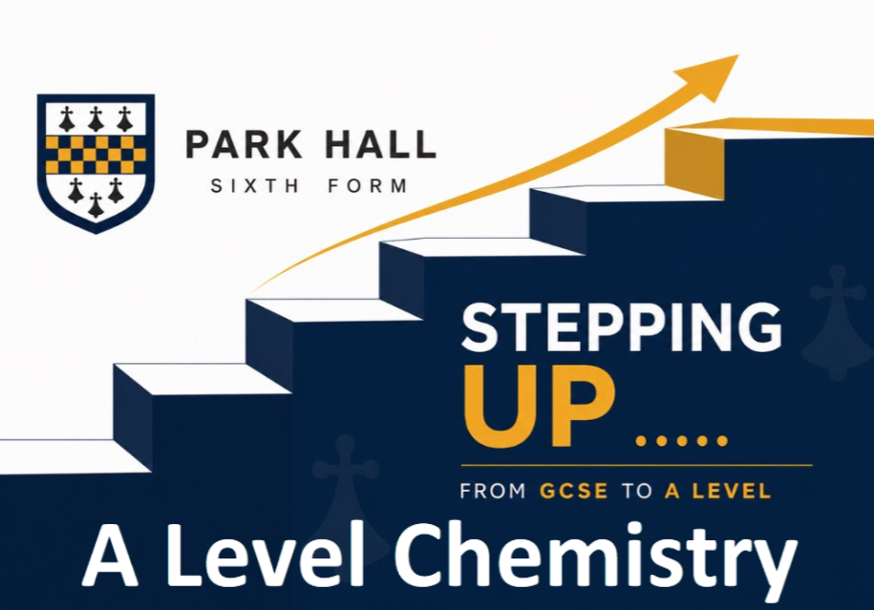
Welcome to your A-Level Chemistry transition workbook!

This booklet is designed to take around 3-4 hours to complete.
It will recap essential GCSE knowledge and build the foundational skills you need for
Year 12.
It will ensure you have a solid grounding in Bonding, atomic structure, and quantitative chemistry. These are fundamental to grasping Year 12 content.


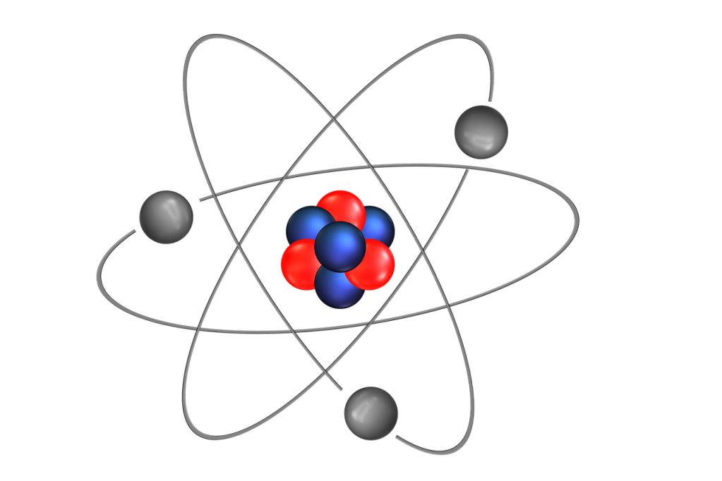

TASK 1 Atomic Structure

Completing this task will help remind you of the basic structure of the atom and how that links to the periodic table.
  - What do the terms A, N and Z represent in Chemistry. How can A and Z be used to determine N?
________________________________________________________________________

________________________________________________________________________

________________________________________________________________________

________________________________________________________________________

________________________________________________________________________

  - Draw a detailed labelled diagram of an atom of Lithium. Include the names of the fundamental particles, their relative charges and masses. Write down the electron configuration of Lithium.

  - Draw simple dot and cross diagrams and write down the electron configurations of the following elements: ¹²C ²⁰Ca

  - Turn to the periodic table on the next page.
Label your periodic table with group names (where applicable) and group numbers, label the energy levels (period numbers), indicate which are metals, non-metals and the transition elements.

  - Explain how the group number and the ‘period number’ relate to the electron configuration of an atom.

________________________________________________________________________

________________________________________________________________________

________________________________________________________________________

________________________________________________________________________

________________________________________________________________________

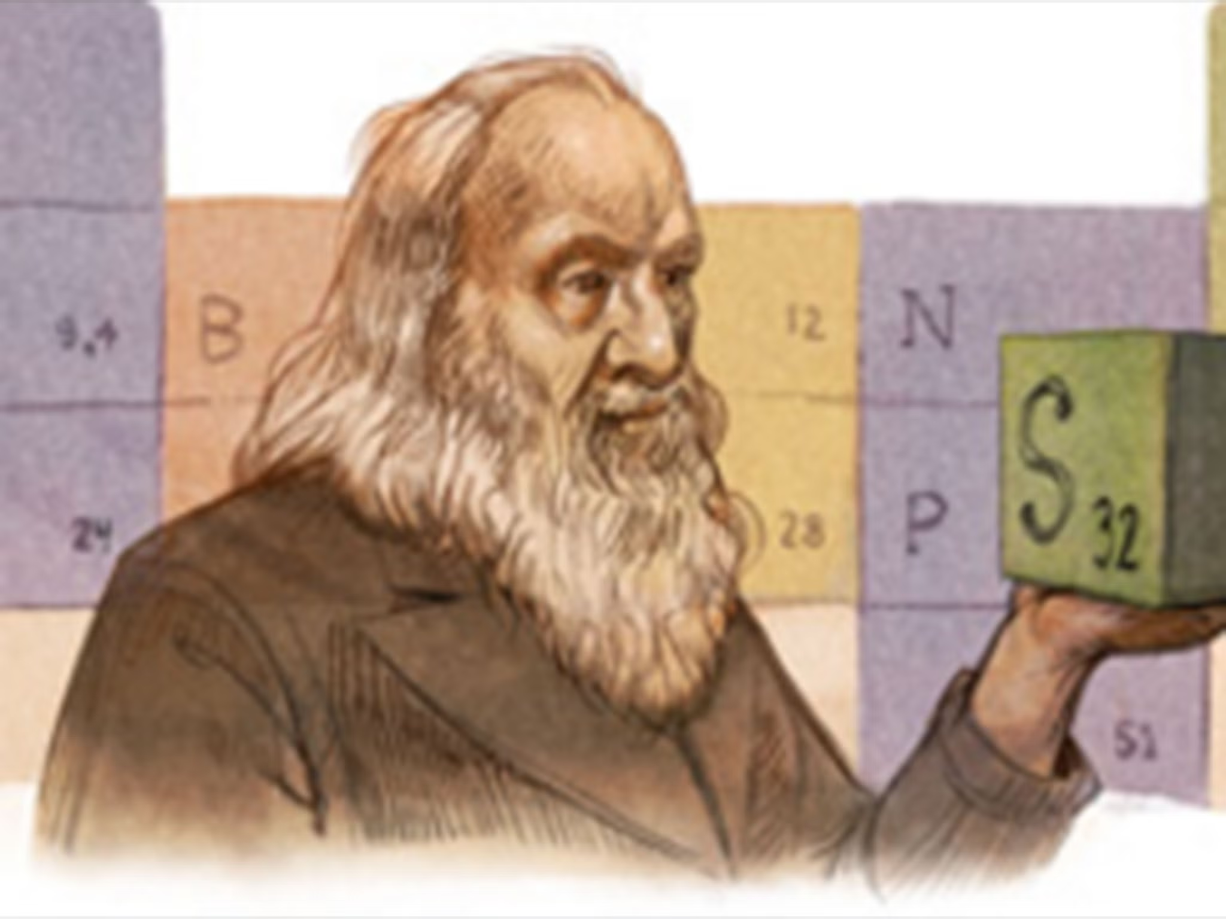

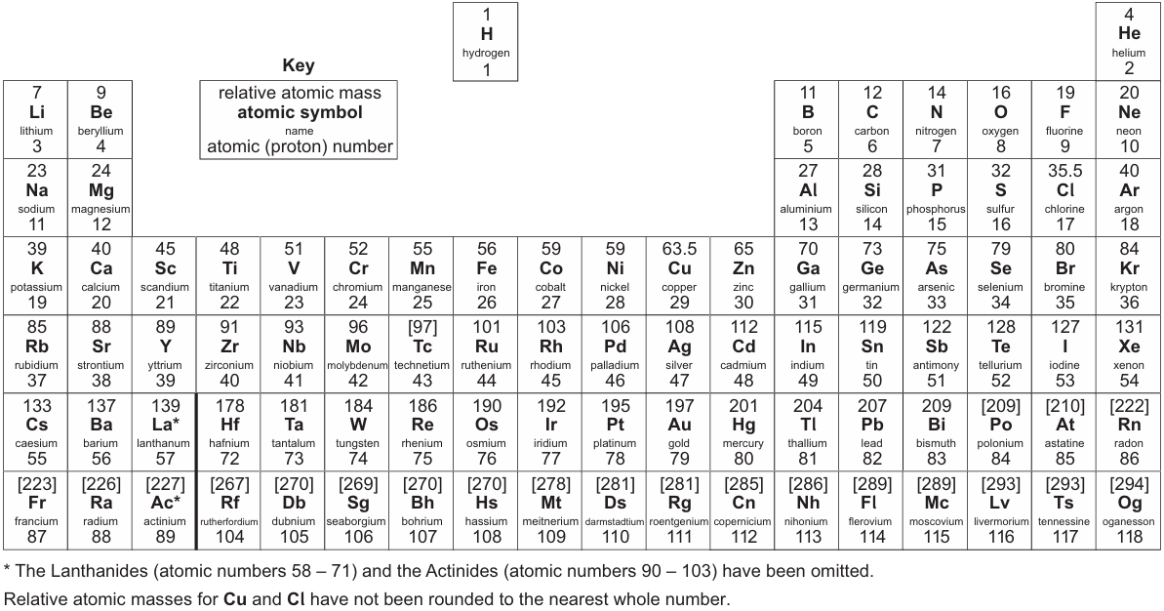

TASK 2 Amount of Substance
Before you can start work on moles (amount of substance) you need to know how to interpret equations and formula.
A Level chemists only ever write balanced symbol equations and you need to know a whole range of formula ‘off by heart’. These tasks will help you to achieve this.

  - Write a definition and give an example for the following terms: formula, molecule, ion (anion, cation)
________________________________________________________________________

________________________________________________________________________

________________________________________________________________________

________________________________________________________________________

________________________________________________________________________

  - How do you deduce the charge of a monatomic ion from its location in the periodic table? Add the charges of the ions in each group to your periodic table.
________________________________________________________________________

________________________________________________________________________

________________________________________________________________________

________________________________________________________________________

________________________________________________________________________
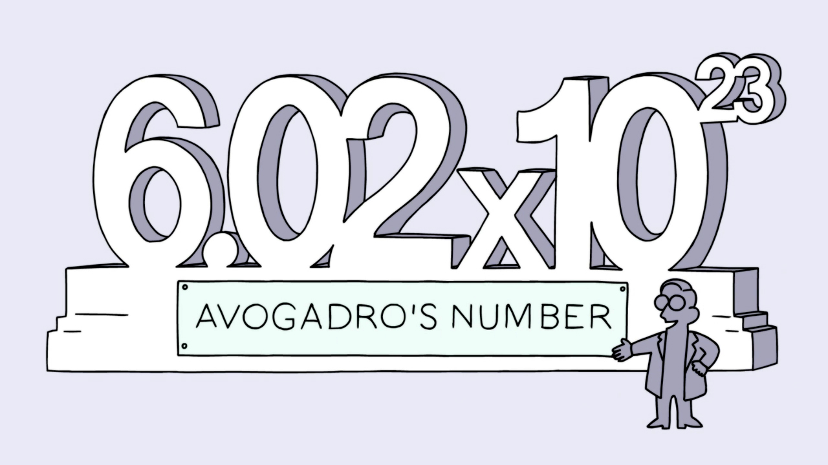

  - Find out and write down the formula of the following molecular compounds (you need to memorise these): methane, oxygen, hydrogen, chlorine, ammonia, hydrochloric acid, sulfuric acid, nitric acid, phosphoric acid.
________________________________________________________________________

________________________________________________________________________

________________________________________________________________________

________________________________________________________________________

________________________________________________________________________

  - Find out and write down the formula and overall charge of the following ions (you need to memorise these): chloride, ammonium, sulfate, nitrate, phosphate, carbonate, hydrogen carbonate , hydride, sulfide and nitride?
________________________________________________________________________

________________________________________________________________________

________________________________________________________________________

________________________________________________________________________

________________________________________________________________________

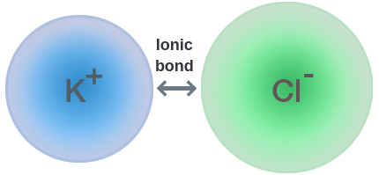

TASK 3- Mole calculations
About 20-30% of A Level Chemistry is based on 'moles' calculations. This will help you get up to speed.
- What is a mole (in chemistry)?
________________________________________________________________________

________________________________________________________________________

________________________________________________________________________

- List the 'Maths' equations you need to use to calculate the following:
  - atom economy
________________________________________________________________________

  - percentage yield
________________________________________________________________________

  - mass (using moles and Mr)
________________________________________________________________________

  - concentration (using moles and volume)
________________________________________________________________________

- What volume does a mole of any gas occupy, in dm³
________________________________________________________________________

Empirical Formula
- A compound is found to contain 3.55 g carbon, 0.61g hydrogen, and 1.59g oxygen by mass. Determine its empirical formula.

- An unknown compound is analysed and found to contain 22.8% sodium, 21.8% boron, and the remainder oxygen by mass. Calculate its empirical formula.

Percentage Yield

- In a reaction, 92.0 grams of glucose (C₆H₁₂O₆) produce 40.0 grams of ethanol (C₂H₅OH). The theoretical yield is 46.0 grams. Calculate the percentage yield.

- If 27.0 grams of aluminum (Al) react with excess oxygen (O₂) to produce 40.0 grams of aluminum oxide (Al₂O₃), and the theoretical yield is 51.0 grams, calculate the percentage yield.

Atom Economy
- Calculate the atom economy for the hydrogenation of ethene (C₂H₄) to produce ethane (C₂H₆).
Reaction: C₂H₄ + H₂ → C₂H₆
- Calculate the atom economy for the reduction of iron(III) oxide (Fe₂O₃) to produce iron (Fe).
Reaction: 2 Fe₂O₃ + 3 C → 4 Fe + 3 CO₂
Reacting Masses
- How many grams of ammonia (NH₃) are produced when 4 grams of nitrogen gas (N₂) react with excess hydrogen gas (H₂)? 3H₂ + N₂ --> 2NH₃

- Determine the mass of carbon dioxide (CO₂) produced when 50 grams of propane (C₃H₈) undergoes complete combustion. C₃H₈ + 5 O₂ --> 3 CO₂ + 4 H₂O

Volume of Gases
- What is the volume occupied by 0.5 moles of oxygen gas (O₂) at room temperature and pressure (rtp)?

Titration Calculations

A student carries out a titration using sodium carbonate solution and nitric acid. The equation for the reaction is:

Na₂CO₃ + 2 HNO₃ → 2 NaNO₃ + CO₂ + H₂O

25.0 cm³ of 0.124 mol/dm³ sodium carbonate solution is neutralised by 23.6 cm³ of nitric acid. Calculate the concentration of the nitric acid.

During a titration 25.00 cm³ of hydrochloric acid reacted with 23.50 cm³ of 0.100 mol/dm³ barium hydroxide solution. The equation for the reaction is:

2 HCl(aq) + Ba(OH)₂(aq) → BaCl₂(aq) + 2 H₂O(l)

Calculate the concentration of the hydrochloric acid in mol/dm³.

TASK 4 Bonding

What hold atoms together? It always comes down to attraction between positive and negative, but this can show up in all sorts of different ways.
Bonding is one of the fundamental basics of Chemistry at any level.

  - Write a definition and give an example for the following terms: ionic bonding, metallic bonding, simple covalent bonding
________________________________________________________________________

________________________________________________________________________

________________________________________________________________________

________________________________________________________________________

________________________________________________________________________

________________________________________________________________________

  - List three examples of macromolecules
________________________________________________________________________

________________________________________________________________________

________________________________________________________________________
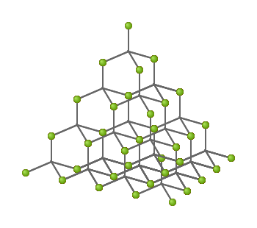
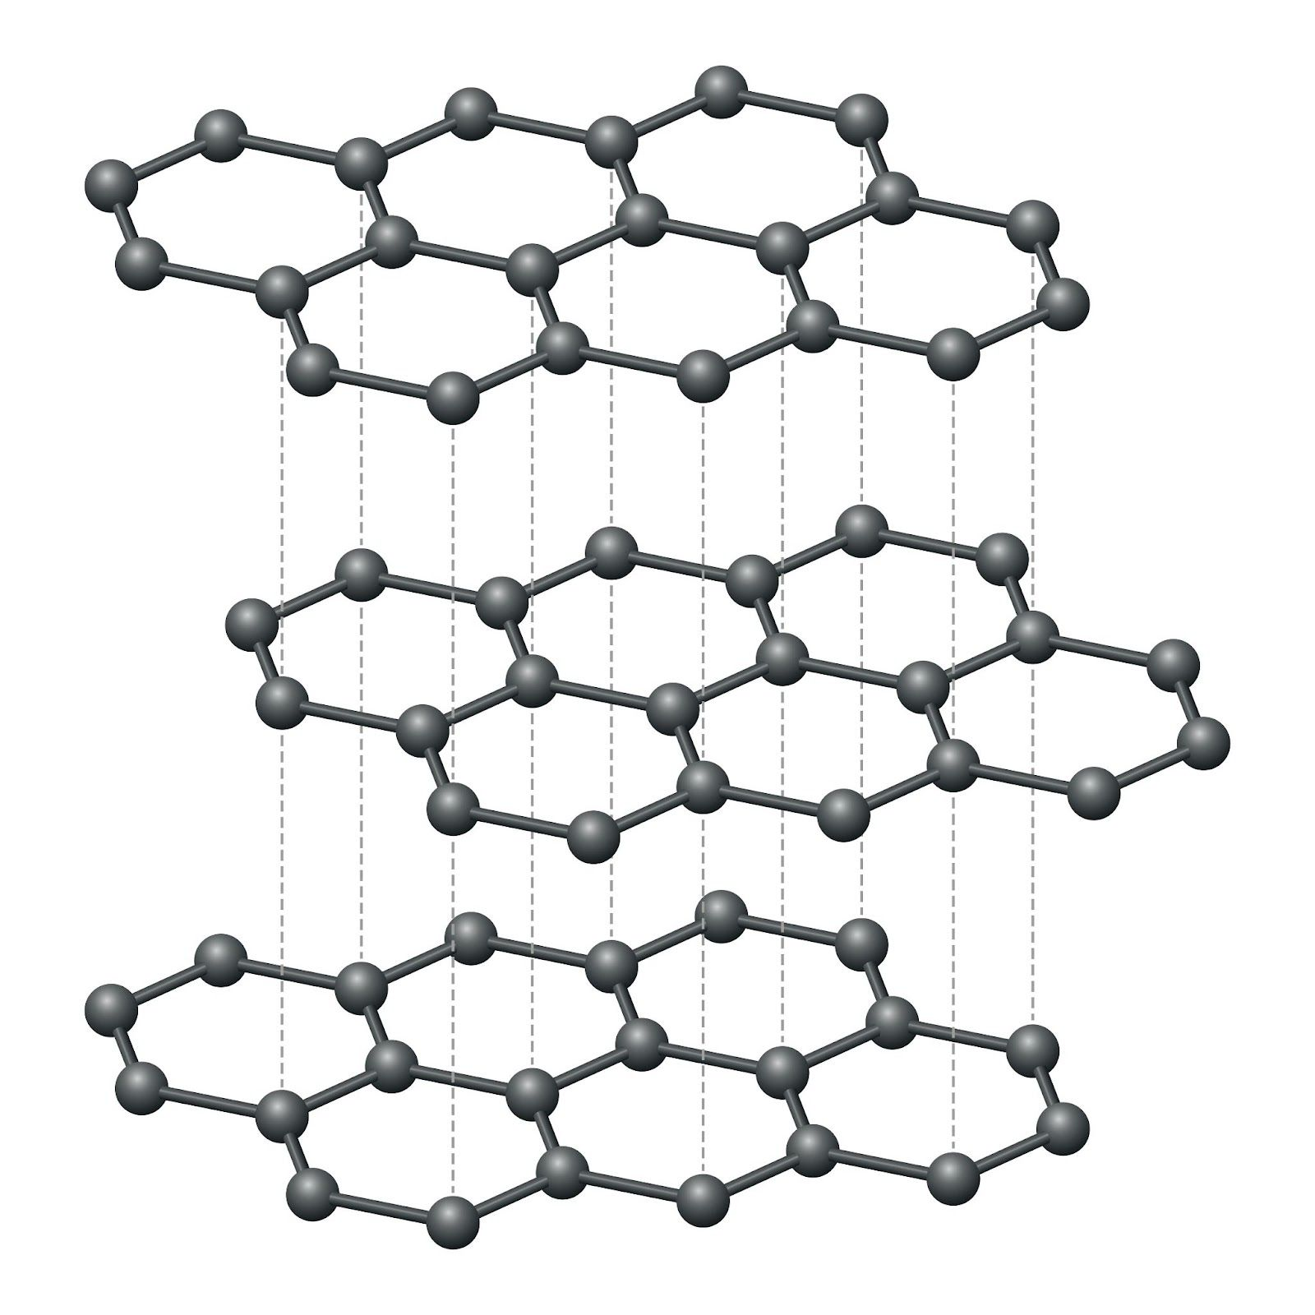

  - Using information about the structure and bonding explain the following properties. Your answers should include the type of bonding present in each substance, a description of the bonding and then an explanation linking the bonding/structure to the stated properties.
a. Sodium chloride has a high melting point, and can conduct electricity when molten
________________________________________________________________________

________________________________________________________________________

________________________________________________________________________

b. Graphite can conduct electricity
________________________________________________________________________

________________________________________________________________________

________________________________________________________________________

c. Copper metal has a high melting point, and can conduct electricity when solid.
________________________________________________________________________

________________________________________________________________________

________________________________________________________________________

d. Oxygen has a very low melting and boiling point
________________________________________________________________________

________________________________________________________________________

________________________________________________________________________

e. Why an alloy is harder than a pure metal
________________________________________________________________________

________________________________________________________________________

________________________________________________________________________
TASK 5 Optional extension

Still need more chemistry in your life? Have a look at some of the videos on this channel!



