Name: ​ ​ Date: ​
​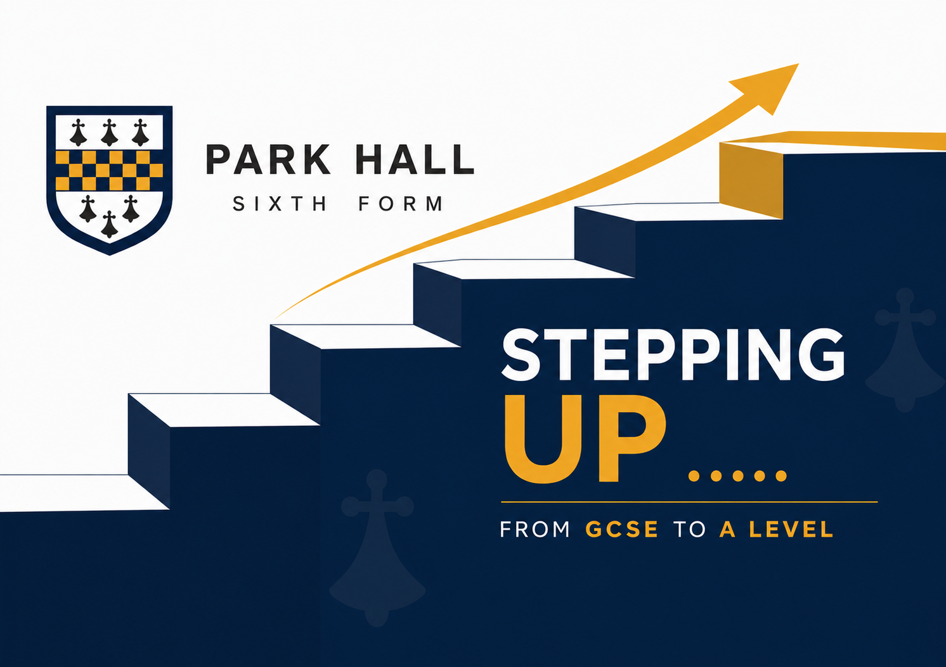
A Level Biology

​
Welcome to your A-Level Biology transition workbook! This booklet is designed to take around 2 hours to complete. It will recap essential GCSE knowledge and build the foundational skills you need for Year 12. If you get stuck on any section, use the QR code below to access the BBC Bitesize (GCSE Biology) Cells topic to refresh your memory.
​

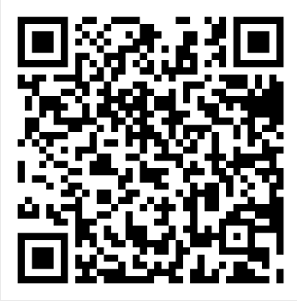

Part 1: Cell Structure
​
Animal Cell Drawing | Plant Cell Drawing
A-Level Biology requires a deep understanding of cell structures, distinguishing between eukaryotic (animal, plant, fungi) and prokaryotic (bacterial) cells.
​
In the boxes below, draw a typical animal cell and a typical plant cell as seen under a light microscope. Label the key organelles.
Complete the table below to state the specific function of each eukaryotic cell structure.
​

Cell Structure | Function
Nucleus
Mitochondria
Ribosomes
Cell Wall (Cellulose)

​

Feature | Eukaryotic Cell | Prokaryotic Cell
Size
Location of DNA
Ribosomes (Size)
Membrane-bound organelles (e.g. mitochondria)
​ Complete the table below to compare Eukaryotic and Prokaryotic cells.
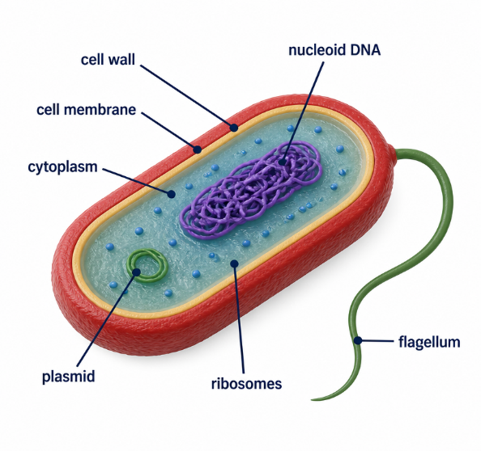
Describe the function of a plasmid in a bacterial cell.
​

​
Name two structures present in plant cells that are never found in animal cells.
​

​
​
​
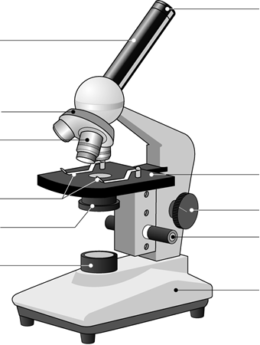
Part 2: Microscopes & Scientific Drawing
​
Label the parts of the microscope.

In Year 12, you will be required to draw cells exactly as you see them through a light microscope. These must follow strict scientific drawing rules. Look at the micrograph of onion epidermal cells below. In the box provided, make a biological drawing of three adjacent cells. Label the cell wall and nucleus.
​
🧠​ | Rules for Biological Drawings:  - Use a sharp HB pencil.  - Draw clear, continuous lines (no sketchy 'hairy' lines).  - Do NOT use shading or cross-hatching.  - Draw HORIZONTAL label lines with a ruler. Lines must not cross and should not have arrowheads.  - Include a title and state the magnification.

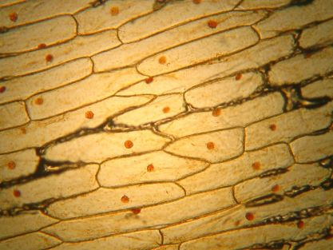

​

​
​

Part 3: Cell Specialisation
​
Complete the table below to describe how the structure of each specialised cell is adapted to its function. If you need to look up the cell please make sure you draw a picture of the cell to help you remember it.
​

Cell Type | Function | Structural Adaptations
Red Blood Cell

Sperm Cell

Root Hair Cell

Neutrophil

Squamous Epithelial Cell

Ciliated Cell

Palisade Cell

Neuron (nerve cell)

​
​
Part 4: Essential Numeracy Skills
​
Maths makes up 10% of the marks in A-Level Biology. Mastering units, standard form, and magnification early will give you a massive advantage.
​
A. Unit Conversions & Standard Form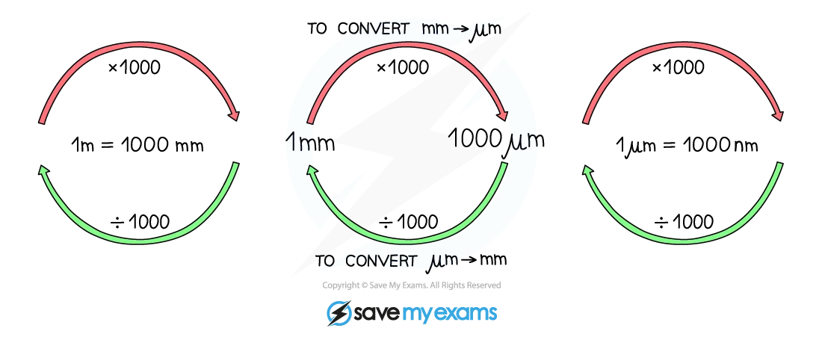
​

Unit Guide:
​
1 millimetre (mm) = 1 × 10⁻³ metres
​
1 micrometre (µm) = 1 × 10⁻⁶ metres (1 mm = 1000 µm)
​
1 nanometre (nm) = 1 × 10⁻⁹ metres (1 µm = 1000 nm)
​
4. Convert the following measurements into the required units:
​

a) 5 mm =  µm | b) 120 µm =  mm | c) 0.8 µm =  nm
​
5. Write the following measurements in standard form (scientific notation):
​

a) 45000 µm =  µm | b) 0.0035 mm =  mm
​
​
6. In a book a micrograph of an erythrocyte was measured as 100mm. The real size of the cell is 50 µm. Calculate the magnification.

B. Magnification Calculations
​
Use the equation: Magnification = Image Size ÷ Actual Size (M = I ÷ A). Remember to ensure both Image Size and Actual Size are in the same units before calculating.
​
7. A student views a palisade mesophyll cell under a microscope. The actual length of the cell is 40 µm. The image length in the student's drawing is 12 mm. Calculate the magnification used. Show your working.

8. An image of a mitochondrion has a magnification of ×20000. The image measures 30 mm in length. Rearrange the equation to calculate the actual length of the mitochondrion in micrometres (µm).
​

​
C. Mean, Median and Range
​
A researcher measured the length of five individual yeast cells. The results (in µm) were: 8, 12, 10, 15, 10
​
9. Calculate the mean, median, and range for this data set. Show your working for the mean.
​


Strengthen your understanding of Biology for next year:
Read: "The Immortal Life of Henrietta Lacks" by Rebecca Skloot
Watch: Our Planet: Episode 1: One Planet

