
Establishing your Routine: Finding Your 15 hours

Use the table below and your timetable to identify / highlight the 15 hours per week when you are going to complete your independent studies. Use:

- Study time
- Early finishes
- Early evenings and weekends

WEEK 1 | Mon | Tue | Wed | Thu | Fri | Sat | Sun
9–10 (P1)
10–11 (P2)
1 –12 (P3)
12–1 (P4)
1-2
2-3 (P5)
3-4
4-5
5-6
6-7
7-8

WEEK 2 | Mon | Tue | Wed | Thu | Fri | Sat | Sun
9–10 (P1)
10–11 (P2)
1 –12 (P3)
12–1 (P4)
1-2
2-3 (P5)
3-4
4-5
5-6
6-7
7-8
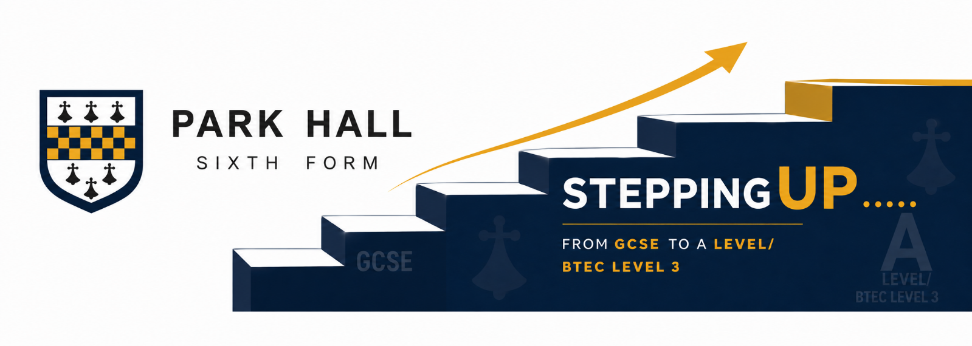
Remember – a good routine helps you to preserve time for those things that you enjoy and boost your sense of wellbeing.
What is your relationship with AI going to be?
High Performing Students | Low performing Students
A task is set | A task is set
Student considers the task and deconstructs it asking ….  What skills do I need to demonstrate here?  What info / concepts / data do I need?  How can I organise / structure my response ? | Student types task into AI
Student may use AI to provide specific support (source information, develop counter arguments, make student responses shorter or more concise).  Exam questions: Student may use AI to assess their response using the mark scheme and recommend areas for improvement. | AI completes task.
 | 
Students develop their own response to the task, using AI to develop their skills and deepen understanding. | Students translates AI response and passes it off as their own
Consequences  Student deconstructed the task  Student planned their own response  Student used deep processing to understand the question and formulate a response  Learning has occurred & LTM activated  Student skills and understanding are better than before. | Consequences  Student did not deconstruct the task  Student did not plan a response  Student did not require their brain to complete any deep processing  No learning & LTM is not activated.  Student is still where they started and no progress is made
Outcome  Student performs well in examinations having developed the independent skills and in depth understanding required.  Student produces legitimate coursework and can explain their approach to potential employers in interview. | Outcome  Student underperforms in examinations due to lack of understanding and undeveloped skills.  Student produces illegitimate coursework that they do not really understand and can’t explain.

What is your relationship with AI going to be?
Consider these two images below as metaphors for our personal relationship with AI.


Why is the man in picture A physically fitter than the man in picture B?

A

B

