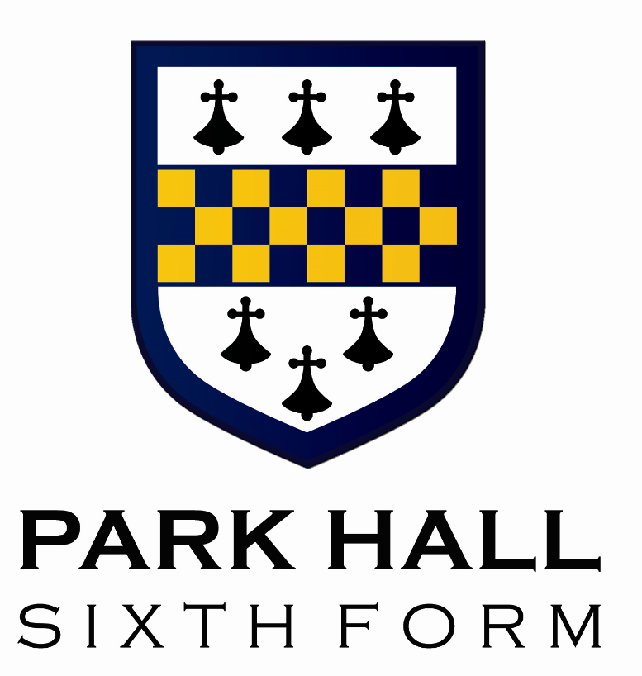
Park Hall Sixth Form
Bursary Policy
2025 - 2026

Park Hall Sixth Form Bursary

The Department for Education has allocated an amount of money to Park Hall to allow the school to grant bursaries to students on low incomes to contribute towards the costs of studying in the Sixth Form.

Eligibility

To be eligible to receive a bursary you must be a full time student at Park Hall Sixth Form and be aged under 19 on 31st August in the academic year in which you begin your programme.

The two levels of payment at Park Hall

Level One

Students who are in or have recently left local authority care or are in receipt of universal credit or Personal Independence Payments.

Level Two

Students who are in receipt of free school meals or with a household income of less than £28,000 per year.
How the funds will be paid
Those eligible for the bursary, will submit claim forms (forms will be provided) attaching receipts for all expenses/purchases which will then be verified and paid directly into student bank accounts. These can be submitted to the Sixth Form office at any time throughout the academic year not just at the end of the term. Funds will be paid directly into the bank account that you provide in your application form. We recommend that you discuss any potential purchases with Mrs Griffiths or Mr Cornell before committing to buy so we can confirm whether or not they can be funded by the Sixth Form Bursary.

Students that qualify for the Sixth Form bursary can claim up to £80 for the cost of appropriate business wear in accordance with our Business Dress Code. To claim back these costs students are advised to confirm with Mrs Griffiths that their intended purchases are appropriate. We will not refund the purchase of items that do not meet the requirements of the Business Dress code. Other suitable costs that can be covered by bursary funds include the following

- Curricular School trips within the UK
- Laptops to support independent study at home (these will be purchased by the school and will remain the property of Park Hall Academy, being returned at the end of a student’s studies).
- School related travel expenses (such as a bus pass)
- School Stationery (Folders, plastic wallets, pens, calculators)
- Educational Text Books/ Course Guides
- Revision Guides and Materials
- UCAS Application Costs

The Process you should follow
If you are eligible for a bursary on any one of the levels, you should apply as soon as possible. All applicants are required to completed the application form and submit evidence that household income is less than £28,000. This evidence may be a P60, letters or emails confirming benefits that you are in receipt of and other evidence of household income. This evidence is a requirement in accordance with Government guidelines for the Bursary Auditors. We would like to strongly encourage any students that feel that they may be eligible to apply. Many of our current students use these funds to purchase personal materials, books and revision guides through the school that greatly support their progress in school.

For more details of the scheme please visit the following web site:
https://www.gov.uk/1619-bursary-fund/overview

Please find our 2025 Park Hall Sixth Form Bursary Application here. Please submit a completed form, along with the required evidence to our Sixth Form Progress Manager Mrs Griffiths either via email at mgriffiths@parkhall.org or via the post to

Mrs M Griffiths
Sixth Form Progress Manager
Park Hall Academy
Water Orton Road
Castle Bromwich
Birmingham
B36 9HF

