BTEC LEVEL 3
IN SPORT
Preparation Booklet

NAME………………………………………..

Anatomy and Physiology

Types of Joints & Bones

From Btec Sport or NCFE Health and Fitness you will already know 2 types of joints; ball and socket & hinge. Listed below are 4 other types of joints. You need to research the following:
- Where these joints are found
- What their structure is
- What movements can occur there
- An example of a sporting movement where the joint would be used

Condyloid:
Gliding:
Saddle:
Pivot:

Type of Bone | Location in the body
Long
Short
Flat
Irregular
Sesamoid

Postural deviations

The 2 images below show 2 types of postural deviations. A postural deviation is when the natural curve of the spine is changed. Next to each image describe the type of postural deviation (what it is/looks like & what causes it).

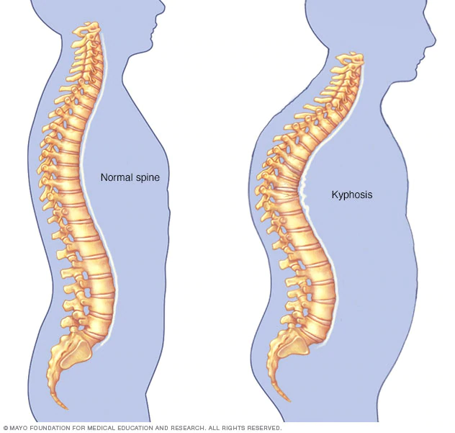

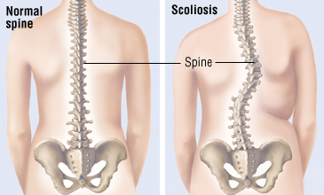

Types of Muscle

There are 3 types of muscle fibre; Type I, Type IIa, Type IIx. Research all 3 types giving their alternative name and then explaining what their characteristics and capabilities are as well as what sports they would be used in, when and why.

Type I:

Type IIa

Type IIx

Lung Volumes

Below is an image of the lung volumes which are measured by a spirogram. Underneath explain what each one is and give the normative value for an average adult including the correct unit of measurement.

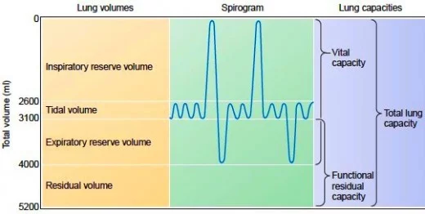

Altitude Training

Research what altitude training is, include the following:
- What it involves
- What happens as a result of it
- How it is beneficial
- What type of sports people would it benefit the most

Sudden arrhythmic death syndrome (SADS)

Research the condition SADS, include the following:
- What it is/why it happens
- Examples of SADS that have occurred in sports people
What is being done to prevent it?

Fitness training and Programming for Health, Sport and Well-being
Task
Creating a fitness and healthy living programme for John
John’s details
Date of birth: 25/07/1984
Occupation and activity levels
- What is your occupation? Builder
- How many hours do you work daily? 7–8 hours per day with a 30-minute lunch break
- How far do you live from your workplace? I work in lots of different places
- How do you travel to work? Drive
- How active would you say your job was? Very active
- How many times a week do you currently take part in physical activity? Six days a week, twice a day
- What type of activity/exercise do you mainly take part in? Weight training
Nutrition
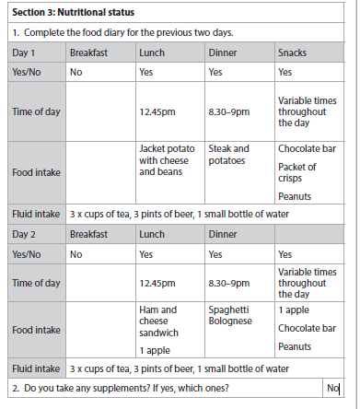

Lifestyle and health
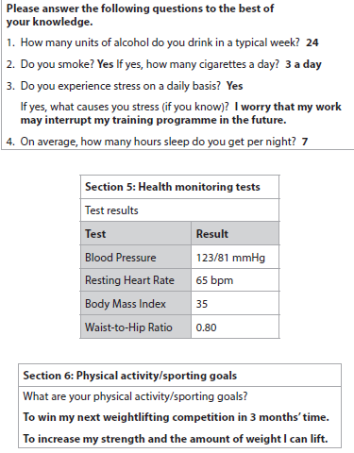
Questions on John’s details

- Interpret the lifestyle factors and screening information for John. What does it tell you about his work, activity levels, nutrition and general health

- Provide lifestyle modification techniques for John. Concentrate on his nutrition

- Propose and justify different training methods that meet John’s needs. Include some ideas of what he could do in the gym

Professional Development in the Sports Industry

Complete the following table by filling in the possible job roles in each category:

Category | Possible Job Roles
Sport and Leisure
Sports Science
Exercise and therapies
Teaching and education
Play work
Gaming

Create a CV for a job in the sports industry that you are interested in. You must include:
- Your personal qualities
- Interests and accomplishments
- Qualifications
- Experience
- Employability skills
- Work history
- A letter of application (no longer than one side of A4)

Create a 30 minute lesson plan for a sport of your choice. You will be teaching 10 boys and 10 girls in year 7.

You will need to consider:
- what equipment you will need
- what space your lesson can take place in
- how you can meet the needs of all the pupils
- health and safety considerations

You will need:
- A warm up
- A lesson objective
- A main part of the lesson
- Differentiation to your lesson

Practical Sports Performance
Task
Examining the skills, techniques and tactics required to perform in selected sports
- Explain the meaning of a sporting technique

- Explain the meaning of a sporting skill

- Explain the meaning of sporting tactics

Use the following link to explain the 3 types of skill below
https://www.brianmac.co.uk/continuum.htm
- Discrete

- Serial

- Continuous

Type of skill?
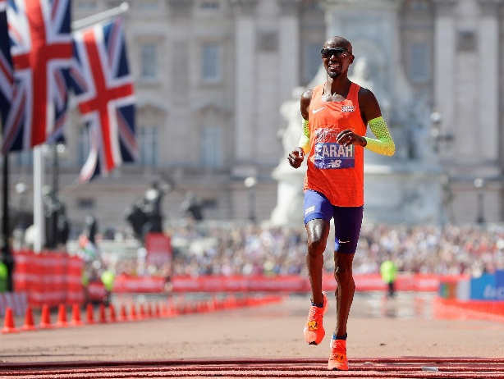
Type of skill?
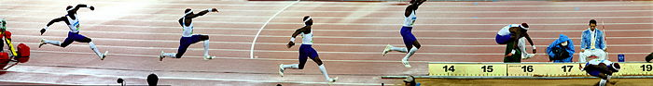

Type of skill?
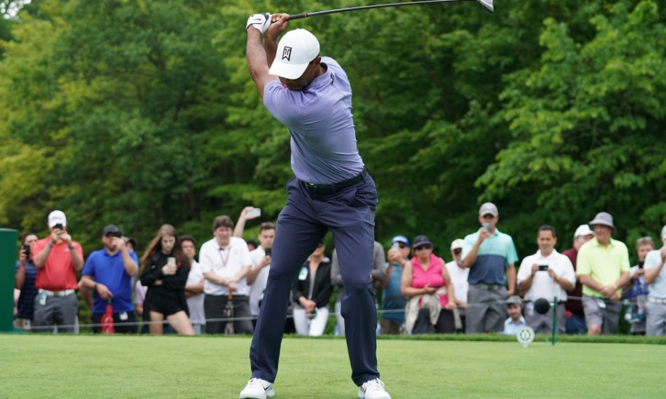

Now paste in further examples of each of the 3 types of skill

Practical Sports Performance

Thinking about tactics
Here is an example of tactics in basketball. The two primary aims of basketball are:
Defence-how to stop the other team scoring
- Marking players man-to-man
- Using a zone to keep players away from the basket ( marking space)
- Defending players full court
Offence-how the team scores
- Running up the court quicker than the defence-fast break
- Spreading the floor to create space to be able to play 1 on 1 offence
- Setting legal obstacles for players on your team ( screening)

Choose one sport and consider tactics for

Attacking/scoring

Defending/stopping scoring

Summary thoughts

