


Park Hall Academy Geography Department
Geography A Level Preparation
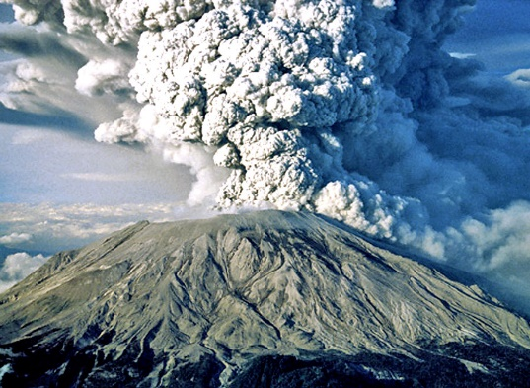

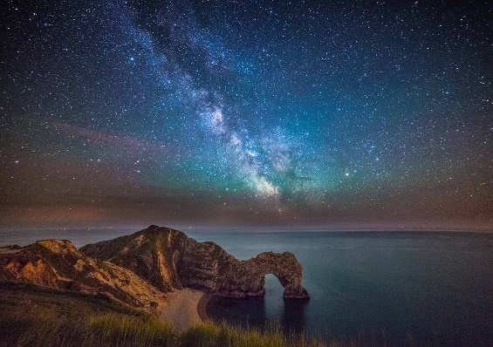

“Geography explain the past, illuminates the present and prepares us for the future. What could be more important than that?”

Michael Palin

Welcome to A-level Geography!

With the start of your A levels many months away, it is important that we do not let slip all the skills and understanding that you have worked so hard for over the last few years. Whether or not you are continuing geography to A level, the skills of researching, analysing and evaluating material are important across all subjects and so the aim for the following weeks is to build on what you have already learnt during your GCSE course.

If you are (very wisely!) intending to continue geography at A level, this work will also provide some excellent resources to use throughout your course, as well as helping to develop further some of the most important skills and enable you to more readily “Think like a geographer.”

Our current intention is to set a variety of tasks that will give you a greater understanding of the world we live in, as well as investigating some aspects of the A level course. (If you are considering A level geography, a summary of the content can be found at https://filestore.aqa.org.uk/resources/geography/specifications/AQA-7037-SP-2016.PDF under Specification at a Glance

AQA A Level Geography Course

Assessment
Unit | Weighting and contents
Component 1 – Physical Geography | - 40% of the A level.  - Written exam 2hrs 30minutes  - 120 marks
- Water and carbon cycles.
- Coastal systems and landscapes
- Hazards
Component 2- Human Geography | - 40% of the A level.  - Written exam 2hrs 30 minutes  - 120 marks
- Global systems and global governance.
- Changing place.
- Population and the environment.
Component 3 – Geography fieldwork investigation | - 20% of the A level.  - 3,000 to 4,000 word written investigation.  - 60 marks.  - Marked by teachers – moderated by AQA.
Students complete an individual investigation, which must include data collected in the field. The individual investigation must be based on a question or issue defined and developed by the student relating to any part of the specification content

Order of teaching
Year 12
- Coastal systems and landscapes
- Hazards
- Changing Place
- NEA (Non-Examined Assessment) Coursework research project
Year 13
- Population and the environment
- Water and carbon cycles
- Global systems and global governance
- NEA (Non-Examined Assessment) Coursework research project – submitted April/May
So you want to be an A level geographer? ….

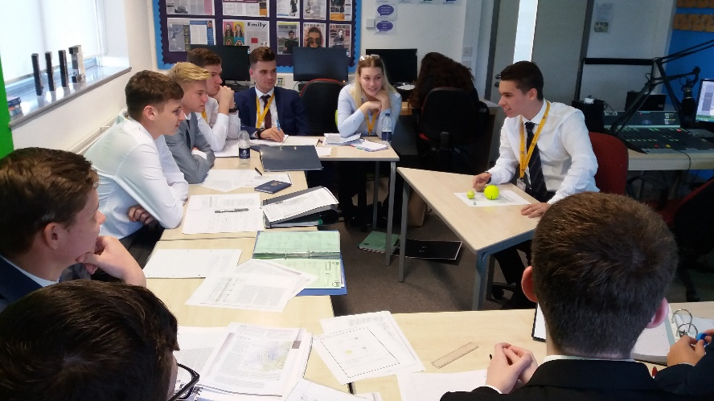
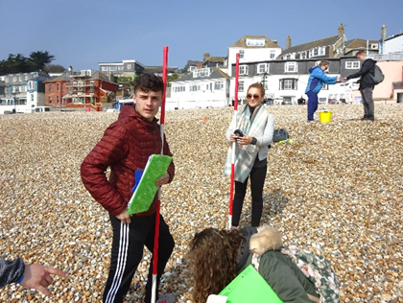

To be a great geographer you need to develop the ability to think synoptically, being able to see the greater overview and how everything begins to link together. Geography is not just about studying people and landscapes; it is also the relationships that exist between people and their environment.

At GCSE, you have covered many of the foundations of the underpinning concepts; physical processes and how they have shaped the landscape and the key human processes that shape our society. GCSE has provided a breadth of study, whereas A Level will now enable you to gain greater depth by exploring topics in detail but also encouraging you to see and explore the links between topics.

The best geographers at A Level keep reading the news and generally seek to improve their geographical understanding by engaging with geographical discussions regarding key issues.

This guide has been designed for you to be able to dip in and out of, from looking at general geographical issues and developing your ability to think like a geographer, through to starting to explore some of the topics we will be looking at in Year 12 and 13 so you can do some valuable background reading.

Task 1 – Key words A level geography
Below is a key word list for coastal systems and landscapes along with hazards. You will need to research what these key words mean – and be aware of them before we start the A level course. This will enable you to access A level reading material a lot more easily and understand the content in lessons and exam questions.
Coasts specialist terms | Definition
abrasion
accretion
arch
attrition
barrier beach (or bar)
barrier island
berm
biological weathering
cave
cavitation
climatic climax community
coastal morphology
compound spit
constructive wave
corrasion
cost-benefit analysis (CBA)
cusp
Dalmatian coast
destructive wave
double spit
drift-aligned beach
emergent coastline
environmental refugee
eustatic change
fjord
halophyte
hard-engineering
high-energy environments
hydraulic action
Integrated Coastal Zone Management (ICZM)
isostatic change
isostatic recovery
isostatic subsidence
landform
landscape
landslide
landslip (or slump)
lithology
longshore (littoral) drift
low-energy environments
mass movement
mudflat
mudflow
offshore bars
pioneer species
raised beach
recurved tip
ria
rip currents
rockfall
runnels
saltation
saltmarsh
sand dune
scree
sediment budget
sediment cell
Shoreline Management Plan (SMP)
slump (or landslip)
soft-engineering
soil creep
solifluction
solution (dissolved load)
solution (corrosion)
spit
stack
stump
submergent coastline
suspension
swash-aligned beach
tidal range
tides
tombolo
traction
vegetation succession
wave quarrying
wave refraction
wave-cut notch
wave-cut platform

Hazards specialist terms | Definition
acid dome volcanoes
adaptation
asthenosphere
atmospheric hazards
caldera
composite cones
(strato-volcanoes)
conservative plate margins
constructive (divergent) plate margins
core
crown fire
crust
destructive (convergent) plate margins
El Niño
extrusive
eye wall
fatalism
fissure eruptions
geophysical hazards
gravitational sliding
ground fire
hazard
hazard management cycle
hot spot
hydrological hazards
igneous rocks
Indian Ocean Dipole (IOD)
intrusive
ladder effect
lahar
liquefaction
lithosphere
Love (L) waves
magma
magma plume
mantle
mid-ocean ridges
mitigation
nuée ardente
palaeomagnetism
prediction
preparedness
prevention
primary or pressure (P) waves
pyroclastic flows
Rayleigh (R) waves
ridge push
rift valleys
Saffir-Simpson scale
sea-floor spreading
secondary or shear (S) waves
seismicity
shield volcanoes
sial
sima
slab pull
storm surge
subduction
submarine volcanoes
supervolcano
surface fire
tephra
transform fault
tropical storm
tsunami
vulcanicity
wildfire

Task 2- Contemporary geographical issues
Task 2 will be aimed at delving into what you enjoy about geography. This will enable you to investigate independently a geographical issue that you find interesting in the form of a 500-word report. For example, you could research one of the following:

- The causes, impacts and responses of the Australian bushfires in 2020.
- Opportunities and challenges of deforestation in the Amazon rainforest.
- Issues of crime in the favelas in Rio.
- The geography of Corona-virus – global distribution and disparities.
- Climate change human vs natural causes – future projections.

It does not have to be one of the titles above it could be your own title – but it needs to be specific, not generic and obviously related to a geographical context. In your report, you need to be able to include some of the key words that you have researched in task 1 if it is coasts or hazards related, also the following key themes into your writing to demonstrate you can write at an A level standard:

Sustainability | Sustainability is about meeting the needs of today without compromising the needs of future generations – what elements of sustainability do you need to discuss about your geographical issue.
Scale | Scale refers to the size of an event or its distribution. Is this geographical issue global, national or local? How far does it extend or have impact? What is the level of response or root cause?
Temporal/change | Temporal refers to spatial and time – so for example how might the impacts of climate change have changed over time and how might they differ in different parts of the world.
Process/theory | Processes could be physical or human processes. For example, you could be looking at the Australian bush fires in 2020 - looking at the process of how wildfires begin and how they are spread.
Impact and management | Impact and management often link. As geographers we may initially look at the causes, what impact does this have (socially, economically, environmentally, and politically) and how is this managed? Who is it managed by? How effective is that management? Is it sustainable?
Synopticity | Synopticity is about how aspects of the geographical issue link to other issues or contexts. So for example, the Australian bushfires can be linked to climate change and change in weather patterns. This can be challenging – do not worry if you are struggling with this theme.

Task 2- Contemporary geographical issues

Suggested reading and research

Websites:
- BBC NEWS https://www.bbc.co.uk/news - an excellent source of up-to-date articles – explore the key headings such as Science, as well as the UK, World and other stories.

- THE GUARDIAN https://www.theguardian.com/uk - again many useful articles and logically ordered – keep an eye on the Environment, Science, Society, Global Development stories in particular!

- THE CONVERSATION.COM http://theconversation.com/uk We can highly recommend you use this! This you will find is useful to support many of your A Levels. It provides up-to-date articles from academics and specialists in the field written in a way that is accessible to all, summarising key points in short but insightful articles.

- GEOGRAPHICAL https://geographical.co.uk/places - brilliant range of articles based around contemporary issues around the world.

- PLACES JOURNAL https://placesjournal.org/explore-places/geography/?gclid=EAIaIQobChMI0PX1pa2a6QIV0u3tCh0LlQgGEAAYASAAEgLF2vD_BwE&cn-reloaded=1

Podcasts:
Costing the Earth – There are some great podcasts here to pick from on a wide variety of geographical issues https://www.bbc.co.uk/programmes/b006r4wn/episodes/player (many topics, including amongst others.. climate change, carbon, urban greening, deforestation, alternative power, plastics etc.)
Royal Geographical Society – “Ask the Geographer” podcasts - https://www.rgs.org/schools/teaching-resources/ask-the-expert-podcasts/ - a fantastic set of podcasts to keep A Level studies up-to-date with the latest geographical research – pick out some that interest you and give them a go!

Task 3 – Hazards case study: Indian Ocean Tsunami 2004
For the hazards section of the course you will need to know many case studies. One of the case studies will be of a seismic event (earthquake related). In your case study, you will need to complete the following:
HAZARDS KNOWLEDGE BOOSTER- First watch the video clips and make notes to further enhance your tectonics knowledge. https://timeforgeography.co.uk/videos_list/plate-tectonics/

- An annotated map to show the location of the tsunami epicenter and affected areas within the Indian Ocean.
- Explain what caused the Boxing Day tsunami in 2004 – use an annotated diagram.
- Categorise the impacts into the following (you may not be able to fill all boxes):
- Click on the links below to read the Geofiles on the Boxing Day Tsunami.
Type of impact | Primary (immediate) | Secondary (impacts resulting as a direct consequence. | Long term impacts
Social
Economic
Environmental
Political

- What were the long term and immediate responses to these hazards?
- Question: ‘An earthquake is much a human disaster as a natural disaster’. Discuss this statement.
Research starting point:
- Watch Netflix: ‘The impossible’
- https://www.telegraph.co.uk/news/worldnews/asia/11303114/2004-Boxing-Day-tsunami-facts.html
- https://earthquake.usgs.gov/earthquakes/eventpage/official20041226005853450_30/executive
- https://www.bbc.co.uk/news/world-asia-30034501
- https://www.newscientist.com/article/dn9931-facts-and-figures-asian-tsunami-disaster/
- https://time.com/3636613/what-caused-the-boxing-day-tsunami/
- http://www.coolgeography.co.uk/GCSE/AQA/Restless%20Earth/Tsunamis/Tsunamis.htm
- https://www.ngdc.noaa.gov/hazard/26dec2004.html
Task 4 – Coastal systems and landscapes case study: Dorset Coastline
For the coasts section of the course you will need to know many case studies. You will need to know about coastal landforms, processes and management. Our residential trip will be to the Dorset coastline. In your case study, you will need to complete the following:
COASTS KNOWLEDGE BOOSTER – First watch the video clips and make notes to further enhance your coasts knowledge. https://timeforgeography.co.uk/videos_list/coasts/
- Find a UK map and locate where Dorset is on the UK map – describe its location.
- Find a geology map of the Dorset coastline and label on the following:
- Where is Swanage?
- The types of rock.
- Concordant and discordant coastlines.
- Names of coastal features and landforms (e.g Old Harry) including picture and explanation of how these landform were created.
- Colour code these landforms into erosion and deposition features.
- Locate Lyme Regis using a map.
- Explain why Lyme Regis needs coastal protection.
- Research the four phases of coastal management at Lyme Regis.
- Click on the link below to read the Geofile on Lyme Regis coastal management
Phase | Description of management strategies. Hard or soft? Cost? Location? | Problems and benefits
1
2
3
4

- Question: To what extent is the coastal management at Lyme Regis successful?
Research starting point:
- https://geographyjog.files.wordpress.com/2018/05/case-study-lyme-regis.pdf
- https://www.dorsetcouncil.gov.uk/countryside-coast-parks/beaches-and-coast/coastal-protection-and-management/coast-protection-in-west-dorset.aspx
- https://www.internetgeography.net/topics/coasts/dorset-coast/
- https://getoutside.ordnancesurvey.co.uk/guides/the-10-best-geological-features-along-the-jurassic-coast/

