

Park Hall Academy Science Department
Biology A-level
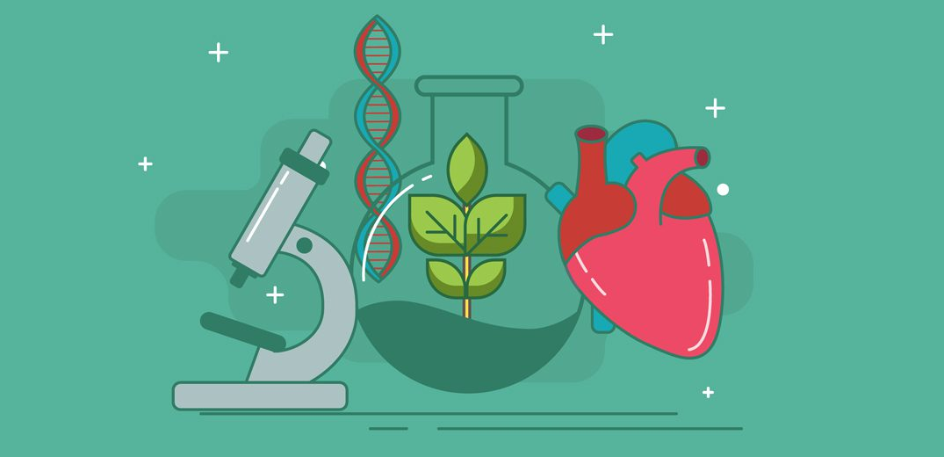

NAME: _______________________________________

Welcome to A-level Biology!

What is Biology?

Biology is the study of living organisms. You will learn about animals and plant’s physical structure, chemical processes, molecular interactions, physiological mechanisms, development and evolution.
Biology is a very popular subject at A-level, but it is also one of the most difficult to study. The A-level course covers a large amount of content in great detail. Use the booklet to explore some of the topics and develop your understanding. We hope you enjoy the tasks and feel free to ask if you have any further questions.
We are so pleased you are considering to study A level Biology with us and have put together this pack to help you prepare for the higher level of study required in Year 12. The jump from GCSE to A level is possibly the biggest in education so the more you can do to prepare the easier you will find it
Why do bridging work?
Preparation is crucial for studying A Level Biology. After completing these exercises, you will need to highlight any areas that you had trouble understanding. We are expecting you to put 100% effort into the tasks to show your commitment to the study you have chosen to do. Don’t try to fit the answers on these pages – you need to create your own material.
All of this work is for YOUR benefit so you can do it in whatever format you like (mind maps, list of answers, labelled diagrams, flashcards etc.).
We want you to be successful at A-level Biology and what this takes at GCSE is different to what is required at A-level. Although you have fewer subjects, there are different skills post-16 and the volume of work is greater due to the increased demand of depth and detail.
Bridging work should help you to gauge your current understanding of the subject and introduce you to the depth of understanding that is required for study at advanced level.

Contents

- Introduction, overview and expectations of the course
- TASK 1: So why study Biology?
- Online resources for you to explore
- Reading/Watching lists
- Lessons
Lesson 1 Microscopes and cell structure
Lesson 2 Proteins, lipids, carbohydrates and enzymes
Lesson 3 Gas exchange
Lesson 4 The circulatory system and blood
Lesson 5 Disease
Lesson 6 DNA and Protein synthesis
Lesson 7 Variation and evolution
Lesson 8 Photosynthesis
Lesson 9 Maths in Biology
Lesson 10 Practical skills
6 Careers and Bonus Biology materials

- Overview of the course:

This is a two-year course which ends with three exam papers. Two exams are 2 hours and 15 minutes long and carry 37% of the course weighting each. The third exam is 1 hour 15 minutes long and is 26% of the course weighting. A-levels are still awarded A*-E. You will also complete a practical element which will be assessed in class and will not contribute to the overall grade. The practical skills must be successfully achieved in those practicals in order to complete the practical element of the course.

At Park Hall Academy we follow the OCR Biology A specification linked below.
https://www.ocr.org.uk/Images/171736-specification-accredited-a-level-gce-biology-a-h420.pdf

Topics we will cover will include:

Module 1 – Development of practical skills in biology
Module 2 – Foundations in biology
Module 3 – Exchange and transport
Module 4 – Biodiversity, evolution and disease
Module 5 – Communication, homeostasis and energy
Module 6 – Genetics, evolution and ecosystems

Look at the specification for more detail about these topics. You will be expected to know and understand (AO1) the information about the topics, to be able to apply (AO2) that knowledge and understanding and to be able to analyse and evaluate (AO3) that knowledge and understanding

Expectations of the course:

- Lessons consist of taking notes, group discussions, practicals, group work and PowerPoint presentations.
- Homework consists of note making, flipped learning, wider reading, past exam questions and essays. It is expected that about 5 hours a week will be spent on Biology homework.
- The Reading and Watching List on the following page will help you to gain wider knowledge and a broader framework in which to apply your knowledge.
- Your progress will be reviewed on a regular basis. The review process will provide feedback at specific times throughout the year. You will also be expected to be within two grades of your target grade on each piece of work.
- You are expected to use the resources available to you in the Learning Resource Centre and work areas of the refectory here and are strongly encouraged to use libraries outside of school, not just the internet.
- Make a Biology chat/WhatsApp for discussion.
- Your folders of notes will be checked on a regular basis to see if you are organised and up to date with your work. We use a system of Study Briefs that will list the topic content and help you to keep track of assessment achievements
- USE YOUR STUDY TIME AND BE PRO-ACTIVE.

TASK 1: So why study Biology?

We would like you to write us a few paragraphs about why you have chosen Biology A level.

Please include answers to:
- What have you enjoyed at GCSE that made you chose this?
- What are you looking forward to learning about?
- What do you think might prove challenging?
- Do you have any thoughts on a career yet?

Science in the News

The news in 2020 (more than any other year in recent history) has been dominated by Biology with the Corona virus pandemic.

We would like you to write us one side of A4 about a part of Biology that’s been in the news over the last couple of years.

It can be the pandemic or something completely different. The key thing is for you to choose something YOU find interesting. It could be related to health, ecology, plants, evolution, genetics……..
As well as telling us about the science please include:
- Why you chose this topic
- Where you got your information

- Online resources for you to explore

Instagram:
@zoestudies
@royalsocbio

Twitter:
@scicurious
@virginiahughes
@marynmck
@carlzimmer

Podcast:
https://www.bbc.co.uk/programmes/b015sqc7
https://www.scientificamerican.com/podcast/60-second-science/
https://naturalselectionpodcast.weebly.com/listen-here.html
‘In Our Time - Microscopes’ https://www.bbc.co.uk/programmes/b03jdy3p
‘In Our Time - Enzymes’ https://www.bbc.co.uk/programmes/b08rp369
https://www.bbc.co.uk/programmes/p002w557/episodes/downloads
https://www.thenakedscientists.com/
https://www.bbc.co.uk/programmes/b036f7w2/episodes/downloads
https://www.bbc.co.uk/programmes/b00snr0w/episodes/downloads

Reading/Watching lists

Reading List – Biology

The Immortal Life of Henrietta Lacks. This is a fascinating account of the story of the life, and afterlife, of one woman who changed the medical world forever.
The Incredible Unlikeliness of Being. Professor Alice Roberts is one of my favourite scientists and this book is A brilliant account of how a single cell transforms itself into a living, breathing, thinking person.

The Body – a guide for occupants by Bill Bryson is EXCELLENT – I was really sad when I got to the end as I wanted it to carry on!

Genome by Matt Ridley - This book is divided into 23 chapters, a chapter for each chromosome and is extremely well written.

Head start to A-level Biology (FREE KINDLE BOOK)

Popular Watching List – Biology

Horizon: Coronovirus (BBC)

The Horizon guide to Pandemics (BBC)

Pain, pus and poison series (BBC)

Nature: Primates (BBC)

Virunga (Netflix)

Something the Lord made (Film)

Talks from world leading Scientists
A New Superweapon in the Fight Against Cancer Available at : http://www.ted.com/talks/paula_hammond_a_new_superweapon_in_the_fight_against_cancer?language=en
Why Bees are Disappearing Available at : http://www.ted.com/talks/marla_spivak_why_bees_are_disappearing?language=en
Why Doctors Don’t Know About the Drugs They Prescribe Available at : http://www.ted.com/talks/ben_goldacre_what_doctors_don_t_know_about_the_drugs_they_prescribe?language=en
Growing New Organs Available at : http://www.ted.com/talks/anthony_atala_growing_organs_engineering_tissue?language=en

Idea: After reading a book or watching a video/TV show why not write a review or summary

Eukaryotes and prokaryotes;
Prokaryotes are singled celled organisms such as bacteria.
Usually much smaller than eukaryotic cells (1/10th the size), do not contain a nucleus, chloroplasts or mitochondria, DNA can be found floating free in the cytoplasm or in loops called Plasmids, some have flagellum for movement.

Eukaryotic cells are more complex and can be single cellular or multi cellular organisms.

Lesson 1 Microscopes;
The Light microscope allows you to view animal cells. It can magnify up to 1500 times. Some organelles such as mitochondria, chloroplasts, vacuoles, cell walls, cell membranes and nuclei are visible. Staining makes these organelles visible.
Draw and annotate the diagram

The electron microscope; invented in 1950s it allows a
much higher magnification (500 000x) and better
resolution, allowing greater detail to be seen.
Electron microscopes allowed detailed ultrastructure
of the cell to be seen, such as ribosomes and the
inside of mitochondria and chloroplasts. The image is
called an ELECTRON MICROGRAPH.

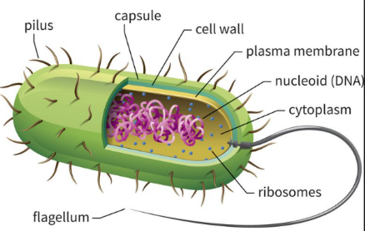
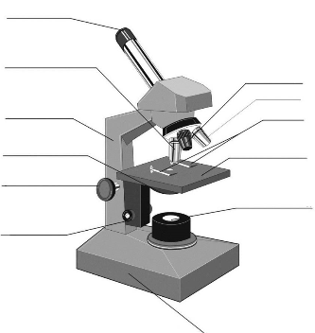

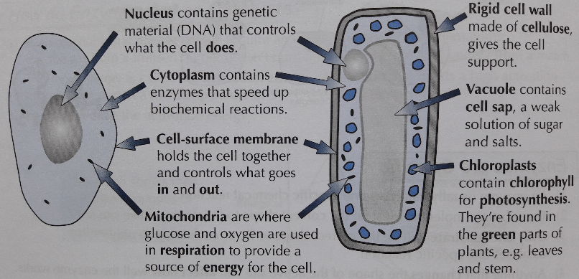

Questions;
Name 3 things visible with a light microscope in both animal and plant cells.___________________________________ ________________________________________________________________________________________________
Name 4 organelles that both plant and an animal cell have. ________________________________________________ ________________________________________________________________________________________________
What is the calculation used to calculate the magnification of an object? _____________________________________ ________________________________________________________________________________________________
What is the function of the mitochondria? ______________________________________________________________

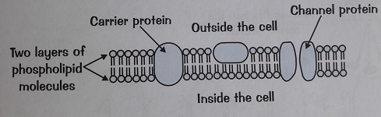
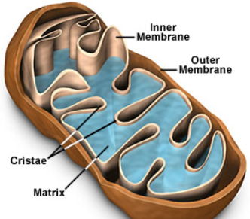
Questions;
Name 2 molecules that make up the cell membrane. _______________________________________________
Describe the membranes of the mitochondria. _______________________________________________
What is the name of the molecule that provide energy to the cell? _______________________________________
What term is used to describe water concentration? _______________________________________________
Cell structure;
Cell surface membrane: Found around every cell, it allows the movement of substances into and out of the cell. It is a partially permeable membrane and will prevent certain substances from entering.

It is made up of a double layer called the PHOSPHOLIPID BILAYER. These are molecules closely packed together in a mosaic pattern. Within the bilayer are large proteins which are also responsible for transport and for cell recognition.
Transport into and out of cells
There are 4 modes of transport you need to be aware of;
Diffusion; can be gas or liquid particles. They move from an area of high concentration to an area of low concentration down a concentration gradient. Small molecules such as oxygen, water and carbon dioxide can pass through the phospholipid bilayer.
Osmosis; occurs only with water. The water particles move from an area of high water concentration to an area of low water concentration, down a concentration gradient, across a partially permeable membrane. NO ENERGY IS REQUIRED. You will be required to refer to water potential in AS level not water concentration.
Facilitated diffusion; Some particles are too large to fit through the phospholipid bilayer and therefore require a carrier protein to assist. The protein carriers are within the bilayer and they change shape when they come into contact with a specific molecule (i.e. Glucose). NO ENERGY IS REQUIRED.
Active transport; This moves substances for an area of low concentration to an area of high concentration against a concentration gradient. ENERGY IS NEEDED for this to occur. Specific carrier proteins are also required these can be called ‘pumps’.

Cell structure;
Nuclei: controls the cell function, containing the DNA which is the coded information for the production of proteins.
During cell division the chromosomes become shorter and thicker and can be seen with a light microscope. The chromosomes will then make a copy of themselves, one copy for each cell produced during cytokinesis.
Nuclei have a double membrane called the nuclear envelope.
Mitochondria: can be seen with a light microscope,
however, greater internal detail can be seen using an
electron microscope.
The mitochondria’s
function is to carry
out aerobic respiration.
The energy released is used to form molecules of ATP.
ATP is used in the cells to provide energy for muscular
contractions, active transport as well as anabolic and
catabolic reactions.
Cell wall: the plant cell wall is made up of cellulose
Molecules laid side by side to form microfibrils.
These provides rigidity and support for the cell.

Enzymes; Help to speed up biochemical reactions.
Metabolism is the sum of all the biochemical reactions that occur per second and a single chain of these reactions is called a metabolic pathway.
Enzymes are biological catalysts and increase the rate of reactions.
Reactions that release energy
need an input energy to start.
The input energy is called the
ACTIVATION ENERGY. Enzymes reduce the activation energy.
Enzymes are proteins; enzymes are globular proteins with a specific order of amino acids that determines what the enzyme does.
Enzymes can be catabolic (break substrates down) or anabolic (build substrates up). Enzymes have a specific site into which the substrates can attach itself, this attachment site is called the active site. The active site is complementary to the shape of the substrate. Once they attach together they form the enzyme substrate complex. The substrate then breaks bonds or makes bonds (depending on the type of enzyme) and the product leaves the active site. The active site is now able to accept another substrate.

Denaturing enzymes; Enzymes have a specific tertiary shape held in place by weak hydrogen bonds and stronger disulphide bonds. These bonds can be broken by an increase in temperature (kinetic energy) or a change in pH (H⁺ in acid or OH⁻ in alkali disrupt the bonds).
Useful enzymes; Digestive enzymes are catabolic, breaking down food into smaller molecules. Enzymes are also needed in DNA replication, building up molecules (DNA polymerase).
Lesson 2: Proteins;
Proteins are made of long chains of amino acids, up to several hundred long. There are only 20 different amino acids and the combination of these 20 produce a wide range of complex proteins. Protein structures are held together with strong bonds called PEPTIDE bonds. The order of the amino acids determines the structure and how it works.
All amino acids have the same structure with one variation on the R group.
Contains; Hydrogen, oxygen,
Nitrogen and carbon.
Proteins structure;
The order of the amino acids forms the PRIMARY STRUCTURE. The protein chain can then coil or fold into pleats which are held together by weak hydrogen bonds to for the SECONDARY STRUCTURE.
Enzymes have a further folding held together with stronger disulphide bonds. This is the TERTIARY STRUCTURE. If the structure is almost spherical it is called a globular protein.

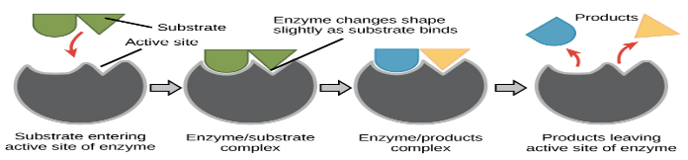
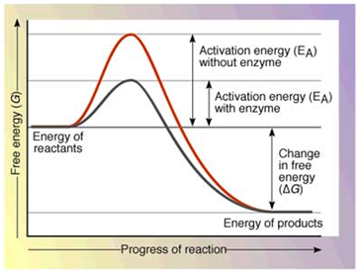
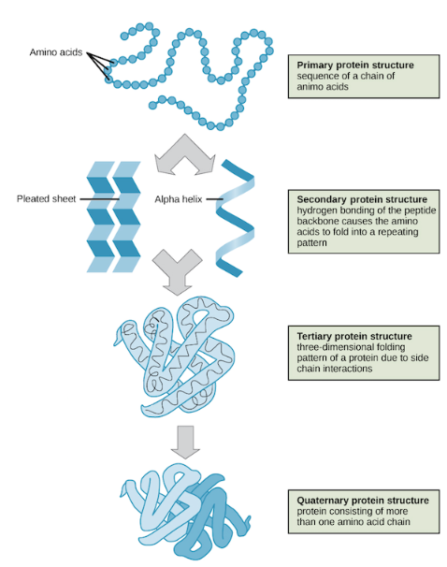
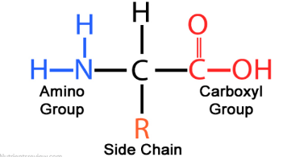
Questions;
What types of bond hold together the secondary structure? ________________ The tertiary structure? ______________________ How many amino acids are there and what elements are found in them? _______________________________________________ Explain why denatured enzymes will not function. __________________________________________________________________ ___________________________________________________________________________________________________________What is activation energy? ____________________________________________________________________________________
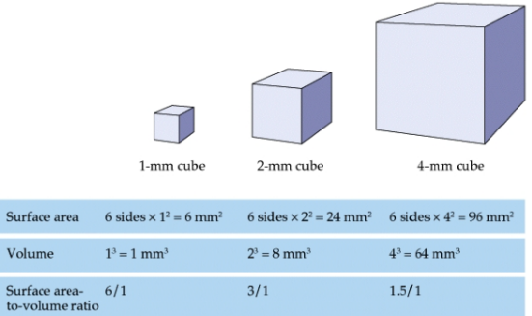
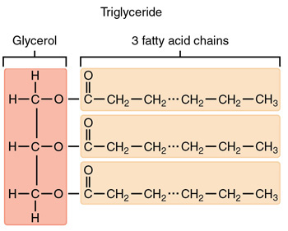
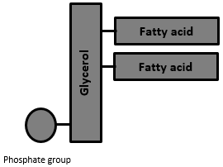
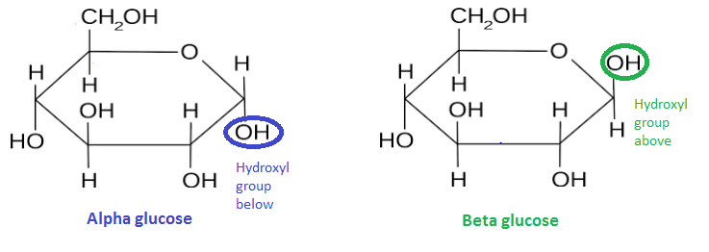
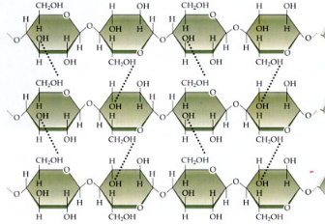
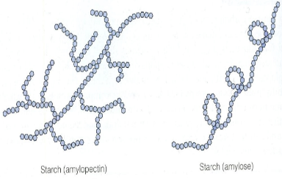
Exchange surfaces;
All good exchange surfaces require adaptations to make the exchange efficient. The smaller the object the quicker exchange is able to occur due to it having a large surface area to volume ration, however larger, more complex organisms have a much smaller surface area to volume ratio.
The larger the object the lower the surface area to volume ratio.

To overcome this, multicellular organisms have highly adapted exchange organs. Adaptations include;
- Folded to increase the surface area to volume ratio for a faster exchange.
- A good blood supply to maintain the concentration gradient.
- One cell thick (thin) to reduce diffusion distance.
Materials that need to be exchanged between the cell and he environment include; heat, oxygen, water, carbon dioxide, nutrients and other waste products such as urea. The adaptations allow MORE substances to be exchanged at a faster rate.

Lipids;
Three elements make up the lipid molecule – carbon, hydrogen and oxygen. Lipids are fats and oils, predominantly made up of a group of lipids called triglycerides. These contain a molecule of GLYCEROL with 3 fatty acids.
The fatty acid is a long chain of carbon atoms with an acid (-COOH) group. Hydrogen atoms are attached to the carbons by single bond. A single bond forms a saturated lipid. If there is a double bond then the lipid is unsaturated, many double bonds forms a polyunsaturated lipid.
Cell membranes are formed from phospholipid. They do not have 3 fatty acid chains but 2 fatty acid chains and a phosphate group.
Questions;
Describe the difference between a triglyceride and a phospholipid. ___________________________________ ______________________________________________Describe the difference between Starch and cellulose. ____________________________________________________________________________________________
What bonds hold Cellulose microfibrils together? ______
Carbohydrates;
Three elements make up the carbohydrate molecule – carbon, hydrogen and oxygen.
There are several types of carbohydrates;
Sugars; Small, sweet, water soluble molecules. Can be monosaccharides or disaccharides. Monosaccharides are single units from which disaccharides are built. Glucose and Fructose are monosaccharides and join together to form the disaccharide sucrose. The joining together of 2 monosaccharides occurs to release a molecule of water this is called a condensation reaction.
Glucose occurs in 2 forms alpha (α) glucose and beta (β) glucose.

Starch; A POLYSACCHARIDE (a large molecule –polymer, made up of monomers). Two different polysaccharides of glucose are used to make starch- amylose and amylopectin. Starch is insoluble so it is a good storage molecule in plants.
Cellulose; a polymer of glucose. Bonding is different in cellulose, molecules are bonded in a long straight line with hydrogen bonds between the strands. It forms microfibrils to provide strength to plant cell walls.
Cellulose Amylopectin Amylose
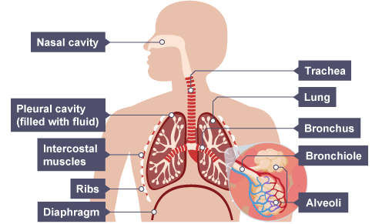
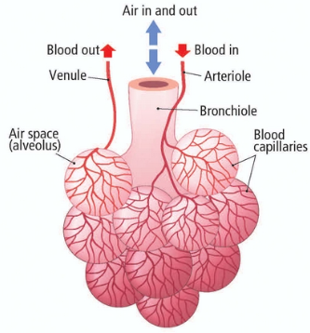
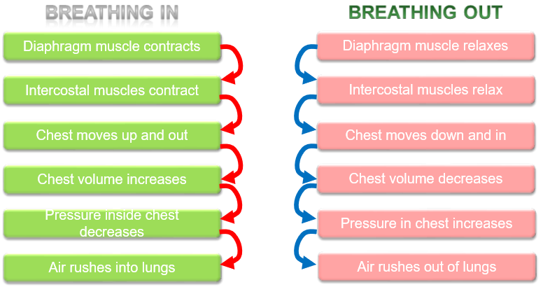
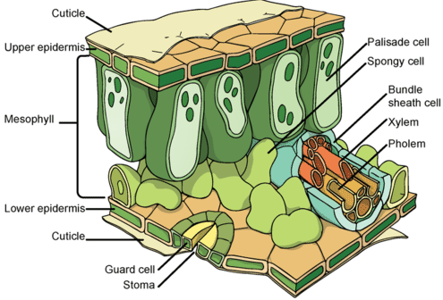
Gas exchange in plants;

Plants also have adaptations to allow gas exchange. The leaf is an organ that is adapted to allow the movement of water from the leaf and the diffusion of carbon dioxide into the leaf. The upper mesophyll layer contains Palisade cells which are packed with chloroplasts to absorb as much energy from the sun as possible for photosynthesis. The lower part of the mesophyll layer is the spongy mesophyll which contains air spaces to facilitated the diffusion of gases into the cells and out of the cells.
The upper epidermis is covered by a waxy cuticle to prevent water loss. The lower epidermis has a specialised pair of cells called the GUARD CELLS. The guard cells have an uneven thickening in the cell wall which causes the cell to bend and open up a hole in the lower epidermis called the STOMA. The stoma allows the water vapour to move out of the leaf into the environment (transpiration) and carbon dioxide to move into the leaf.
Transpiration; The movement of water from the root and out of the leaf is called the transpiration stream. Water passes into the root by osmosis and then moves through the root by 3 different processes;
- The symplast pathway; water moves from root cell to root cell through the cytoplasm.
- The apoplast pathway; water moves through the cell wall, not passing over the cell membrane, carrying minerals with it through a process called MASS FLOW.
- The vacuolar pathway; water moves from root cell to root cell via the cytoplasm and the vacuole.
Water moves out of the leaf by diffusion into the environment. The water moves from root to leaf through a specialised tube called the xylem. Water is pulled up the xylem due to an attraction force between the water particles causing a tension in the xylem (Cohesion tension) and the attraction between the water particles and the sides of the xylem vessel (adhesion).
The second vessel in the plant is the phloem and this is responsible for translocation, the mass flow of substances from the leaf to the rest of the plant.
Lesson 3 Gas exchange in animals;
Lungs; Multi cellular organisms have evolved a complex blood supply system and a large gas exchange system (lungs). The lungs contain millions of tiny air sacs called ALVEOLI which are then folded to further increase the surface area of the lung.

The alveoli are further adapted by having a single flattened layer of epithelial squamous cells which reduces the diffusion distance increasing the speed of diffusion. Alveoli have a dense network of capillaries to move the blood away quickly, maintaining a steep diffusion gradient. The walls of the alveoli are fully permeable to dissolved oxygen and carbon dioxide.
Breathing/ventilation; The process of maintaining a high concentration of oxygen inside the lungs and getting rid of the waste product carbon dioxide. Ventilation increases he rate of diffusion.
Lungs are suspended in the airtight Thorax and any change in volume will affect the pressure in the thorax.

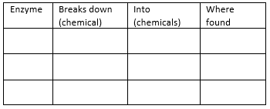
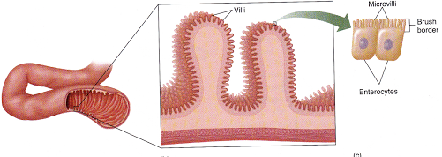
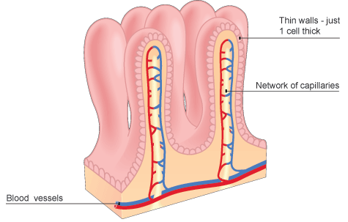
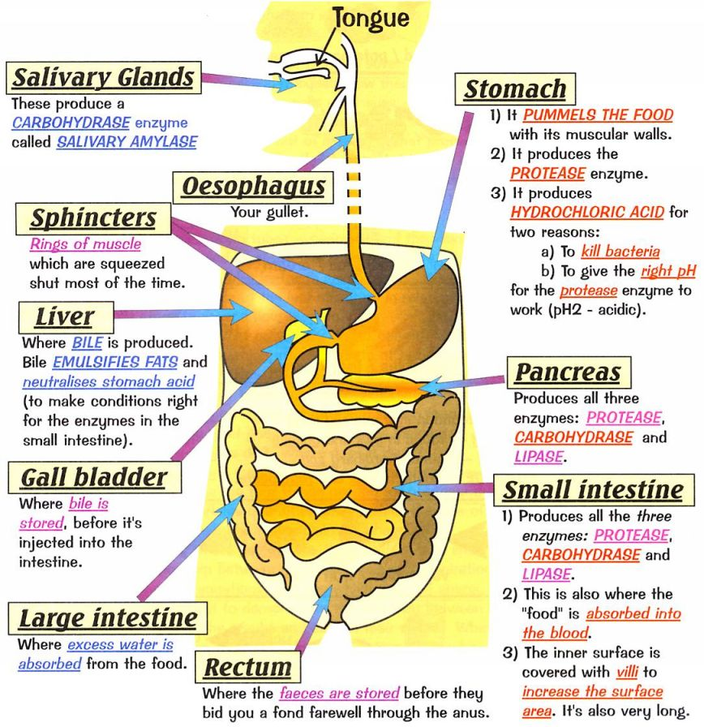
Questions; What are the features that makes a surface better adapted for exchange? __________________________________________ What is transpiration? ________________________________ What is translocation? ________________________________
Questions; What are the 3 ways water moved through the root? _________ __________________________________________________________________________________________________________What are the 3 digestive enzymes, what do they break down and where are they found?

What is the role of Bile? _________________________________ _____________________________________________________ How is the small intestine adapted to increase the rate of diffusion of digested food products? _______________________ __________________________________________________________________________________________________________
Other exchange surfaces:
All of the digested food is now small enough to pass through the wall of the small intestine into the blood stream.

As an exchange surface it displays the same characteristic adaptations as the lung; Large surface area to volume ratio, good blood supply and one cell thick.
Microvilli; the walls of the small intestine are highly folded into villi, to increase the SA:Vol. ratio. However, this can be increase further by each individual cell having further folds called microvilli.
Other exchange surfaces;
Digestion; The human digestive system has 3 main functions;
- Mechanical breakdown of food
- Chemical breakdown of food
- Absorption of digested food particles into the blood stream.

The digestive system contains 3 types of enzyme;
- Carbohydrase enzymes for breaking down complex carbohydrates into simple sugars. These are found in the mouth (amylase enzyme), the pancreas and the small intestine.
- Protease enzymes break down proteins into amino acids. These are found in the stomach (protease enzyme requires a pH 2 which is provided by the hydrochloric acid), the pancreas and the small intestine.
- Lipase enzymes breaks down lipids into fatty acids and glycerol. These are found in the pancreas and the small intestine.
Bile is an important chemical in digestion. Bile is made in the liver and stored in the gall bladder. It has 2 roles;
- Makes the digested food, leaving the stomach, slightly alkali for enzymes to work in.
- It emulsifies the lipids, breaking them up into small droplets to increase the surface area for lipase to digest.
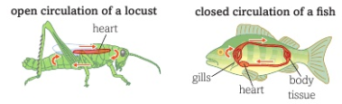
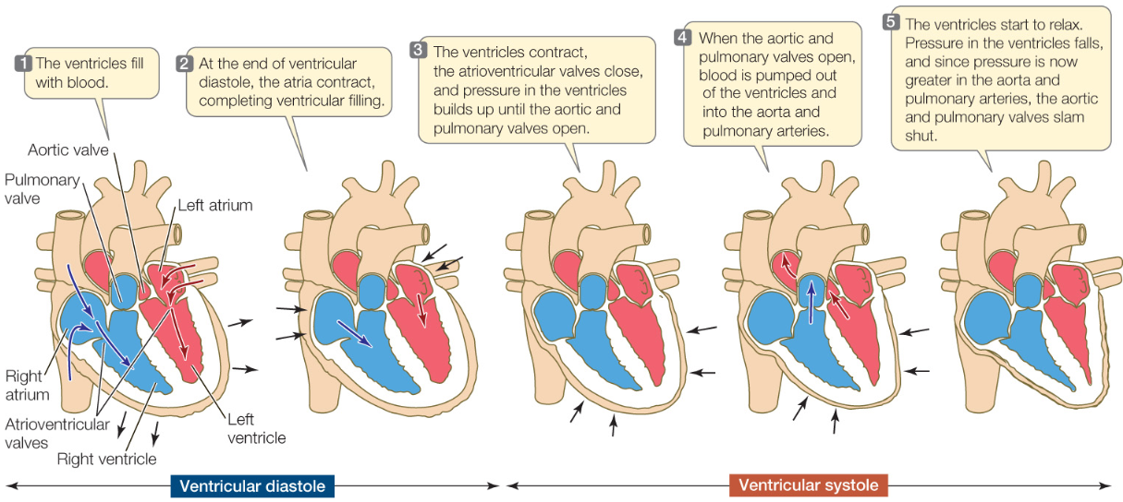
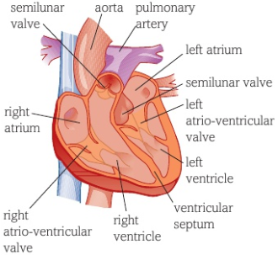
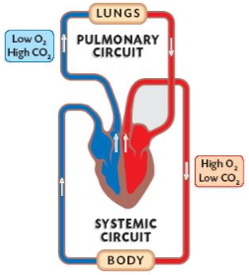
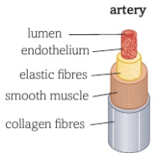
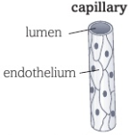
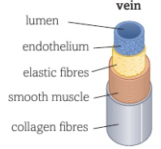
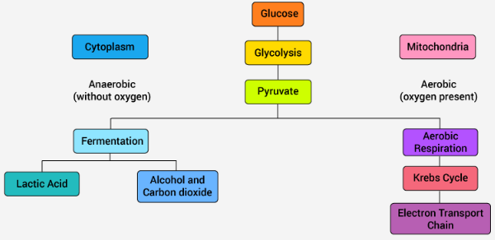
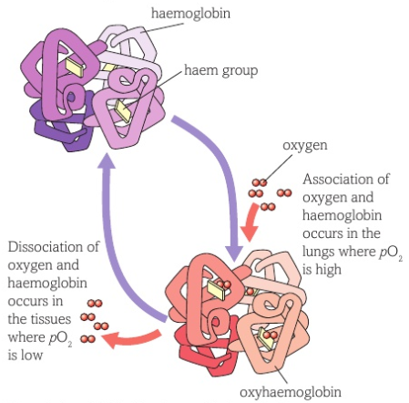
Questions;
What is the name of the system that sends blood to body organs? _____________________________________________________ Which blood vessels contain valves? _______________________ Which blood vessel has the thickest smooth muscle and what is its function? ___________________________________________ Which Valves close when the ventricles contract? _____________ Which side of the heart is the thickest and why? ______________
The heart;
The heart has two separate pumps. The right side of the heart pumps blood to the lungs and the left side pumps blood to the body. Valves within the heart keep the blood flowing in the correct direction. Valves open and close in response to the changes of pressure inside the chambers.
The heart is made up of 4 chambers; the right atria, the right ventricle, the left atria and the left ventricle. The left side of the heart has a thicker muscular wall to create enough pressure to force the blood around the whole body.
The hearts contractions are initiated by a cluster of specialised cells called the SINO-ATRIAL NODE or the PACEMAKER. These cells send out electrical impulses at regular intervals.
The coronary arteries supply the muscle in the heart with blood.
The cardiac cycle; This is the sequence of events that occur in a single heartbeat.

Lesson 4: The circulatory system and blood vessels;
Large multicellular organisms have a small surface area to volume ratio and have evolved a complex circulatory system to transport chemicals around the body, this is called the CIRCULATORY SYSTEM.
Some organisms such as flat worms can diffuse oxygen and glucose across their surface. Less active organisms such as insects may have a much more simplified circulatory system.

Fish have a more complex system were by the blood enters the heart once before being transported to the systemic system this is called a single circulatory system. Mammals have evolved a double circulatory system with a pulmonary and a systemic circuit.
The heart pumps the deoxygenated blood to the lungs (pulmonary system) to pick up oxygen and removes carbon dioxide. The oxygenated blood is then returned to the heart to be pumped out to the organs (systemic system).
The blood travels through 3 main types of blood vessels; 1) The Arteries; carry blood away from the heart. They have a thick layer of elastic tissue and smooth muscle. The elastic walls stretch when the heart contracts and the elastic tissue recoils to maintain the pressure. 2) Capillaries; These consist of a single layer of endothelial cells. The arteries subdivide arterioles which further divide into thousands of capillaries. The capillaries come into close contact with body cells providing a huge surface area to volume ratio and a short diffusion distance for the exchange of oxygen, glucose, carbon dioxide, urea and other substances. 3) Veins; The capillaries start to come back together forming venules and then veins. Veins carry blood back towards the heart. Blood is at a lower pressure and therefore do not need such a thick layer of elastic tissue or smooth muscle. The veins contain valves to prevent the blood flowing backwards.

Questions continued….
11) Define the term anaerobic respiration _________________ ____________________________________________________ 12) Write a word equation for; a) anaerobic respiration in plants and yeast ____________________________________________________ b) anaerobic respiration in mammals ____________________________________________________ 13) What is the oxygen debt? ___________________________ ____________________________________________________ 14) Why can a person not anaerobically respire for a long time? ____________________________________________________ ____________________________________________________
Respiration;
Aerobic respiration; This occurs in the mitochondria of cells. It requires a number of small stages to break down glucose (C₆H₁₂O₆) to release a large amount of energy; adenosine triphosphate (ATP). The first stage is a stage called GLYCOLYSIS, this occurs in the cytoplasm and converts glucose into two 3 carbon molecules called PYRUVATE. Pyruvate is formed in both aerobic and anaerobic respiration, however in aerobic respiration the pyruvate passes into the matrix of the Mitochondria. Pyruvate then goes into the link reaction to form acetyl CoA which then passes into to the Kreb cycle with the oxidise products passing into oxidative phosphorylation to form ATP and waste products carbon dioxide and water.

Anaerobic respiration; Respiration without oxygen. This form of respiration occurs without oxygen. Glucose is converted into pyruvate, through the process of GLYCOLYSIS, in the cytoplasm and is unable to pass into the mitochondria. The process of glycolysis releases small amounts of energy and over a short period of time it can keep the muscles working.
Anaerobic respiration in plants and yeast forms carbon dioxide and alcohol. Anaerobic respiration in animals forms lactic acid. The build-up of lactic acid in muscles must be broken down as the formation of the acid alters the pH and affects enzymes in the cells, slowing down reactions. As the lactate ions build up in the muscles this causes pain called fatigue. The oxygen required to convert the lactate ions back to pyruvate is called the oxygen debt.
Questions;
1)What substance is picked up by the blood in the lungs? ____________________________________________________ 2) What is the name of the protein found in the erythrocyte? ____________________________________________________ 3) What metal ion is present in the protein? ________________ 4) What does it mean if the blood is said to be ‘fully saturated’? ________________________________________________________________________________________________________ 5) Which gas affects the oxygen binding properties of haemoglobin? ________________________________________ 6) What is the term used to describe oxygen leaving the haemoglobin protein? _________________________________ 7) What is the name of the stage of respiration that is common to aerobic and anaerobic respiration? _____________________ 8) What are the products of the first stage of respiration? ____________________________________________________ 9) Name the remaining 3 stages of aerobic respiration. ________________________________________________________________________________________________________ 10) Name the molecule that is produced and will supply energy to other parts of the body. ______________________________
The blood;
Blood is made up of 4 different components; 1) Plasma; the liquid part of blood that transports the cells, dissolved substances and thermal energy. 2) Platelets; cell fragments responsible for clotting of the blood. 3) White blood cells; there are many different white blood cells all responsible for protecting the body from pathogens. 4) Red blood cells AKA erythrocytes; these are responsible for transporting oxygen to body cells. Erythrocytes contain a complex protein called HAEMOGLOBIN. Haemoglobin contains four iron ions each will bind to one oxygen. One haemoglobin can carry 4 molecules of oxygen (100% saturated) and becomes OXYHAEMOGLOBIN. Due to the low availability of oxygen in the tissue and the high concentration of carbon dioxide, the oxygen will dissociate from the haemoglobin. The carbon dioxide from the respiring tissues makes the haemoglobin less able to ‘hold on’ to the oxygen so increases the rate at which the oxygen dissociates.

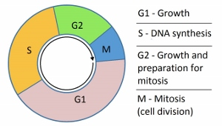
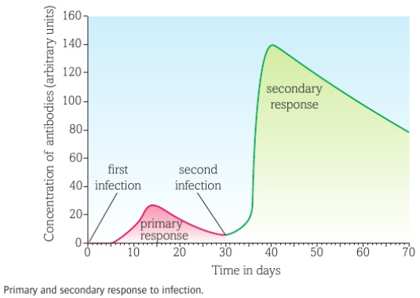
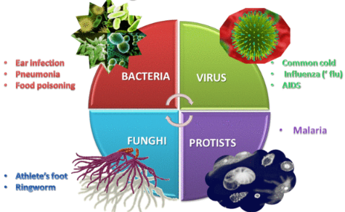
Questions;
What is a pathogen? ________________________________ _________________________________________________ Give 3 examples of non-communicable disease. __________________________________________________________________________________________________ How do bacteria make us ill? _________________________ _________________________________________________ How do viruses make us ill? __________________________ _________________________________________________ What do monocytes do? _____________________________ __________________________________________________________________________________________________ What do macrophages do? ___________________________ _________________________________________________ What are the 2 main types of lymphocytes? _________________________________________________ What do memory cells do? ___________________________ _________________________________________________ Look at the graph. Describe the different between the primary and secondary response. ______________________ ____________________________________________________________________________________________________________________________________________________________________________________________________
Risk factors;
A risk factor is something that will increase the chance of becoming ill. Risk factors do not always lead to the disease, just increase the risk. Some risk factors are unavoidable such as genetic risk factors; genetic predisposition to producing high quantities of cholesterol, having high blood pressure or carrying the BRCA gene which increase the risk of breast cancer.
Other risk factors are avoidable such as; smoking, drinking alcohol, unprotected sex, high fat or high salt diet. Some risk factors (carcinogens) can cause DNA to mutate and cause cells to go into uncontrolled cell growth.
Lesson 5 Disease;
Disease can be communicable and non-communicable.
♦ Non-communicable disease are disease’s which cannot be directly passed for person to person. These include cancer, heart disease, diabetes and Alzheimer’s. ♦ Communicable disease are disease which can be transmitted from organism to organism. These are caused by PATHOGENS such as VIRUSES, BACTERIA, FUNGI and PROTISTS. Bacteria will produce toxins. Viruses will place their genetic information into a cell and the information replicates and bursts the host cells. Fungi produce mycelium and exocytose digestive enzymes to digest the tissue it is living on; it then reabsorbs the digestive products. Protists use a host to complete an important part of its life cycle and will damage the hosts cells/organs in the process.
If the first lines of defence do not prevent the pathogen entering the body, then the bodies defence systems will be activated. All cells have a unique protein structure (ANTIGEN) identifying it as not self and activating the immune system. White blood cells will respond in different ways. First the MONOCYTES and MACROPHAGES (types of phagocyte) identify the pathogen as ‘foreign’. These cells will engulf the pathogen and destroy it. Macrophages do not destroy all of the pathogen, it retains the antigen of the pathogen and ‘presents’ it on its own surface. This is now an ANTIGEN PRESENTING CELL and initiates the next round of specific white blood cells. The LYMPHOCYTES now have 3 jobs, track down and destroy the pathogens (T Lymphocytes), produce antibodies (B Lymphocytes) and make memory cells to produce antibodies quickly if the pathogen enters the body again in the future.
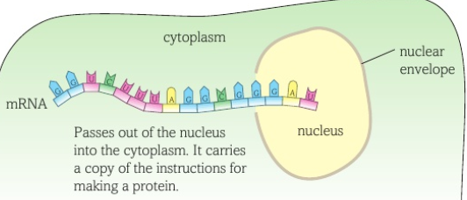
The mRNA passes out of the nucleus carrying the code for a protein. Once in the cytoplasm the mRNA binds to a ribosome. Within the cytoplasm there is another molecule called transferRNA (tRNA). At one end, the anticodon is complementary to the mRNA. At the opposite end there are three unpaired bases which code for an amino acid. The amino acid is brought in to form a peptide bond with the amino acids brought in by the previous tRNA. This forms a polypeptide chain which will form hydrogen and disulfide bonds to form the unique protein.
Mutations: Mutations change the order of bases in the DNA. Some bases may change to a different base (substitution), some bases may be deleted and some bases may be added. Mutations can cause the following; - Incorrect protein to be produces - No change in protein being made - Causes a harmful proteins/ no protein to be made
Lesson 6 DNA and protein synthesis;
DNA is a complex chemical, found in the nucleus of eukaryotes and in the cytoplasm of prokaryotes. DNA is made up of; pentose sugar, phosphate and nitrogenous bases forming a NUCLEOTIDE. There are 4 different nitrogenous bases; A= Adenine T= Thymine C= Cytosine G= Guanine Complementary pair; A pairs with T C pairs with G The bases pair up in the formation stated above. They are held together by hydrogen bonds. The two strands run in opposite directions causing the molecule to spiral forming a DOUBLE HELIX. DNA controls the production of proteins. A section of DNA that codes for a protein is called a gene. Proteins are made up of a string of amino acids, each protein has a different number and order of amino acids. The proteins also have different bonds which holds the molecule in a unique shape which means all proteins have a different function.

Protein synthesis; Protein synthesis occurs in the cytoplasm, carried out by RIBOSOMES. When a protein is required then the gene has to be copied producing a molecule called messengerRNA (mRNA). mRNA is small enough to pass out of the nucleus into the cytoplasm. mRNA is a template, containing nucleotides and bases. The nucleotide on the mRNA will line up with the complementary base. However, on RNA there is no Thymine, RNA will have the base URACIL (U).
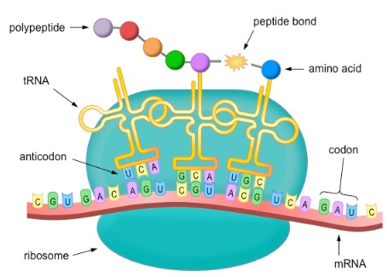
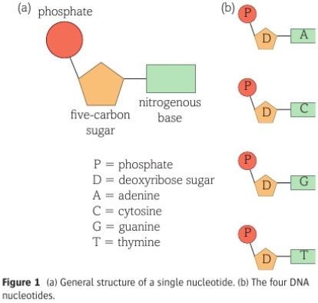
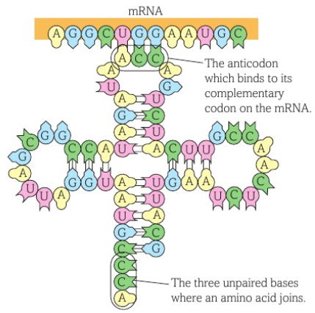
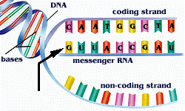
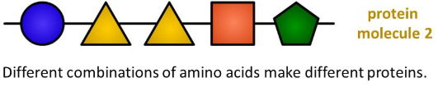
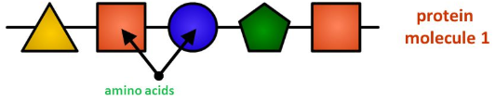
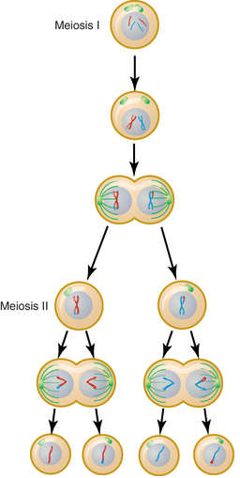
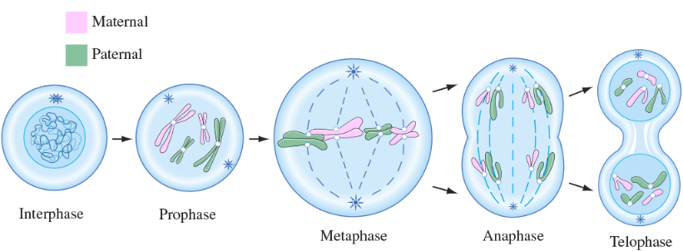
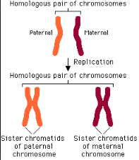
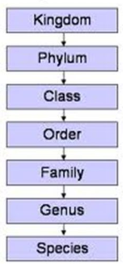
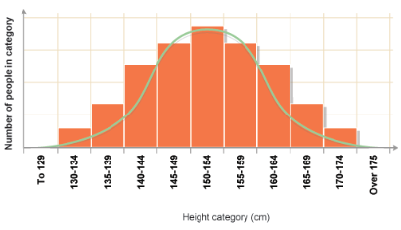
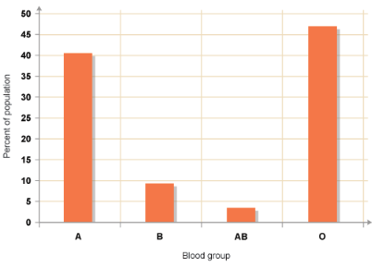
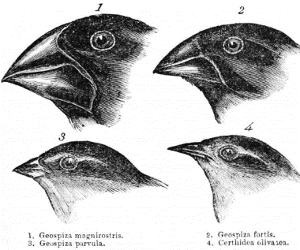
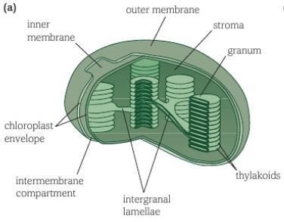
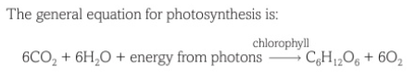
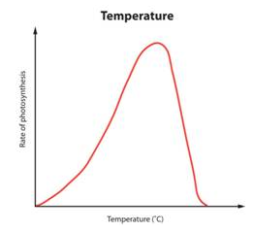
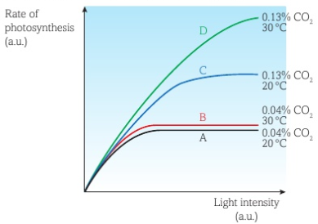
3
Pr
Questions; What are the components of a nucleotide. ________________ ___________________________________________________ What are the names of the 4 nitrogenous bases? ___________________________________________________ What type of bonds hold the 2 strands together? __________ What is the name of a section of DNA that codes for a protein? ___________________________________________ What are proteins made from? _________________________ DNA is too big to leave the nucleus, what is the copy of the gene called that enters the cytoplasm? __________________ What organelle will this molecule attach to? ______________ Which molecule has a complementary anticodon and brings in the correct amino acid? _______________________________
Questions;
Which cell division forms haploid cells? __________________ What happens during prophase? _______________________ __________________________________________________ What do centrioles do? ______________________________ __________________________________________________ Which organs produce haploid cells? ____________________ __________________________________________________What happens in Telophase? __________________________
7) Anaphase 2; The spindle fibres start to drag the chromatids to opposite sides of the cell. 8) Telophase 2; The nuclei’s start to reform and the cytoplasm spits to form 4 haploid cells that are genetically different to the parent cells.
6) Metaphase 2; Spindle fibres attach to the centromeres.
5)Prophase 2; New nucleus breaks down and chromosomes coil and condense.
3) Anaphase I; Spindle fibres attach to the centromere and pull the chromosomes to opposites poles. 4)Telophase I; Two nuclear envelopes surround the divided genetic information. Each contains half the number of chromosomes.
1) Prophase I; The chromosomes condense and the nuclear envelope breaks down. Homologous chromosomes pair up and can cross over DNA (Recombination).
2) Metaphase I; The homologous pairs arrange themselves randomly along the equator.
Prophase; The DNA becomes supercoiled and compact and can now be seen under a light microscope. It has the X shape.
Meiosis; This cell division is responsible for the production of sex cells and introduces genetic variation. It results in the formation of gametes containing half the original genetic information (Haploid number). This ensures, that during fertilisation, the embryo obtains two complete sets of genetic information.
In meiosis the cell undergoes 2 cellular divisions.
Telophase; A nuclear envelope forms around each set of chromatids and the cytoplasm divides forming 2 genetically identical cells.
Anaphase; The spindle fibres pull the centromere apart and the chromatids separate and are dragged to the poles of the cell.
Metaphase; the nuclear membrane breaks down, the chromosomes line up along the equator of the cell and spindle fibres, produced by the centrioles, attach to the chromosomes.
Interphase; DNA molecules are indistinct in the nucleus. They replicate their DNA, attaching at the centromeres.
Genetics and cell division;
The DNA molecule contains thousands of genes along its length. The DNA molecule is wound up into a chromosome. Each body cell in a human contains 23 pairs of chromosomes (diploid number), one from mother and one from father. These pair up forming a homologous pair, both the same size and containing the same genes (these genes can be different alleles). A chromosome is often seen as an X shaped molecule. The X shape is actually one chromosome attached to an exact copy of itself (2 CHROMATIDS). They are joined together by an attachment called a centromere. In preparation for cell division the chromosome will make a copy of itself. All damaged tissue and cells are replaced by a process of cell division called MITOSIS. Mitosis is also seen in asexual reproduction, the offspring are genetically identical to the parent. Mitosis cell division;
Questions;
What type of variation can be displayed as a distribution curve? _____________________________________________________ What type of variation can be displayed on a bar chart? _____________________________________________________ Describe Natural selection. _______________________________ ____________________________________________________________________________________________________________________________________________________________________________________________________________________ What are the 3 domains? ________________________________ What method did Linnaeus use to group organisms? __________ _____________________________________________________ What newer methods are now used? ______________________ _____________________________________________________ Define species. ________________________________________
King Prawn Curry Or Fat Greasy Sausages.
Classification;
Developed by Carl Linnaeus in the 18th century, it was a method of sorting, grouping and naming different groups of organisms.

A species was classified as a group of organisms that look very similar to each other and can reproduce to form fertile offspring.
Technology has advanced and organisms can now be classified on a genetic level using base sequence, proteins and enzymes in common and growth during embryonic stage.

The Three Domains; Taxonomic ranking was altered in the 1970’s with the introduction of the domains before kingdom. It was further clarified in the 1990’s with better understanding of cellular structure. Archaea are prokaryotic cells, Bacteria (even though bacteria are prokaryotic cells just like Archaea, their cell membranes have a different composition) and Eukarya (eukaryotes).

Organisms were grouped into divisions based on characteristics they had in common. The five kingdoms are; Animalia, Plantae, Fungi, Prokaryotes, Protoctists. The kingdoms then divide into Phylum; in Animalia these are; Cnidaria (invertebrates), Chordata (vertebrates), Arthropods, Molluscs and Echinoderms.
In animals the vertebrate’s phylum further splits into Mammalia (Mammals), Fish, Birds, Amphibians and Reptiles.
Order, Genus and species further classifies the organisms. The Genus and species names are always written in Latin and italics. The genus name has a capital letter and the species is lower case.

Lesson 7 Variation and evolution;
Due to the mechanisms used to produce haploid cells through meiosis, genetic variation occurs. Organisms of the same species show some variation due to alleles. There are 2 types of variation;
- Genetic variation; passed from parent to child (blood group, eye colour).
- Environmental variation; caused by the environment (scars, accents, freckles)
Some variation can be due to a combination of both genetic variation and environmental variation (intelligence, height and weight). Some characteristics fall into the category of continuous variation whereby there is a large range in variations (height and weight).

Other characteristics fall into a few distinct categories such as blood type, colour, tongue rolling; this is called discontinuous variation.
Sometimes a variation may lead to a characteristic that helps the organism to survive and be better adapted to its environment. The variation may be that the animal is slightly fast or better camouflaged. This slight difference within the species will allow the individual to compete better, survive, breed and potentially pass on the genetic variation to it’s offspring. This is called Natural selection. Evolution can occur through natural selection. Gradual changes over millions of years can ultimately lead to the formation of a new species.

as antibiotic-resistant bacteria. Darwin noticed that the finches - songbirds - on the different islands in the Galápagos were fundamentally similar to each other, but showed wide variations in their size, beaks and claws from island to island. For example, their beaks were different depending on the local food source. Darwin concluded that, because the islands are so distant from the mainland, the finches that had arrived there in the past had changed over time.
Questions; Define photoautotroph. ________________________________________________________________________________ Where in the chloroplast are the photosynthetic pigments found? _______________________________________________________ _____________________________________________________________________________________________________________ What reactant of photosynthesis is broken down in the light dependent stage? ____________________________________________ What reactant of photosynthesis is used in the light independent stage? _________________________________________________ What effect does increasing temperature have on the rate of photosynthesis? _____________________________________________ _____________________________________________________________________________________________________________
Lesson 8 Photosynthesis;
Photoautotrophs are organisms that produce their own food with the use of solar energy. They are the source of chemical energy for other organisms within a food chain.

Photosynthesis is and endothermic reaction requiring the energy to initiate it. A special organelle in the plant cell called the CHLOROPLAST contains a chemical called CHLOROPHYLL. The chloroplast has an inner and outer membrane called the

The photosystems contain different photosynthetic pigments which absorb different wavelengths of light. A fluid filled matrix called the STROMA surrounds the grana and contains enzymes and DNA for protein production within the chloroplast. Photosynthesis occurs in two stages; - The Light dependent stage (LDS); this uses light energy and water to provide hydrogen ions and electrons, which are moved through electron carriers, to produce oxygen and reduced NADP which can pass into the next phase. - The light independent stage (LIS) or CALVIN CYCLE; the Calvin cycle uses inorganic carbon dioxide gas to produce organic glucose. A five carbon compound called Ribulose bisphosphate accepts one carbon from the carbon dioxide with the help of an enzyme, RuBisCo. This forms and unstable 6 carbon compound which dissociates into two 3 carbon molecules called glycerate-3-phosphate (GP) which then accepts a hydrogen ion from the reduced NADP (brought in from the light dependent stage) to make 2 molecules of triose phosphate (TP). TP can then be synthesised into other sugars or used to synthesis amino acids, fatty acids and glycerol.
envelope. Inside the chloroplast are flattened sacs called GRANA. The grana stack up to form THYLAKOIDS. The chemical, chlorophyll is embedded in the Thylakoid membrane in PHOTOSYSTEMS.
Limiting factors and Photosynthesis;
Factors that can affect the rate of photosynthesis are called limiting factors. These can be the raw materials of photosynthesis (carbon dioxide and water), Light intensity or factors that affect enzymes responsible for photosynthesis (temperature and pH).
Water stress; water does not generally limit photosynthesis since it is required in other cellular reactions the plant, turgidity, transpiration stream and cooling is usually dead before water is at a low enough level to affect photosynthesis.
Carbon dioxide;

Light intensity; Light is required to provide photons of energy in the LDS. Light can also cause the stoma to open in the leaf bringing about transpiration.
Temperature;

pH; Similar to temperature, enzymes work best in particular pH’s. If the pH alters then bonds break and the enzyme denatures.
second increase as does the reaction rate. However, these reactions are reliant upon enzymes. Enzymes have a specific structure to allow them to carry out the specific function. As the temperature increases then hydrogen and disulfide bonds, holding the tertiary structure, will break and the enzymes active site changes shape (DENATURES) and the enzyme can no longer catalyse the reaction.
At lower temperatures the rate of reaction is slow due to the molecules and enzymes having less kinetic energy and therefore fewer collisions per second. As the temperature increases, the molecules gain more kinetic energy and collisions per

Without the presence of carbon dioxide then photosynthesis will stop. Ribulose bisphosphate needs a carbon from CO₂ to become the 6 carbon molecule and then the 3 carbon TP. Without TP no glucose is made.
Lesson 9: Maths in Biology
There is plenty of maths in Biology so you need to keep your GCSE knowledge fresh in your mind. Here are some Qs for you to practise some key skills.
- Calculate the following conversions:
a 0.004 m into mm b 130 000 ms into s
c 31.3 ml into μl d 104 ng into mg

2. Give the following values in a different unit so they make more sense to the reader.
Choose the final units yourself. (Hint: make the final number as close in magnitude to zero as you can. For example, you would convert 1000 m into 1 km.)
a 0.000 057 m b 8 600 000 μl c 68 000 ms d 0.009 cm

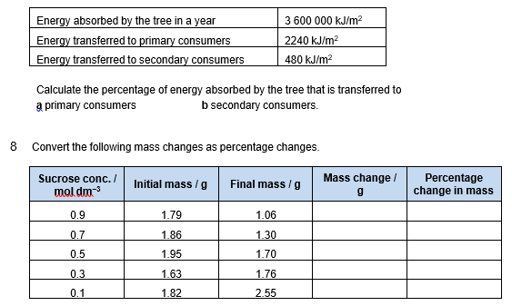
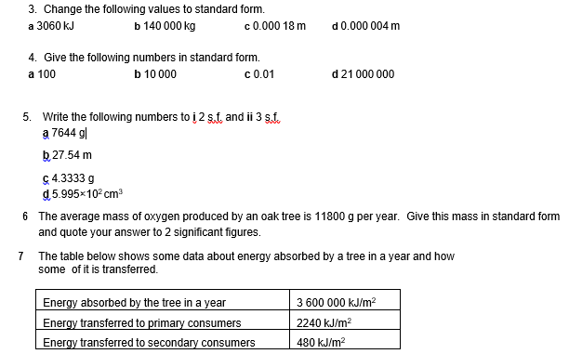

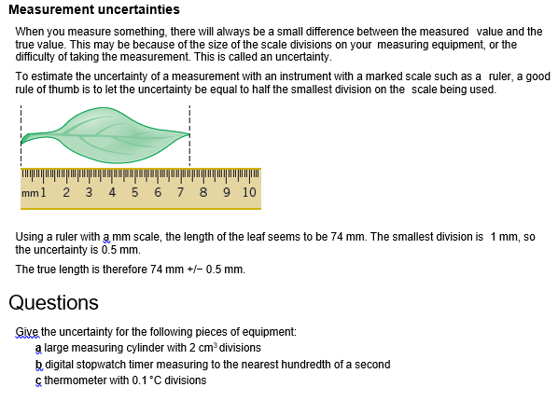
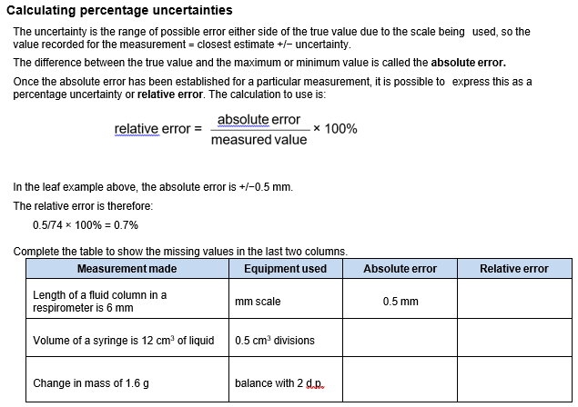

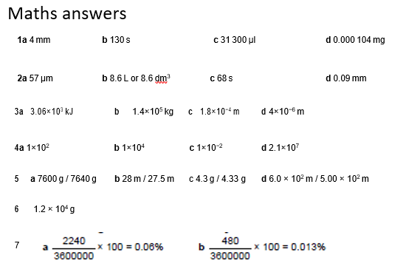

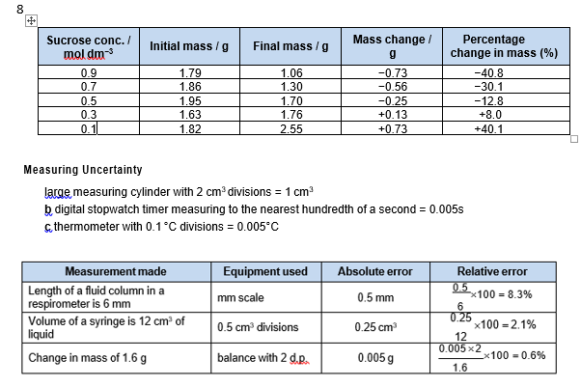

Lesson 10: Practical skills
How close are you?!
Produce a glossary for these terms.
Have a go at writing your own definition BEFORE looking them up.

Accuracy
Anomaly
Calibration
Causal link
Chance
Control experiment
Control group
Control variable
Correlation
Dependent variable
Errors
Evidence
Hypothesis
Independent variable
Null hypothesis
Precision
Probability
Random distribution
Random error
Raw data
Repeatability
Reproducibility
Systematic error
True value
Validity

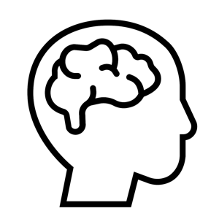

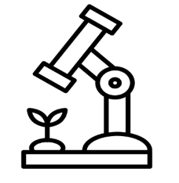
Once a Biologist….Always a Biologist!

Below are some suggestions for free online courses you may wish to look into. In addition to some useful websites and TV programmes which might be of interest if you are thinking of pursuing a career in healthcare or with animals.

 | 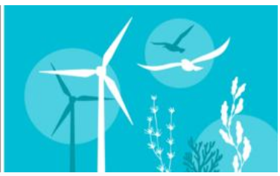 | 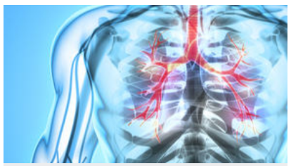 | 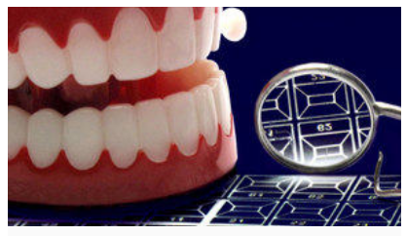 | 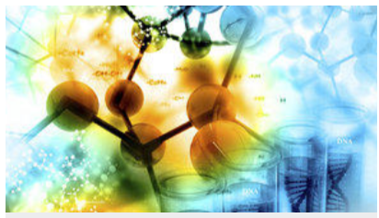
Keep learning with free online courses. | FurtureLearn: Ecology and Wildlife Conservation | FutureLearn: What is the body? | FutureLearn: Discover Dentistry | FutureLearn: Biochemistry: The Molecules of Life

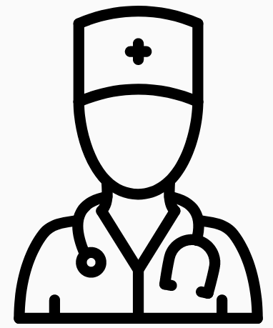 |  |  |  | 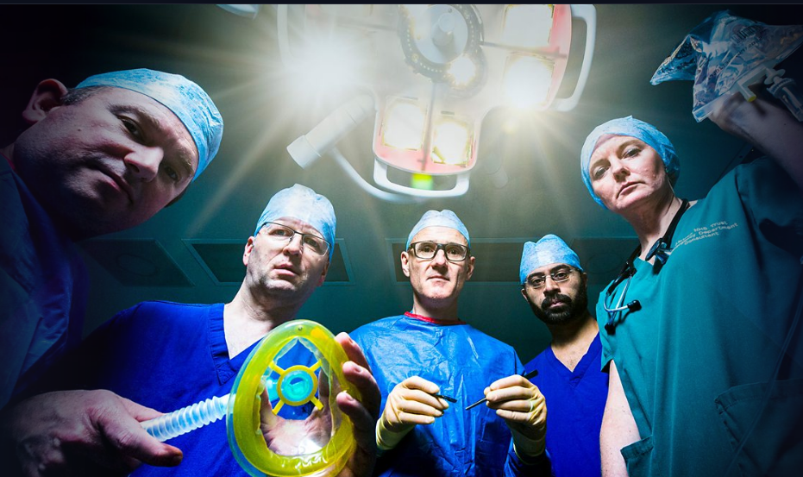
Thinking of a career in healthcare? | General Medical Council | The Medic Portal – one stop website packed with great information. | Health Careers – find information about lots of careers in the NHS. | BBC iPlayer – Hospital

 |  |  |   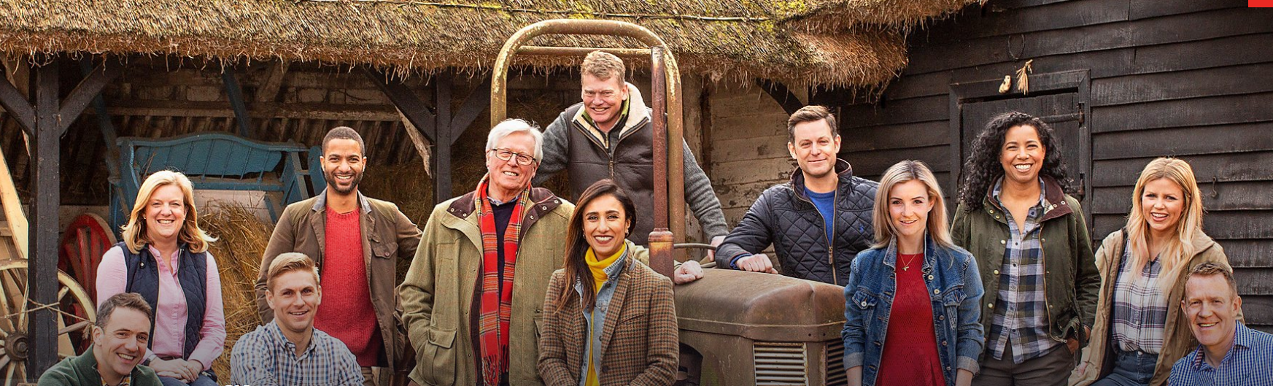 | 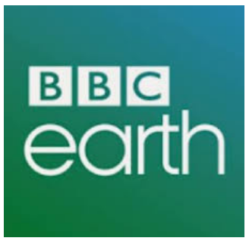
Thinking of a career with animals? | BBC Wildlife magazine | British Veterinary Associatrion – info about how to become a vet | BBC iPlayer – Countryfile | BBC Earth

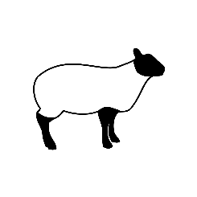
The biology department would love you to stay cognitively engaged over the coming weeks despite the cancellation of exams. Below are some suggestions of books, websites, films, podcasts and TV shows you could watch to keep up to date with veterinary developments.
So you want a career with animals?

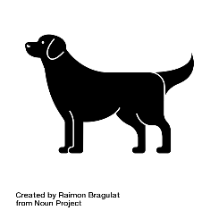

 | 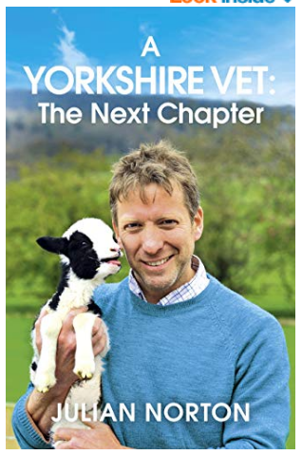 | 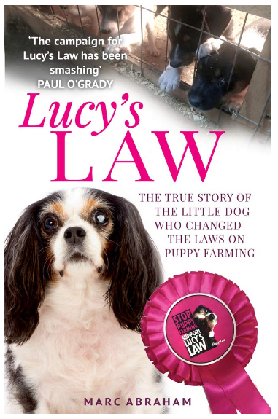 | 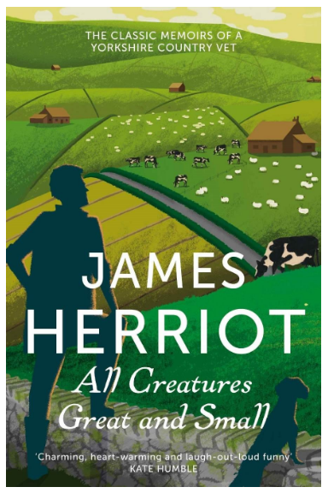 | 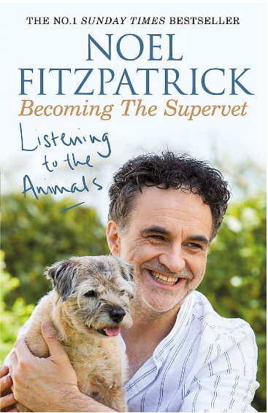
 | The Yorkshire Vet by Julian Norton | Lucy’s Law by Marc Abraham | All Creatures Great and Small by James Herriot | Becoming the Supervet by Noel Fitzpatrick

 |  | 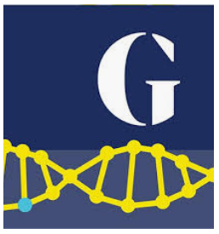 | 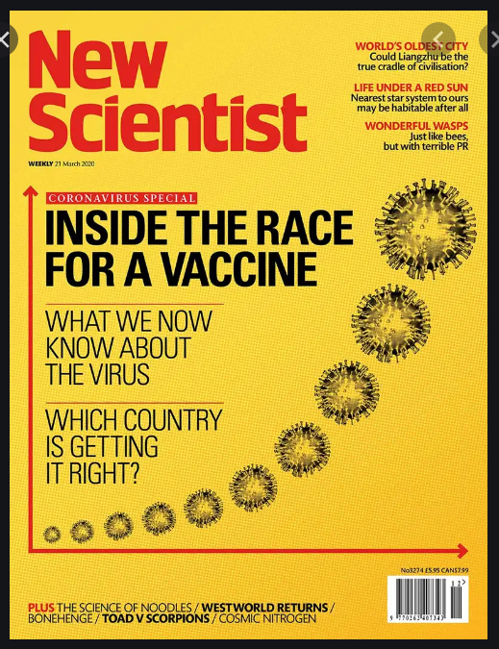 |  | 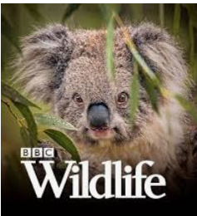
 | BBC Nature News | Guardian Environment | New Scientist | BBC Science and Environment | BBC Wildlife magazine
 | Horizon – back catalogue  The Supervet  The Yorkshire Vet  The Secret Life of the Zoo  BBC Earth |    | TED talks  The Life Scientific  Inside Science  iPlayer Science and Nature Playlist

BONUS BIOLOGY ACTIVITIES
Virology & Global Health | - Explained: The Next Global Pandemic (20 mins)  https://www.netflix.com/watch/81062202?trackId=13752289&tctx=0%2C3%2C0d03e68c-6321-41f2-9dfa-11f336ddc8ca-52560540%2C%2C  - The Life Scientific - viruses: https://www.bbc.co.uk/programmes/m0009b2t
Key Biological Concepts | - Short video - electron microscopy images https://www.youtube.com/watch?v=yutNM8AIkkk  - Podcast - ‘In Our Time - Microscopes’ https://www.bbc.co.uk/programmes/b03jdy3p  - Podcast - ‘In Our Time - Enzymes’ https://www.bbc.co.uk/programmes/b08rp369
Cells and Control | TEDx - Animations of unseeable biology https://www.ted.com/talks/drew_berry_animations_of_unseeable_biology?language=en  TEDx - A look inside the brain in real time  https://www.ted.com/talks/christopher_decharms_a_look_inside_the_brain_in_real_time#t-179742  In Our Time - Free Radicals: https://www.bbc.co.uk/programmes/m0000xqd  Reading on microbes: https://www.sciencenews.org/topic/microbes  In Our Time - The Brain https://www.bbc.co.uk/programmes/b00b54yx
Genetics | - Article - Virus mutations - https://www.historyofvaccines.org/content/articles/viruses-and-evolution  - Movie - Gattaca.  - In Our Time: Genetic Mutation https://www.bbc.co.uk/programmes/b008drvm
Natural Selection & Genetic Modification | Can Science Make Me Perfect?  https://www.bbc.co.uk/iplayer/episode/b0b6q3qy/can-science-make-me-perfect-with-alice-roberts  - In Our Time: Neanderthals https://www.bbc.co.uk/programmes/b00sq1nv  - The Life Scientific: evolution of cancer https://www.bbc.co.uk/programmes/m0003ks6
Health & Disease | - CrowdScience: How did humans discover medicine? https://www.bbc.co.uk/sounds/play/w3csz1v9  - CrowdScience: Is vaping bad for your health? https://www.bbc.co.uk/sounds/play/w3cswvx3  - In Our Time: Penicillin https://www.bbc.co.uk/programmes/b07dnnkm  - In Our Time: The Origins of Infectious Disease https://www.bbc.co.uk/programmes/b011pldm
Plants | - TEDx - How can we make crops survive without water?  https://www.ted.com/talks/jill_farrant_how_we_can_make_crops_survive_without_water#t-16976  - Podcast: Plants, from roots to riches https://www.bbc.co.uk/programmes/b048s3my/episodes/downloads  - Plenty of articles to read: https://www.sciencenews.org/topic/plants
Homeostasis & Hormones | - Interviews with researchers working on hormones: https://endocrinepod.com/episodes/  - OpenUniversity course on diabetes: https://www.open.edu/openlearn/science-maths-technology/biology/living-diabetes/content-section-3.1
Exchange & Transport | In Our Time: Discovery of Oxygen https://www.bbc.co.uk/programmes/b0088nql  In Our Time: The Heart https://www.bbc.co.uk/programmes/p003c1bh  The Big Picture - respiration https://www.stem.org.uk/resources/elibrary/resource/460338/cellular-respiration#&gid=undefined&pid=1

