Mathematics Enrichment and Further Education Activities




Contents
Page 3 - Working with Charts, Graphs and Tables

This is an Open University free online course where you will look at how statistics is used in real life. This is an excellent course that Mr Goodridge has completed too.
Page 12 - Algebra for A-level Maths
This is a course, designed and delivered by Mr Goodridge, which takes you through some of the more challenging GCSE algebra that is essential for A-level Mathematics. These are the topics that you need to be confident with before you start the course. Work through the videos, questions and quizzes to complete the course.
Page 21 - AS Pre-Test Work
During your first AS mathematics lesson you will complete a test. This is based on some of the key algebra needed to be successful throughout the start of the course. The test is identical to the test in this booklet, just different numbers.
Page 26 - AS Summer Refresher Work
Over a long summer holiday, it is easy to forget how to complete some of the mathematics you were once confident with. This set of questions is designed to remind you how to complete some of the essential topics for the start of AS mathematics.
Page 31 - Famous Mathematicians
There is so much more to mathematics then just doing maths questions. The history of mathematics is littered with fascinating stories and people. This task will give you a glimpse into some of the amazing mathematicians and the work they did to help us understand the mathematic world we now know.


https://www.open.edu/openlearn/science-maths-technology/free-courses/?filter=date/grid/662/all/all/all/&page=4
Write your reflections and answers to the activities as you work through the course in the spaces below. Please use separate paper if needed
2. Reflecting on your mathematical history. Activity 1
- What were your experiences of mathematics?

- How do you feel about these experiences?

- How could past experiences have influenced the way that you feel?

- Can you see why some people don't feel this way? Why could this be?

1.Your worries and concerns with charts, graphs and tables.
Activity 4.
Now, think about the patterns shown by the proportion of overseas students. What are the perceived changes and expectations here?
Activity 3.
- Where does the table come from? When was it prepared?

- Where does the data come from? Does its source tell us anything?

- On the left-hand side of the table is a list of headings referring to proportions. What could make this easier to follow?

Activity 2.
- What influences might the identity of the newspaper have had on how you react to the diagram or article and, in particular, to the conclusions drawn?

- Where was the data in the graphs derived from?

- How does it relate to the article?

- What conclusions can you draw from the use of the graphs related text?

4.2. Activity 6.
What can we tell about the table entitled ‘Provision of company cars’, using the questions we asked earlier and which are reproduced below the article?

- Who wrote the article and table, and for which publication?

- What influences has this had on the article and its conclusions?

- Where was the data in the table derived from?

- How does the table relate to the article?

- What conclusions can you draw from the table and related text?

Activity 5.
Overall, what does the table show us about the changing face of UK business schools?

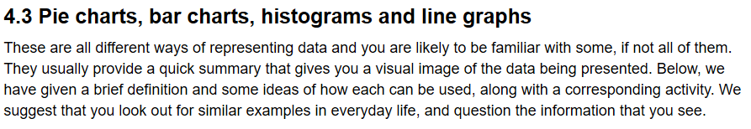
If you find something in a newspaper or magazine and it is ok to do, cut it out and stick it here
4.4. Activity 8.
- What is the chart about?

- How has the cost of living in the UK changed in the period since 1993?

- Where was the data in the bar chart derived from?

- How does it relate to the article?

- What conclusions can you draw from the bar charts and related text?

4.3.1. Activity 7.
- Which newspaper ran about a third of all advertisements?

- Which two newspapers together ran about a third of all advertisements?

- Where was the data in the pie charts derived from?

- How does it relate to the article?

- What conclusions can you draw from the pie charts and related text?

4.6 Activity 10.
- Overall, what is the graph trying to say?

- The graph joins up the lines between the years. How reasonable do you think this is?

- Where was the data in the graph derived from?

- How does it relate to the article?

- What conclusions can you draw about the use of the graph and related text?

4.5. Activity 9.
- What is shown on the vertical axis?

- What was the most common pay settlement?

- How many settlements were for a pay freeze?

- Where was the data in the histograms derived from?

- What specific influences has the data source had on the graphs, diagrams or articles and its conclusions in particular?

- How does it relate to the article?

- What conclusions can you draw about the use of the histograms and related text?

4.8.3. Activity 14.
The following list is the number of goals scored by a football team in a series of 18 games:
0, 0, 0, 3, 0, 1, 1, 2, 0, 2, 0, 0, 4, 0, 1, 2, 0, 0
Calculate the mode, median and mean for this list.

4.8.2. Activity 13.
Consider the scores of one batsman during the cricket season:
0, 0, 0, 4, 7, 10, 12, 15, 24, 30, 42, 48
Calculate the median and the mean of this set of scores.

4.8.1. Activity 12.
A sample of 15 batteries was tested. The batteries lasted, in hours:
23, 28, 25, 30, 18, 29, 23, 19, 30, 24, 25, 21, 26, 25, 23
- Calculate the mean life of a battery, correct to one decimal place (i.e. with one figure after the decimal point).

- How many hours of life will the company claim?

4.7. Activity 11.
Which of these represents the greater proportion:
10 per cent of 1260 or 140 out of 1260?
139 out of 1500 or 75 out of 250?

Activity 17.
- What impression do you get about the number of deaths in 1948 compared with the number of children aged 17 years and under found guilty of any crime now?

- Do we have any idea of the number of children living in poverty in 1948?

- Can we tell from the bar chart if the number of children living in poverty has increased or decreased since 1948?

5.1. Activity 15.
- What do you think 4.1m means?

- What do you think 55+ means?

- What impression do you get about the workforce aged 55+ and the manufacturing workforce?

- Describe what appears to have happened to the female workforce in comparison to the workforce aged 55+.

- What can you say about the time scales of these graphs?

Activity 16.
- What impression do you think the author is trying to give?

- There appears to be a crossover point, when did it take place?

- How many UK nurses were registered with the NHS at this time?

- How many EU/non-EU nurses were registered with the NHS at this time?

- Describe what the actual situation as regards UK and EU/non-EU nurses was at this time.

End of the course
Activity 20.
- What trend do you think that this graph is trying convey?

- Do you find it easy to interpret this graph? Explain your answer.

Activity 19.
The author of the article in which this bar chart appeared makes the following final comment in the accompanying text:
One specialist I spoke to reckons that the rate could rise to over 50% within the next 20 years. A quick look at the graph suggests he could be right.
What do you think about this statement?

Activity 18.
- Which age group got the largest number of mentions?

- Which age group got the fewest mentions?

- What does this chart tell us?

- Look at the horizontal scale and comment on it.

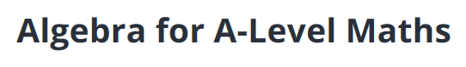

https://www.udemy.com/course/algebraforalevelmaths

Use these boxes to show your working out and the answers to the questions in the ‘Time to Practise’ sections.
Section 2 – 3. Solve an equation with the unknown on both sides
Section 2 – 5. Solve equations with fractions
Section 3 - 8. Solving a quadratic equation
Section 3 - 11. Sketch a quadratic
Section 3 - 14. The Quadratic Formula
Section 4 – 17. Completing the Square
Section 4 – 20. Simultaneous Equations (both linear)
Section 4 – 23. Simultaneous equations (one linear and one quadratic)
End of the course
Section 6 – 26. Rearranging Equations
AS Maths Pre-Test Work
Name: Score: /32

Question 1
Simplify this expression 5(3a-b+3c)−5a+9c

Answer…………………………….(1 mark)

Question 2
Simplify this expression 32x⁷ ÷ 2x³

Answer…………………………….(1 mark)

Question 3
Simplify this expression (2y⁶)³÷2y¹⁵

Answer…………………………….(2 marks)

Question 4
Expand and simplify if possible:
5x²(3x-2)−x²(3x−7)

Answer…………………………….(2 marks)

Question 5
Factorise this expression completely:
6y²−21y

Answer…………………………….(1 mark)

Question 6
Factorise this expression completely:
y²−9x²

Answer…………………………….(1 mark)

Question 7
a) Factorise x² -2x−8

Answer…………………………….(2 marks)
b) solve x² -2x−8= 0

Answer………………and …………….(1 mark)
c) sketch the graph of y = x² -2x−8 clearly showing where the graph crosses both axes

Answer…………………………….(3 marks)

Question 8
Factorise:
16x²−49y²

Answer…………………………….(2 marks)

Question 9
Evaluate:
6f² x 5f⁶

Answer…………………………….(1 mark)

Question 10
Evaluate:
81^{0.5}

Answer…………………………….(1 mark)

Question 11
Evaluate:
64^{1/3}

Answer…………………………….(1 mark)

Question 12
Simplify:
√48

Answer…………………………….(2 marks)

Question 13
Simplify:
√18+√32

Answer…………………………….(2 marks)

Question 14
Rationalise the denominator:

Answer…………………………….(2 marks)

Question 15
Rationalise the denominator:

Answer…………………………….(3 marks)

Question 16

Solve the simultaneous equations

3x + 2y = 4

4x + 5y = 17

Answer…………………………….(4 marks)

End of the Pre-Test

Surds
AS Maths Summer Refresher Work
If you need any help with these questions, go to https://corbettmaths.com/contents/ and watch the videos.
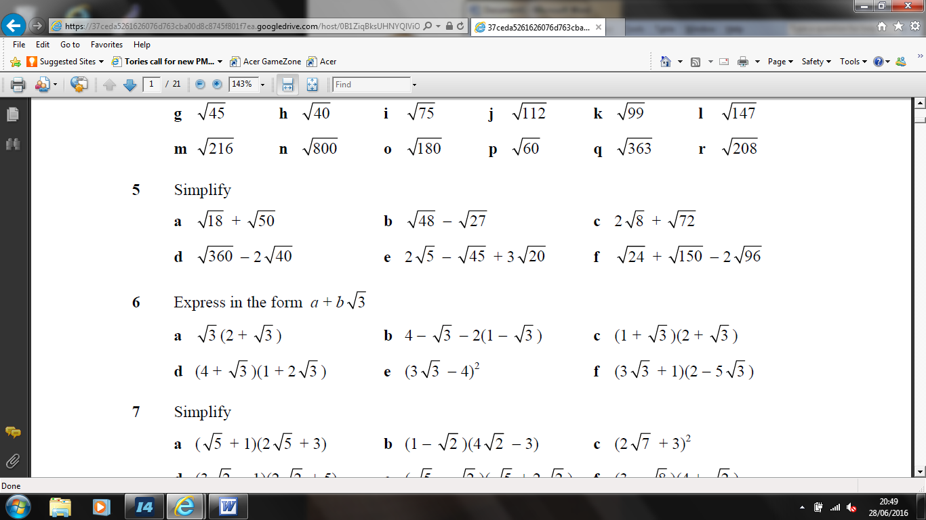
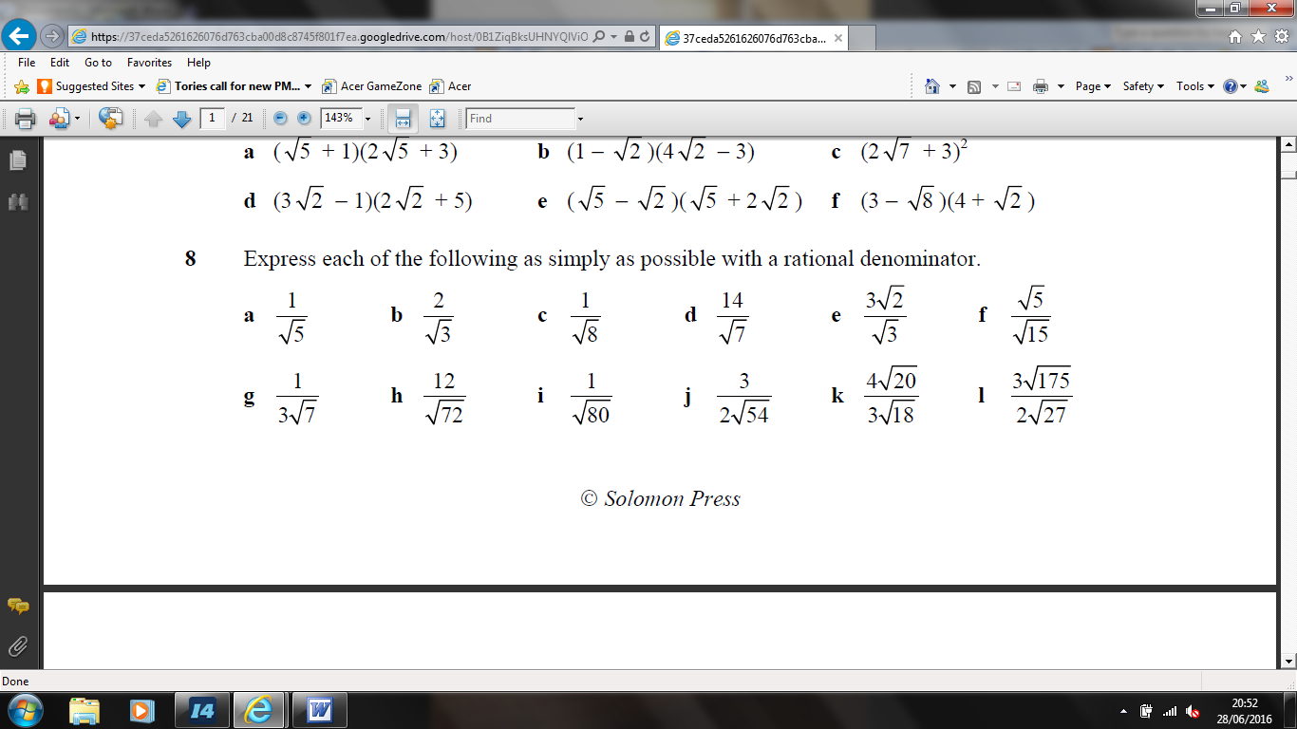
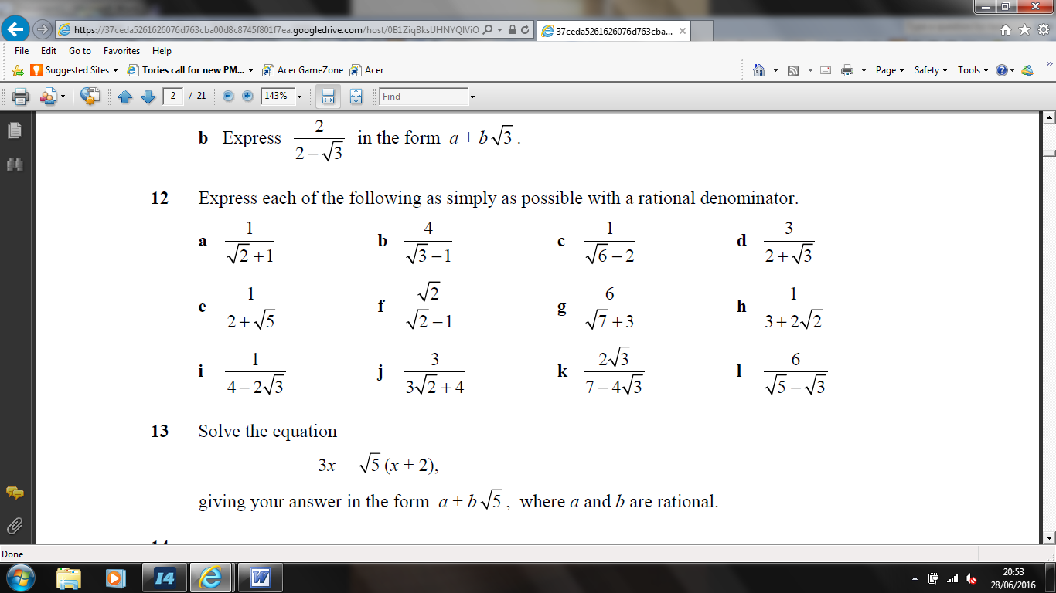

Surds Working Out and Solutions

Surds Working Out and Solutions (continued)

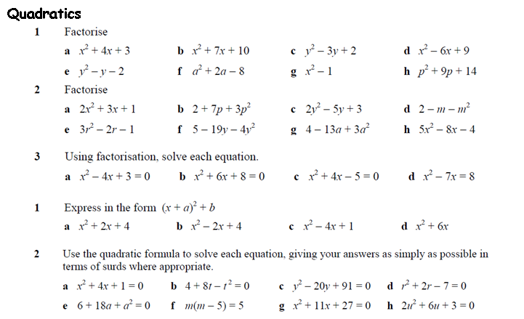
Quadratics Working Out and Solutions

Quadratics Working Out and Solutions

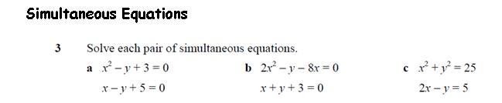

Simultaneous Equations Working Out and Solutions

End of the Refresher Work
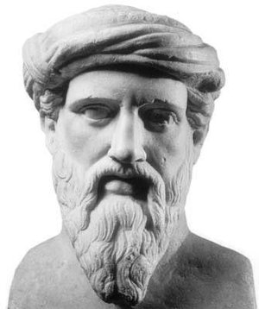
Famous Mathematicians – Pythagoras
When and where did he live?

What is he famous for in mathematics?

What other interesting things did you find out about Pythagoras?

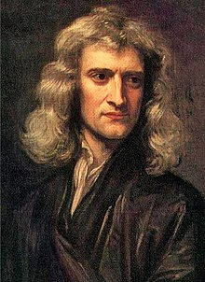
Famous Mathematicians – Sir Isaac Newton
When and where did he live?

What is he famous for in mathematics?

What other interesting things did you find out about Newton? (look for the Newton-Leibniz debate as we will learn about this in Year 12)

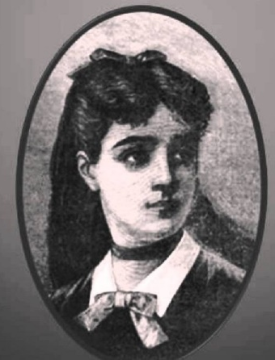
Famous Mathematicians – Sophie Germain
When and where did she live?

What is she famous for in mathematics?

What other interesting things did you find out about Germain?

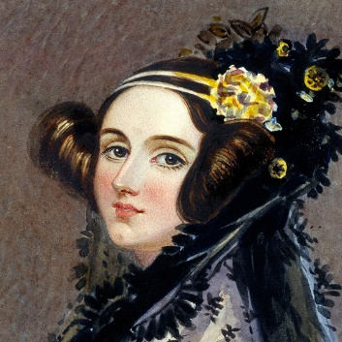
Famous Mathematicians – Ada Lovelace
When and where did she live?

What is she famous for in mathematics?

What other interesting things did you find out about Lovelace?

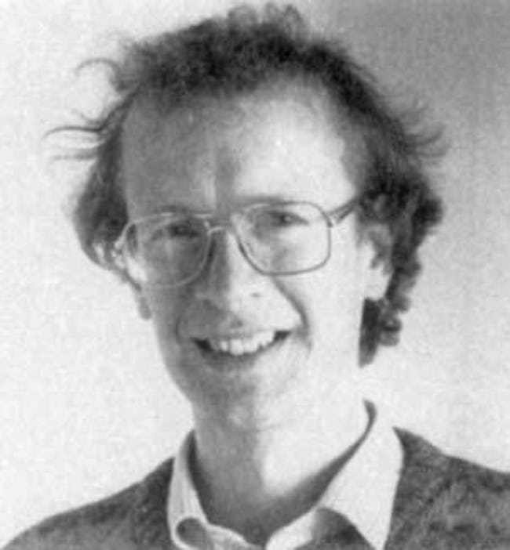
Famous Mathematicians – Andrew Wiles
When and where did he live?

What is he famous for in mathematics?

What other interesting things did you find out about Wiles?

Now find out about another mathematician!
Famous Mathematicians –
When and where did they live?

What are they famous for in mathematics?

What other interesting things did you find out about them?

End of the Famous Mathematicians Work

