

Park Hall Academy Social Science Department
Sociology-Let’s get learning!


NAME: _______________________________________

Welcome to A-level Sociology!

What is Sociology?

You have chosen a subject that will ‘keep you on your toes’ and make you think in ways you couldn’t imagine. You will certainly have a very different outlook on society by the end of your course.
As you will find out from your induction into the course, Sociology is the study of society, how it is organised and how we experience it. It is one of the most popular subjects to study at A-level and at university, but make no mistake, it is also one of the most difficult subjects to study. As none of you have studied this subject before, you are likely to be overwhelmed in the first few weeks of the course. Because of this, it is vital that you ask for any help that you may need with any class work, essays, home works, etc.

Online? There are some fantastic resources available via Social Networks. Here are just a few to get you started…

Instagram:
https://www.instagram.com/allsociology/

Twitter
https://twitter.com/allsociology

Podcast:
http://anchorfm/allsociology

Website:
www.sociologystuff.com

Website:
www.thesociologyguy.com
Contents

Lesson 1 Introduction and overview of the course
Lesson 2 Introduction to A-level Sociology
Lesson 3 Identity
Lesson 4 Culture
Lesson 5/6 Socialisation
Lesson 7/8 Introduction to theories - Functionalism
Lesson 9/10 Introduction to theories - Marxism

Induction

LESSON 1

Overview of the course:

This is a two-year course which ends with three two-hour papers each carrying an equal weighting towards your final A-level grade (A*-E).

Topics we will cover will include:

Year 12 Year 13

Theories of Sociology Crime and Deviance
Methods of Sociology Beliefs in Society
Families & Households Methods of Sociology
Education Theories of Sociology

Look at the specification for more detail about these topics. You will be expected to know and understand (AO1) the information about the topics, to be able to apply (AO2) that knowledge and understanding and to be able to analyse and evaluate (AO3) that knowledge and understanding.

Task 1

Highlight the topics on your specification and make a note below of the sections there are to each topic:

Education…………………………………………………………………………………………………….
…………………………………………………………………………………………………………………..
Theory and Methods (Year 1)……………………………………………………………………………
…………………………………………………………………………………………………………………
Families and Households…………………………………………………………………………………………………
………………………………………………………………………………………………………………….
Beliefs in Society………………………………………………………………………………………………………
…………………………………………………………………………………………………………………
Crime and Deviance …………………………………………………………………………………………………………………
………………………………………………………………………………………………………………….
Theory and Methods (Year 2) …………………………………………………………………………………………………………………
………………………………………………………………………………………………………………….

What do you think ‘Methods in Context’ means?

Expectations of the course:

- Lessons consist of taking notes, group discussions, watching relevant DVDs/documentaries, group work and PowerPoint presentations.
- Homework consists of note making, wider reading, investigations, past exam questions, power points and essays. It is expected that about 5 hours a week will be spent on Sociology homework.
- The Reading and Watching List on the following page will help you to gain wider knowledge and a broader framework in which to apply your knowledge. You will be expected to choose something to watch/read every half term and to feed back to the rest of the class. You may do this individually, in pairs or groups.
- Your progress will be reviewed on a regular basis. The review process will provide feedback at specific times throughout the year. You will also be expected to be within two grades of your target grade on each piece of work.
- You are expected to use the resources available to you in the Learning Resource Centre and work areas of the refectory here and are strongly encouraged to use libraries outside of school, not just the internet.
- Make a Sociology chat/whatsapp for discussion.
- Your folders of notes will be checked on a regular basis to see if you are organised and up to date with your work. We use a system of Study Briefs that will list the topic content and help you to keep track of assessment achievements
- USE YOUR STUDY TIME AND BE PRO-ACTIVE.

Questions?

Reading List - Sociology
- Brave New World – Aldous Huxley
- Animal Farm – George Orwell
- 1984 – George Orwell
- Chavs: The Demonisation of the Working Class – Owen Jones
- The Establishment and How They Get Away With It – Owen Jones
- The Handmaid’s Tale – Margaret Atwood (also a series)
- Vox – Christina Dalcher
- The God Delusion – Richard Dawkins
- Outsiders: Studies in Sociology of Deviance – Howard S Becker
- Folk Devils and Moral Panics – Stanley Cohen
- A Glasgow Gang Observed – Patrick James
- Gang Leader For A Day – Sudhir Venkatesh
- Haralambos
- A wide range of newspapers including The Guardian and Independent

Watching List - Sociology
- Any documentaries, including Panorama, Louis Theroux, Stacey Dooley etc
- Rich House/Poor House
- Black Mirror series (Netflix)
- Years and Years (BBC i-player)
- Goodfellas
- The Godfather (part 2 is the best)
- My Scientology Movie
- The ‘Up’ series (eg. 56 Up, 63 Up) on Netflix or Youtube
- The Secret Life of 5 year olds
- McMafia (previously BBC i-player)
- Freedom Writer’s Diary
- Dangerous Minds
- Chernobyl (drama)
- When They See Us (Netflix)
- The Society (Netflix)
- A Bug’s Life or Antz (for Marxism)
- Ted Talks/Sociology
Task 2
Choose something from the Reading and Watching List that you are going to report back on at the end of theterm. Share your decision next lesson.

Task 3
Picture 1:………………………………………………………………………………………………………
…………………………………………………………………………………………………………………..
Picture 2:………………………………………………………………………………………………………
…………………………………………………………………………………………………………………..
Picture 3:………………………………………………………………………………………………………
…………………………………………………………………………………………………………………..
Picture 4:………………………………………………………………………………………………………
………………………………………………………………………………………………………………….

Task 4
Slide 1 Statement:……………………………………………………………………………………………
………………………………………………………………………………………………………………….
Slide 2 Statement:……………………………………………………………………………………………
………………………………………………………………………………………………………………….
Slide 3 Statement:……………………………………………………………………………………………
………………………………………………………………………………………………………………….

Homework:

Watch the following clip and jot down 5 things that tell you what Sociology is.

https://www.youtube.com/watch?v=YnCJU6PaCio

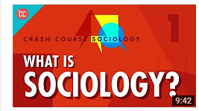
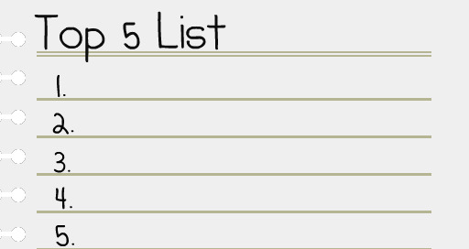

THINGS TO BRING FOR NEXT LESSON…

- Pen
- Paper
- File
- Induction booklet

Lesson 2 - An Introduction to A-level Sociology
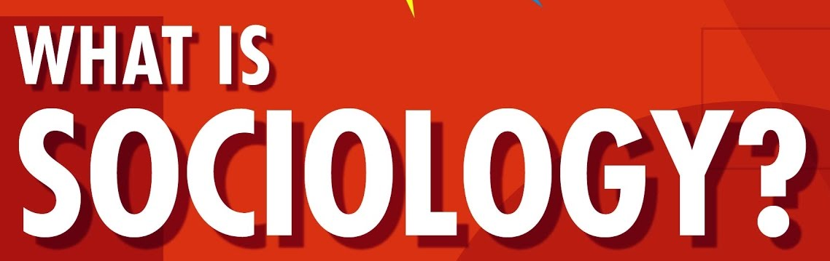

Sociology is the study of human social life. There are many different aspects of Sociology to address, so you must be curious and attentive to looking at the world in a different way!


Look at this photograph; not everything is as it seems!

There is usually another way of looking at things – and that is what we do as sociologists.

We take normal, taken-for-granted life and turn it upside down, looking for meanings. And very often we end up seeing things very differently.

Social Change

The social world is changing. Some argue it is growing; others say it is shrinking. The important point to grasp is: society does not remain static over time; it constantly changes - through decades and centuries and across countries, societies.

Task 1

Think of 3 different ways society has changed over the last 100 years. Try to be specific about the change.

……………………………………………………………………………………………………………………………………………………………………

……………………………………………………………………………………………………………………………………………………………………

……………………………………………………………………………………………………………………………………………………………………

……………………………………………………………………………………………………………………………………………………………………

Now, name 3 ways in which British society is different to another (America, Italy etc.)


………………………………………………………………………………………………………

………………………………………………………………………………………………………

………………………………………………………………………………………………………

………………………………………………………………………………………………………

……………………………………………………………………………………………………………………………………………………………………

………………………………………………………………………………………………………………………………………………………………......

Task 2

Why do you think has society changed? Why are societies different?

……………………………………………………………………………………………………………………………………………………………………

……………………………………………………………………………………………………………………………………………………………………

……………………………………………………………………………………………………………………………………………………………………

…………………………………………………………………………………………………………………………………………………………………….

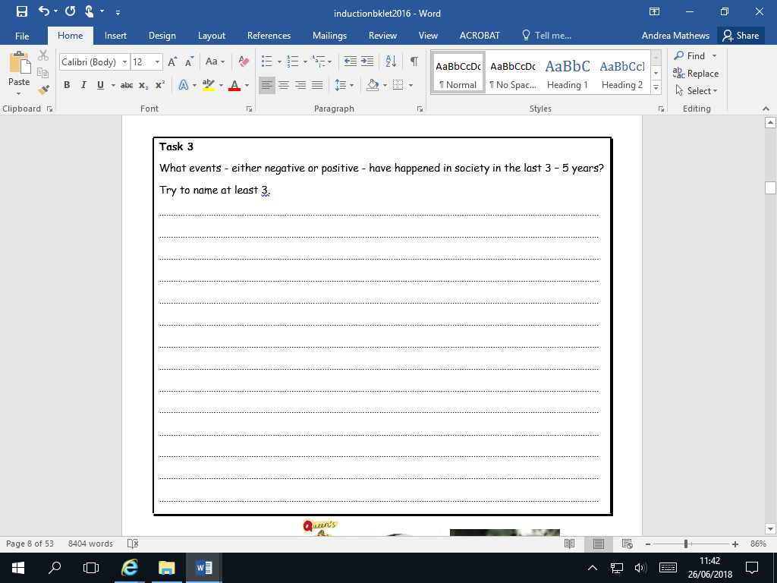

Homework: bring a news story to next lesson. Give reasons for your choice and suggest how it links to Sociology.
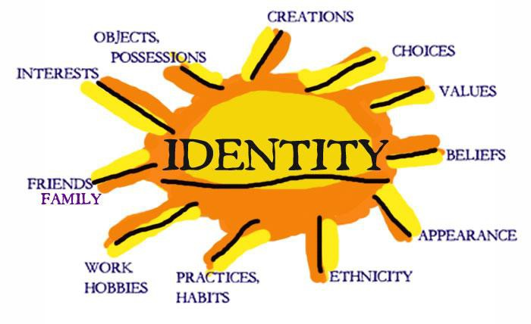
Lesson 3 - Identity

Who are you? Are you part of a group, an individual, a student, a sister, a brother?
Identity is about how we

see and define ourselves –

our personalities – and how

other people see and define us. Many aspects of our individual identity are influenced by

agencies of socialisation. These are structures or groups of people.

Task 1

Suggest six examples of structures or groups of people that impact upon you:

……………………………………………………………………………………………………………………………………………………………………

……………………………………………………………………………………………………………………………………………………………………

……………………………………………………………………………………………………………………………………………………………………

……………………………………………………………………………………………………………………………………………………………………

……………………………………………………………………………………………………………………………………………………………………

……………………………………………………………………………………………………………………………………………………………………

……………………………………………………………………………………………………………………………………………………………………

……………………………………………………………………………………………………………………………………………………………………

……………………………………………………………………………………………………………………………………………………………………

Individuals are like moulded putty, squished and squashed by society and its structures, but there are decisions we make that are driven by internal motivations. Behaviour that comes from within us – decisions we make in order to do things - is called agency. Agency behaviour is meaningful and a reflection of self-will. Sometimes we can challenge and oppose structures, and in this way we help construct a part of our identity.

Task 2

List three agency decisions you have made or will make today.

1. ………………………………………………………………………………………………………………

2. ………………………………………………………………………………………………………………

3. …………………………………………………………………………………………………………………

Task 3

Make a poster of how your identity is shaped by factors in your life.

Consider agency factors and structural factors.

Brainstorm some ideas first on what you can include in your poster.

……………………………………………………………………………………………………………………………………………………………………

……………………………………………………………………………………………………………………………………………………………………

……………………………………………………………………………………………………………………………………………………………………

……………………………………………………………………………………………………………………………………………………………………

……………………………………………………………………………………………………………………………………………………………………

……………………………………………………………………………………………………………………………………………………………………

……………………………………………………………………………………………………………………………………………………………………

……………………………………………………………………………………………………………………………………………………………………

……………………………………………………………………………………………………………………………………………………………………
Nature vs Nurture – The Big Debate
There are many ways of explaining why certain people do things in certain ways. For example, biologists think that people behave as they do because they are controlled by nature. This is known as Nature theory. Humans are compared to animals and seen to act on instinct.

Sociologists believe that people behave as they do because they are taught how to behave. For example, the sociologist Michael Haralambos states, ‘Human beings learn their behavior and use their intelligence whereas animals simply act on instinct.’ This is known as Nurture theory. Nurture means the way you are brought up. It is also a reference to socialization, the lifelong process by which we learn our culture, values, norms and how to behave.

Task 4

Write down a list of things that you were taught by other people about how to behave.

……………………………………………………………………………………………………………………………………………………………………

……………………………………………………………………………………………………………………………………………………………………

……………………………………………………………………………………………………………………………………………………………………

……………………………………………………………………………………………………………………………………………………………………

……………………………………………………………………………………………………………………………………………………………………

……………………………………………………………………………………………………………………………………………………………………

……………………………………………………………………………………………………………………………………………………………………

……………………………………………………………………………………………………………………………………………………………………

…………………………………………………………………………………………………………………………………………………………………


Sociologists reject nature theories for two particular reasons. If people behaved as they do because of nature, they would all act the same as each other. The following reasons show why people do not all act the same:

- History: people acted differently in the past from the way that
they do today. They had different ideas and different beliefs.

Task 5

Think of two ways in which we are different from people in the past:

1.………………………………………………………………………………………………………………

2.………………………………………………………………………………………………………………

- Anthropology: this is the study of different human societies. Wherever you go in the world, people act differently from the way they do in Britain.

Task 6

Think of four ways in which people in other countries are different from people in Britain:

1………………………………………………………………………………………………………………

2………………………………………………………………………………………………………………

3………………………………………………………………………………………………………………

4………………………………………………………………………………………………………………


Lesson 4 - Social behaviour and culture
Sociology is the study of human groups and social life in modern societies. Sociology recognises that as members of society we have to learn social behaviour and this is done through a variety of social institutions and social groups right throughout our lives.

Task 1

WHAT MAKES US HUMAN?

- Are we meant to live alone?
- What would a person be like if they grew up without human contact?
- What would a person be like if they were then introduced into a society?
- Do we need a society in which to survive?
- Can someone be truly human if they grew up without human contact?
- Are we ruled by our instincts? (An instinct can be defined as a complex, unlearned pattern of behaviour that is universal in a species).

It should have become clear that humans, more than most other animals, are dependent upon other humans for the most basic needs such as food and shelter.

We do not arrive in this world equipped with a collection of instincts inherited from our parents that will enable us to survive in a potentially hostile environment.

Homework

Can you find examples where:

a) behaviour is NOT driven by instincts

b) behaviour is ONLY driven by instincts.



Virtually all the things that we do have to be learned from others, for example walking, speaking, knowing what to eat, defending ourselves etc. A desert island baby is unlikely to survive, therefore we need other people.
We have now established an important principle. Human behaviour is largely learned through a process called socialisation. Therefore what is termed as culture, which is our way of life, including the ways in which we behave relates to:

- the language we speak
- the clothes we wear
- the food we eat and whether we eat it with knives, forks and spoons
- the homes we live in
- to the things we believe about the origins of life
- what is good or bad
- or the ways in which we should be governed.

The above are all acquired from other people (this involves the process of socialisation into the culture of our society)

Task 2

In groups, using the above list, describe the British culture.


It is through our membership of social groups that we acquire an understanding of the ways in which behaviour is patterned and organised and of the values, customs, norms and roles of our society. Sociologists refer to this as culture — the learned, shared behaviour of members of society. Culture is a social blueprint, a guide for living. It refers to all the aspects of human behaviour that are learnt rather than genetically transmitted. The following activity shows you the importance of culture.

A subculture is a culture within a broader mainstream culture, with its own separate values, practices, and beliefs eg. Bikers, goths, skateboarders, scousers, yuppies, hippies etc.

The Shirbit Tribe

The Shirbit culture believes that the human body is ugly and feeble. The Shirbit, therefore, indulge in rituals and ceremonies designed to avoid this, and so every household has a shrine devoted to the body.
The rituals associated with the shrine are private and secret. Adults do not discuss the rituals and children are only told enough for them to be successfully initiated.
The focal point of the shrine is a box built into the wall where key charms and magical potions for the face and body are kept. These are obtained from medicine men, who write down the ingredients in an ancient and secret language, understood only by the herbalist who prepares the potion.
Beneath the charm-box, is a small font. Every day, every member of the family enters the shrine chamber in succession and bows their head before the charm-box, mingling all sorts of holy water in the font and proceeds with a brief rite of absolution.
The Shirbit have a pathological horror of and fascination with the mouth, the condition of which is believed to have a supernatural influence on all social relationships. Were it not for the rituals of the mouth, they believe their teeth would fall out, their friends would desert them and their lovers would reject them.

Finally, men and women indulge in barbaric acts of self-mutilation. Men engage in a daily body ritual of scraping and lacerating their faces with a sharp instrument, whilst women bake their heads and hair with scorching tools.

Task 3

What aspects seem alien? In what ways, can this resemble British culture?

……………………………………………………………………………………………………………………………………………………………………

……………………………………………………………………………………………………………………………………………………………………

……………………………………………………………………………………………………………………………………………………………………

…………………………………………………………………………………………………………………………………………………..……………

…………………………………………………………………………………………………………………………………………………………………


Essay Homework
This essay is designed to allow you to demonstrate your sociological understanding and writing skills.
You will be assessed on the quality of your written style, the level to which you have understood and can use sociological concepts, your organisational skills and ability to follow instructions.
Essay title:
Evaluate the view that society is becoming more equal in the 21st century.
You will need to pay particular attention to the next few lessons on socialisation and role.
You should think firstly about what is meant by ‘equality’. Consider ways you think equality has been achieved and give examples. Try to think widely and consider global issues – it may help to make comparisons with other countries/societies.
To evaluate, you need to ‘weigh up’ and make a judgement so you also need to think about how some groups in society may still experience inequality, why this might be the case and whether equality can /should be achieved.
Your essay should:
- Have clear paragraphs, an introduction and conclusion
- Accurate spelling, punctuation and full sentences
- Correct use of grammar
- Accurate phrasing
- Discuss different types of equality eg. gender, social class, ethnicity

Your essay should be at least 500 words and hand written.
You should hand in your essay on the following date:

Deadline:
_________________________

Plan:
___________________________________________________________________________________________________________________________________________________________________________________________________________________________________________________________________________________________________________________________________________________________________________________________________________________________________________________________________________________________________________________________________________________________________________________________________________________________________________________________________________________________________________________________________________________________________________________________________________________________________________________________________________________________________________________________________________________________________________________________________________________________________________________________________________________________________________________________________________________________________________________________________________________________________________________________________________________________________________________________________________________________________________________________________________________________________________________________________________________________________________________________________________________________________________________________________________________________________________________________________________________________________________________________________________________________________________________________________________________________________________________________________________________________________________________________________________________



Lesson 5 and 6

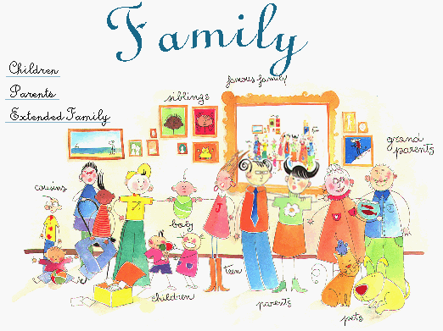
Socialisation is the term that sociologists use to describe the life-long process of learning the culture of any society. Culture is socially transmitted from one generation to the next through the process of socialisation. The American sociologist Charles Cooley (1864–1929) distinguished two types of socialisation: primary and secondary. These two forms of socialisation are defined partly in terms of the particular groups or ‘agencies’ in which they occur:

Primary socialisation
The family is the main agency where an individual learns many of the basic lessons for life such as language, how to act as a boy or a girl, how to share and how to love.



Secondary socialisation
Associated with the later stages of identity formation, from later childhood and continuing through adulthood. The school is an important example of an agency of secondary socialisation, but all formal organisations, including religion and work, are influential.

Task 1

List 2 ways in which your family teach you something. Similarly, list two ways in which

school teaches you something (something other than subjects!)

……………………………………………………………………………………………………………………………………………………………………

……………………………………………………………………………………………………………………………………………………………………

……………………………………………………………………………………………………………………………………………………………………

Socialisation is not only the process by which we learn the culture of our society; it is also a mechanism of social control.


This refers to methods used to persuade or force individuals to conform to those values, norms and patterns of behaviour which the culture of their society requires. Social control involves the use of rewards and punishments. Sociologists refer to these as sanctions. These may be either positive sanctions (rewards) or negative sanctions (various types of punishment):

Positive sanctions may range from gifts of sweets from parents to children, to merits and prizes at school, to promotion at work or to knighthoods and medals.


Negative sanctions may range from expressions of disapproval, physical punishment, being ridiculed or gossiped about, dismissal from work to being fined or imprisoned.

Task 2

List and briefly explain three positive and three negative sanctions which affect the way

you behave in your daily life:

POSITIVE

1. …………………………………………………………………………………………………………………

2. …………………………………………………………………………………………………………………

3. …………………………………………………………………………………………………………………

NEGATIVE

1. …………………………………………………………………………………………………………………

2. …………………………………………………………………………………………………………………

3. ……………………………………………………………………………………………………………….
Key Concepts in Socialisation and Culture

Norms

Norms are social rules which define correct and acceptable behaviour in a society or social group to which people are expected to conform. They are essential to human society. They guide and direct our behaviour and allow us both to understand and predict the behaviour of others.
Norms exist in all areas of social life. In Britain, being late for work or an appointment; jumping queues in supermarkets; laughing during funerals; walking through the streets naked or never saying hello to friends are likely to be seen as rude, annoying or odd because they are not following the norms of accepted behaviour.
Norms are usually enforced informally—by the disapproval of other people, embarrassment, or a ‘telling off’ from parents.

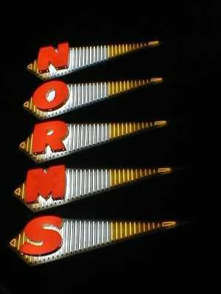
Task 3

Think of some norms for each of these situations.
School: ………………………………………………………………………………………………………………
……………………………………………………………………………………………………………………………..
……………………………………………………………………………………………………………………………..
Home: ………………………………………………………………………………………………………………..
……………………………………………………………………………………………………………………………..
……………………………………………………………………………………………………………………………..
Friend’s house: ………………………………………………………………………………………………
…………………………………………………………………………………………………………………………………………………………………….
…………………………………………………………………………………………………………………………………………………………………….

Homework: British Norms

Look at the following link and answer the questions.

https://www.telegraph.co.uk/education/10899837/Quiz-How-British-are-you.html

Then, have a look at this link and summarise the main British norms.
https://www.studying-in-uk.org/british-culture-and-social-norms/

What do these sources tell you about norms?

Values

Values are less specific than norms. They are general guides for behaviour. Values are ideas and beliefs about what is ‘right’ and ‘wrong’ and about standards which are worth maintaining and achieving in any society. In Britain, values include beliefs about respect for human life, privacy and private property, about the importance of marriage and the importance of money and success.

There are official legal rules concerning values which are formally enforced by the police, courts and prison and involve legal punishment if they are broken. For example, laws against murder enforce the value attached to human life in our society.
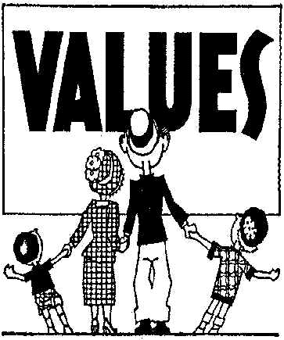

Task 4

Think of two values that are really important to you as a person. You may have strong views about animals or children.
1……………………………………………………………………………………………………………

……………………………………………………………………………………………………………..

2………………………………………………………………………………………………………………

Status

Sociologists use the term ‘status’ to refer to a position in society, for example father, doctor, son, bank manager, teacher. Statuses may be ascribed or achieved.
Ascribed statuses are fixed, often at birth, and are largely unchangeable. For example, gender and race are fixed characteristics usually given by others.

An achieved status involves some degree of choice and results partly from individual achievement. For example, a person achieves his or her job as a
teacher, doctor or scientist on the basis of ability and effort.

Task 5

Give some examples of what might give a 16 year old status (both positive and negative)

Positive: ……………………………………………………………………………………………………...

…………………………………………………………………………………………………………………

Negative: ……………………………………………………………………………………………………..................

…………………………………………………………………………………………………………………
Role

Each status has an accompanying role. A role is a set of norms which defines appropriate and expected behaviour for those who occupy a particular status.
A role can be compared to that of an actor on the stage following a ‘script’.

Roles are patterns of behaviour which are expected from people in different positions in society. People in society play many different roles in their lifetimes, such as those of a boy or girl, a child and an adult, a student, a parent, a friend and work roles like factory worker, police officer or teacher. People in these roles are expected by society to behave in particular ways. The police officer who steals or the teacher who is drunk in the classroom, show what these expectations of behaviour are!

Task 6

List some of the roles you play and briefly outline what others expect of you in each of these roles. For example, how are you expected to behave as a student/pupil and what activities are you expected to carry out which you wouldn’t have to if you were not a student?

…………………………………………………………………………………………………………………
…………………………………………………………………………………………………………………

…………………………………………………………………………………………………………………

…………………………………………………………………………………………………………………


One person plays many roles at the same time. For example, a woman may play the roles of woman, mother, worker, sister and wife at the same time. This may lead to role conflict, where the successful performance of two or more roles at the same time may come into conflict with one another, such as the conflict between the roles of full-time worker and mother which some women experience. For example, what happens if a child is ill? (Note: consider why women are referred to and not men.)

From your list of roles, try to pick out two examples of those which conflict with each other. Give a brief explanation of each example of role conflict.

………………………………………………………………………………………………………………………………………………………………………………………………………………………………………………………………………………………………………………………………………………………………………………………………………………………………………………………………………………………………………………………………………………………………………………………........

Lesson 7 and 8 – Introduction to Theories: Functionalism
Recap
List the key words you have learned so far with their definitions in the table.
Key Term | Definition
Sociology
Sociological Theory

Sociologists interpret the social world in different ways. Sociology emerged during the 19th century, a period of dramatic social change. Sociologists tried to make sense of the changes and explain the reasons for them. These explanations, or social theories, fall into two basic perspectives. These two perspectives represent a tension between groups of sociologists. Recently, some sociologists have tried to combine aspects of structural theories with action theories.

Structural theories
• Society is made up of social institutions (organisations)
• These institutions work together and support each other
• They take the view that society shapes the individual
• The individual has little ability to change their position in society.

Action theories (Agency)
• Society is the product of many meanings
• The meanings that individuals give to actions and behaviour shape society
• Individuals can change society through small scale changes in society
• Individuals therefore, are not passive but active in shaping the social world.

There are different types of theoretical perspective; structural theories argue that society shapes the individual whereas social action theories suggest that the individual has a greater role in shaping society through their thoughts and actions.

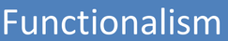

Functionalism is a structural theory, which argues that society plays a powerful role in shaping the individual. Below are the concepts which are central to this theoretical perspective.
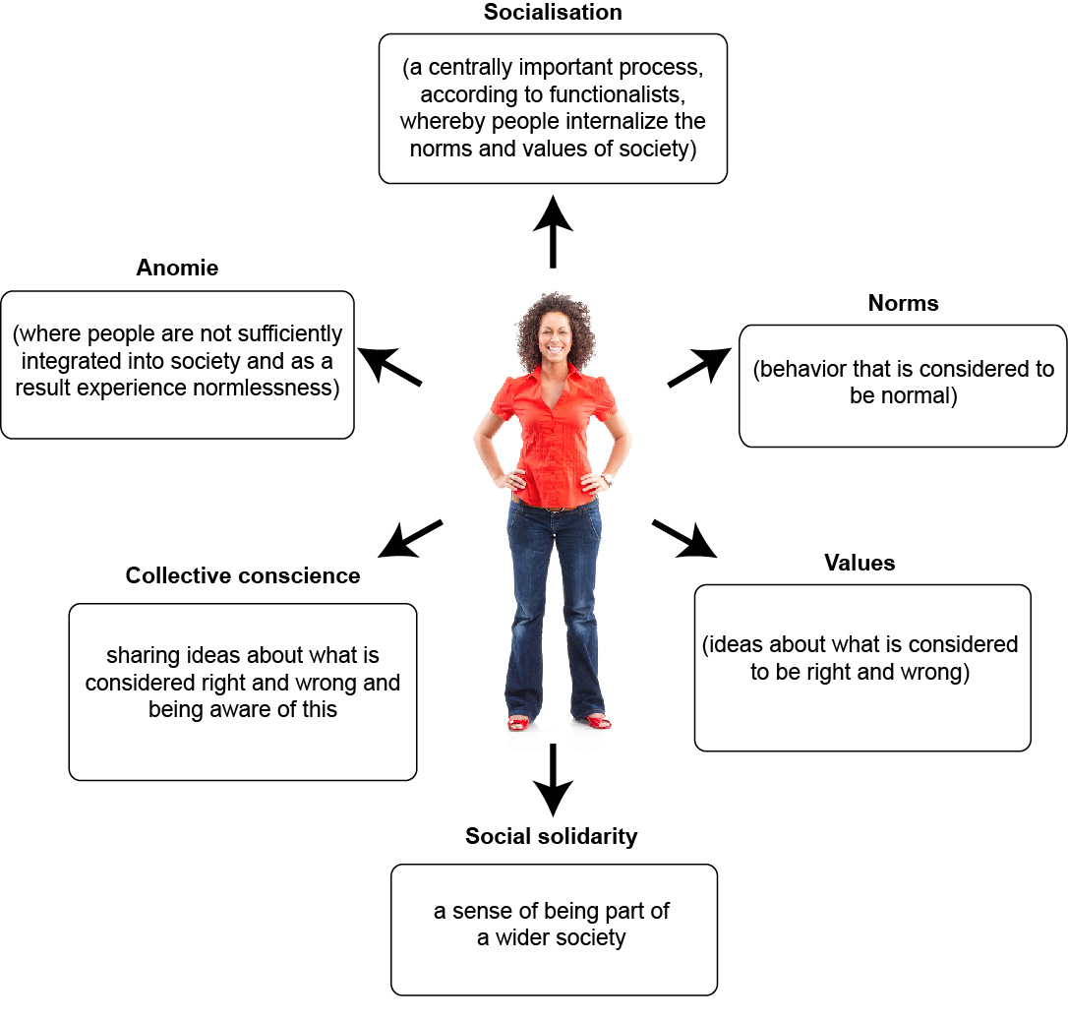

Task 1: Functionalist concepts
- In small groups discuss each of the concepts above (socialisation, norms, values, social solidarity, collective conscience, anomie) and give an example of each concept, this might relate to your own experience.
- Then look at the following images. Link each image to a Functionalist concept, explaining the link.







Evaluation
When many Functionalists were writing, the world was a very different place. It was made up largely of people of similar ethnic backgrounds. Today, society is very different, there are many more people from a wide range of different cultural backgrounds living together in UK society. Therefore it can be more difficult to agree on common values. Consider differing views on what is considered ‘right’ and ‘wrong’ among different religious groups. In fact in many cases, these different views can lead to social conflict. This has caused some to question if functionalist ideas are relevant today.

Task 2: Evaluating Functionalism
Using the examples, explain how each challenges the Functionalist view that there is value consensus within UK society.

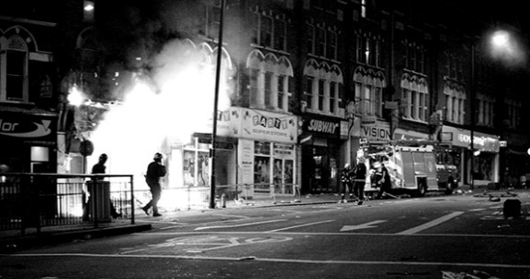


Key Functionalist thinkers
Emile Durkheim (1858-1917)
One of the earliest sociologists was the French academic, Durkheim, who was responsible for developing the discipline of sociology in terms of setting it apart from other disciplines and showing how it is possible for the study of society to be rigorous, scientific and relevant.
Durkheim starts from the view that people are basically selfish and that they need to be encouraged to think about the wider social group or else there is a danger that they will simply think of themselves and society would break down. Durkheim called this shared set of ideas about the importance of the wider social group the collective conscience.
Durkheim, like Parsons and other social theorists, explored the change in society from small scale, tight knit communities to complex industrialised societies. Durkheim believed that social forces are very important in shaping the individual and that if people are not integrated into society fully, anomie and disorder will occur. Durkheim believed that it is possible to ascertain social facts about society which could be used to understand and overcome social problems.

Task 3: Durkheim
- What assumptions does Durkheim make about people in general?

- What is the collective conscience?

- Give some examples of ‘social disorder’.

Talcott Parsons (1902 – 1979)
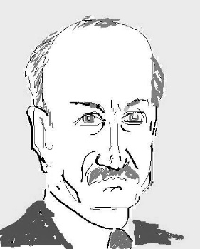
The American sociologist, Parsons (1970), developed the ideas of Durkheim and argues that it was useful to draw an analogy (or similarities) between society and the human body. This is known as the organic analogy. Parsons argues that the organs within the body are like institutions in society such as the family, education, the law and religion. Parsons argues that if one part of the body fails, then the rest will fail too. This is because the organs are interdependent – they rely on each other.

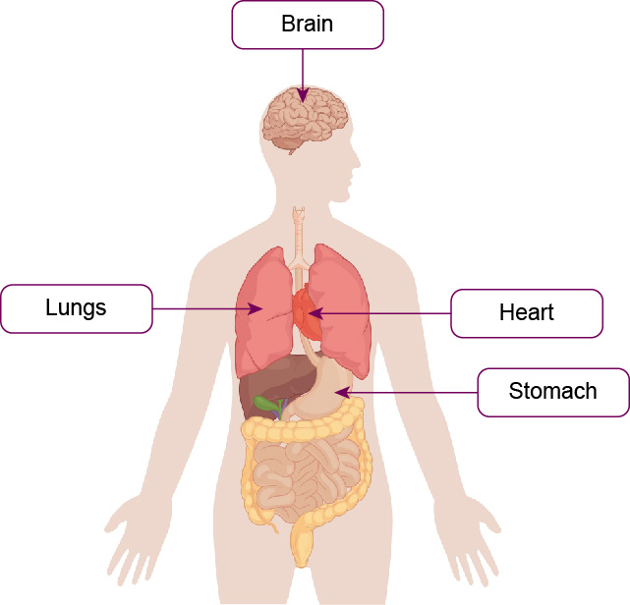

Task 4: Parsons
- Look at the previous diagram, and explain in your own words what is meant by the organic analogy.

- Can you think of an example of how problems within the family, such as the increase in divorce rate over recent years, might lead to problems in other parts of society?

- Think of one other way in which institutions are related to each other, for example, education and the economy (the world of work).

Parsons argued that the central question in sociology is how do people co-operate in society and how is social order possible? And the answer he developed is that people share a set of cultural values which allows people to decide what is important and what is not. This set of ideas about what is considered to be important is known as value consensus.
The process by which people learn to be part of society and the value consensus is through their integration into society. Parsons argues that people become integrated through two key processes:

A summary of Parsons’ processes through which people become integrated into society.
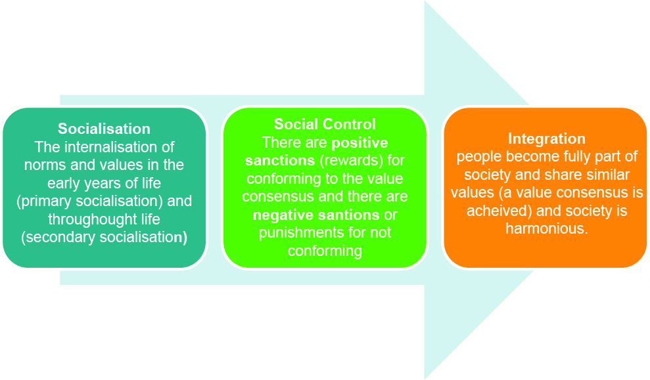

Task 5: How does society change?
Parsons argues that society can and does change and this is achieved by a process known as structural differentiation. Parsons’ view was that society is becoming more and more complex. Whereas in the past, the family carried out a number of important functions (such as learning to write, healthcare and work), today, other institutions have replaced these functions and have become specialised institutions themselves. Think of the expansion of the welfare state and the NHS which is where we now turn for healthcare for example, rather than the family.
Give 2 other examples of Parsons’ theory of structural differentiation.

Evaluation of Parsons
Although Parsons had some very well-known and respected ideas he has been criticised. Parsons argues that social harmony is both possible and desirable, and in reality, it could be argued that there is not harmony but in fact, different groups experience conflict in values. Parsons is therefore criticised for being overly optimistic. Another criticism is that Parsons makes the assumption that people are similar and want society to work together in society. This may or may not have been true for large parts of the society that he was writing for (America in the 1950s), however, today, society is even more culturally diverse and this makes some argue that Parsons’ ideas are not useful to understanding contemporary society. Parsons was white, middle class and middle aged, living a life of affluence and this too may have made him see society more positively than it might actually be.

Task 6: Evaluating Parsons’ ideas
In your own words summarise the evaluation of Parsons’ ideas:

Task 7: Applying Functionalist ideas to understanding the concept of socialisation
For each of the formal agencies of social control, suggest how each institution maintains social harmony.
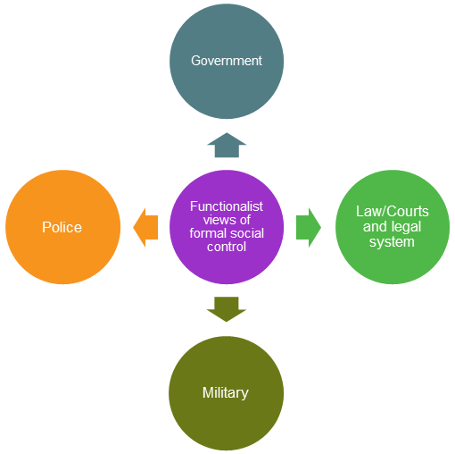

Agency | How they maintain social harmony
Government:

Police:

Military:

Law/Courts and legal system:

Task 8
Consider how different agencies of socialisation work according to Functionalists.
The first two have been done for you. Complete the other sections:
Agency of socialisation | Explanation of how this agency maintains social harmony | Examples
The family | Using positive sanctions such as providing love and support, individuals are encouraged to accept challenging situations and become prepared to tolerate other people beyond the family. | Rewarding good behaviour with praise or punishing bad behaviour such as telling children off.
Peer group | Friends act as a form of social control, both positively and negatively. Very influential among young people. | Excluding those who do not conform to socially accepted ideas about right or wrong behaviour.
Media

Religion

Education

Workplace

Task 9
Fill in the gaps
Functionalism is a ____ ______ , which means that it believes that society plays an important role in shaping the individual. Structural theories assume that the individual passively accepts societal pressures. Functionalism is a consensus theory which means that it sees society as being basically and that is possible and desirable.
Early functionalists such as Durkheim were keen to show how sociology could be a separate academic discipline, and claimed that society could be understood in much the same way as
_____ understand the world around us. Durkheim argued that social facts could be established about society, meaning that certain ‘truths’ about social forces could be understood, also meaning that the solutions to social problems could be found.
Functionalists take a scientific numerical approach to research, known as _______ . This means that they believe that it is possible for sociologists to be objective, not allowing their own feelings to affect the research. Functionalists favour numerical or quantitative data and argue that from this it is possible to establish cause and effect relationships.
Functionalists take a traditional approach to some aspects of social life. For example, they regard gender roles as being based on biological differences between men and women. They claim that women’s roles as caregivers (the ______ role) is an extension of their biological
____ role. The male role, on the other hand is based on providing for the family (the role).
Functionalists have been criticised for being overly optimistic about the extent of social harmony.
_____ have criticised functionalists for their assumptions about gender roles being traditional, arguing that there is no reason why these roles cannot be interchangeable and that traditional __ oppress women. Another potential problem with functionalism is that many of the functionalist ideas were developed some time ago when society was different, leading some to question if functionalist ideas are relevant. For example, increasing ____ . has resulted in far more cultural diversity making the idea of a more complex and at times challenging.

structural theory
migration
instrumental
positive
Feminists
childbearing
gender roles
expressive
value consensus
social harmony
positivism
natural sciences

Lesson 9 and 10 - Marxism
Marxism
Karl Marx was born in Germany in 1818 and died in London in 1883. He is known as an economist and a philosopher as well as a social theorist, whose ideas have had huge impact around the world. His ideas inspired the foundation for many communist societies. At the turn of the twentieth century, over half the world was being organised and governed under the influence of his ideas.

Marx argued that the relationship that people have with the economy shapes everything else; ideas, relationships, belief systems, culture. Marx argued that throughout history, society has transformed from feudal society into Capitalist society, which is based on two social classes, the ruling class (bourgeoisie) who own the means of production (factories, for example) and the working class (proletariat) who are exploited (taken advantage of) for their wage labour. This means that the ruling class uses the working class to produce goods and services and keep the profit for themselves. Capitalism is based on the idea of private ownership of property, which encourages the individual pursuit of profit. Marxists argue that this system creates great inequalities in societies between the two social classes.

Marx was highly critical of capitalism and argued that the ruling class would get more and more rich and powerful while conditions for the working class would continue to be poor. Marx argued that in capitalist society, the working class feel alienated (removed from their labour) and exploited. Marx claimed that institutions such as religion and the family provide some relief from these feelings of exploitation and alienation. In other words, explaining away inequality and making people accept their oppressed position. He calls this false class-consciousness, the idea that people are not aware of the true extent of their exploitation.

However, Marx argued that the proletariat would become aware of their exploited position, come together and overthrow the system through a revolution, after which society would change radically into a communist or socialist society. Marx argued that this new type of society would remove the private ownership of property, and make sure that everyone was equal, removing social class differences. Contemporary examples of communist societies are China, Cuba and the former USSR.

Evaluation of Marxist ideas:
- Society has changed a lot since Marx was writing. There are now many attempts to make society fairer through the introduction of free healthcare, benefits, minimum pay, laws to protect people at work.
- The working class uprising and revolution didn’t happen in the UK, and where it did happen, communism has been prone to corruption by a small powerful elite while the majority are often hugely disadvantaged (for example in the former USSR).
- How relevant is social class today in shaping a person’s identity? There are many other sources of identity and some claim that the lines between different social classes are becoming much more blurred today or less relevant.
- Marx suggested that there was little/no social mobility possible within capitalism, however there is increasing evidence that people do have the ability to change their class position.
- Class is still very important in explaining inequality in society, for example, in determining success in education and at work.
- Feminists claim that Marxists ignore the oppression of women.

Task 1: Evaluation of Marxism
Summarise the Marxist approach, in your own words using the information above.

Which of the evaluation statements above are positive and which are negative?

In your own view is Marxism useful for understanding society today? Give reasons.

A Marxist View of Culture
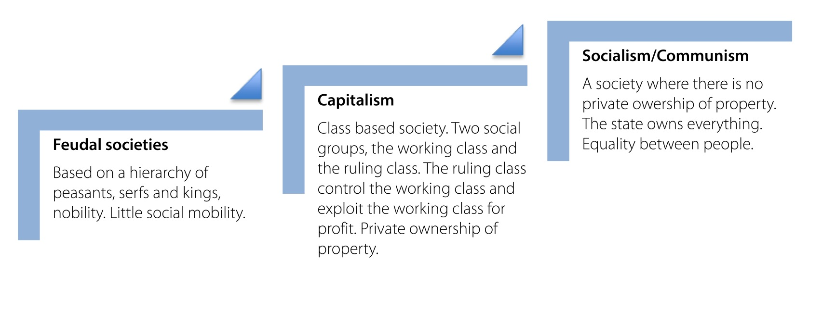

Applying Marxist ideas to understanding culture

Task 2
Using the diagram above, make notes on each box and explain from a Marxist perspective.

