SGR/KWS


WATER ORTON ROAD CASTLE BROMWICH
BIRMINGHAM B36 9HF
0121 748 0400 WWW.PARKHALLSCHOOL.ORG.UK

ASSOCIATE HEADTEACHER: DR T CLOSE

May 2026

Dear Parent(s) / Carer(s)

Biometric Information (fingerprints)

Park Hall Academy students use a cashless system to purchase food from the cafeteria as a way to speed up the queuing system and to prevent students from having to carry cash to and from school. This is done through students using their fingerprint.

In order for students to purchase food from the cafeteria, we are now required by law to have written consent off parents in order to use and process biometric information. Please be assured that this information remains within the Academy and that the biometric information taken is an algorithm and not the actual fingerprint itself. The preference of the Academy is to use biometrics as this is more secure and faster than any other method of identification and we would appreciate your co-operation with regards to this matter.

Fingerprints will be taken on Thursday 3rd September 2026.

If you have any queries with regard to this matter, please do not hesitate to contact me.

Yours faithfully
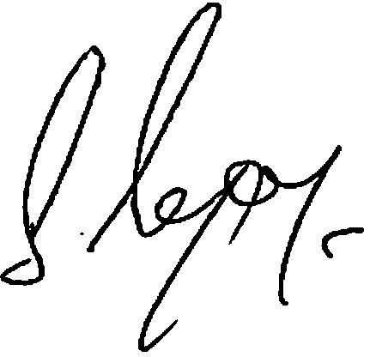

Mr S Gregory
Deputy Headteacher

