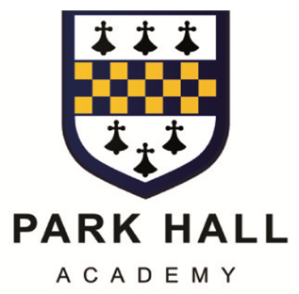

WATER ORTON ROAD CASTLE BROMWICH
BIRMINGHAM B36 9HF
0121 748 0400 WWW.PARKHALLSCHOOL.ORG.UK

ASSOCIATE HEADTEACHER: DR T CLOSE

TCL/KWS

May 2026

Dear Parent(s) / Carer(s)

Please find attached a data collection sheet and some additional guidance notes that explain how we use this data.

It is essential that we have accurate up-to-date information and we ask that you fill in the form and return it, via your child, to the school reception.

Notes to help you fill in the following forms

Contact Information
- The information in this section relates to the details the academy needs to hold on contacts for each pupil
- The academy must be informed about everyone who has legal parental responsibility for a child or young person, as well as any court orders in place in relation to them
- As a minimum, a name should be provided for all contacts with parental responsibility, even if address or telephone numbers are not known. A copy of any court order should be provided to the school
- If you are unsure of what legal parental responsibility is, please speak to the academy
- The contact priority field indicates the order in which contacts will be telephoned should the need arise and can be amended if required
- Please give details of all relevant contacts below (continue on a separate sheet if necessary)

Dietary Requirements
- This section is for you to record any food allergies or specific dietary requirements relating to cultural or religious reasons
- If your child is vegetarian or vegan, please be specific about whether your child can eat eggs, cheese, fish etc

Dinner Arrangements
- This part of the form enables us to keep track of the meal arrangements for your child in school
- It is important to the academy to be aware of all pupils who are entitled to free school meals, even if your child brings sandwiches or pays for dinner. This is because the proportion of pupils entitled to free meals can affect our funding and the judgement of our progress by Ofsted
- If, parents are in receipt of any of the following benefits, they may be entitled to claim free meals for their child:

- Income-related Employment and Support Allowance
- Support under Part VI of the Immigration and Asylum Act 1999
- The guaranteed element of Pension Credit
- Child Tax Credit (provided you’re not also entitled to Working Tax Credit and have an annual gross income of no more than £16,190)
- Working Tax Credit run-on - paid for 4 weeks after you stop qualifying for Working Tax Credit
- Universal Credit - if you apply on or after 1 April 2018 your household income must be less than £7,400 a year (after tax and not including any benefits you get)
Please be aware that all information remains confidential and at no time are other pupils made aware of who has a free meal.

Parents in Military Service
- The academy is required to collect information on pupils with parents who are service personnel serving regular HM Forces military units of all forces and exercising parental care and responsibility
- This information is used by the Department for Education to identify the impact that being a service child has on their education
- Information of this nature will remain completely confidential

It would be very much appreciated if the data form could be returned to the Academy as soon as possible.

Yours faithfully
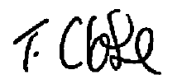

Dr T Close
Associate Headteacher

