NHA/KWS
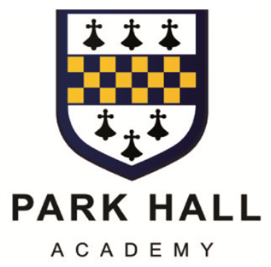

WATER ORTON ROAD CASTLE BROMWICH
BIRMINGHAM B36 9HF
0121 748 0400 WWW.PARKHALLSCHOOL.ORG.UK

ASSOCIATE HEADTEACHER: DR T CLOSE

May 2026

Dear Parent(s) / Carer(s)

Revised Free School Meal Applications

We have received notification that all free school meal applications can now be accessed online only. There will no longer be any written applications.

Parents of pupils that already receive free school meals and attend a Solihull Authority school do not need to make a new application unless there is a change in circumstances. If your child attends a Birmingham Authority school and you wish to apply for free school meals please see paragraph below.

You can apply for free school meals by using the Parent Portal which is part of the existing school admissions online system. Re-visit your account at www.solihull.gov.uk/enrol and after logging on, click on the free school meals button where you are required to provide three pieces of additional information. If you do not have an account you can create a new one by clicking on register in the top left-hand corner of the screen and you will then be able to make an application.

Please ensure applications are submitted by 16th July 2026 where possible as this will enable the Solihull MBC Free School Meal Team to process applications prior to the start of the Autumn term in September. If you are unable to apply by that date you will still be able to apply online but please note applications will be processed on a first come first served basis.

Further information and a link to the online Parent Portal can be found on the Solihull MBC website www.solihull.gov.uk/fsm (attached are some additional guidance notes).

If you need any further information please do not hesitate to contact Mrs Dann at Park Hall Academy on 0121 748 0400.

Yours faithfully
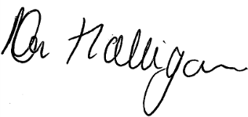

Mr N Halligan
Deputy Executive Headteacher

