School Synergy Student Login:
On an internet browser such as Google Chrome, Microsoft Edge or Safari (Mac), please visit the following website:
https://parkhall.schoolsynergy.co.uk/default.aspx
Now click the Microsoft logo.
This will open a sign-in window and allow you to enter your school email address.
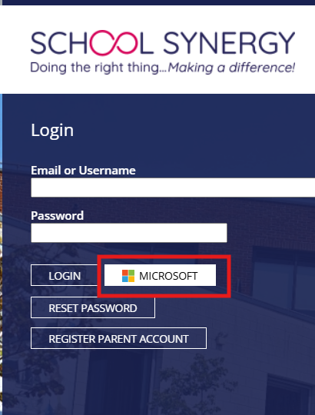 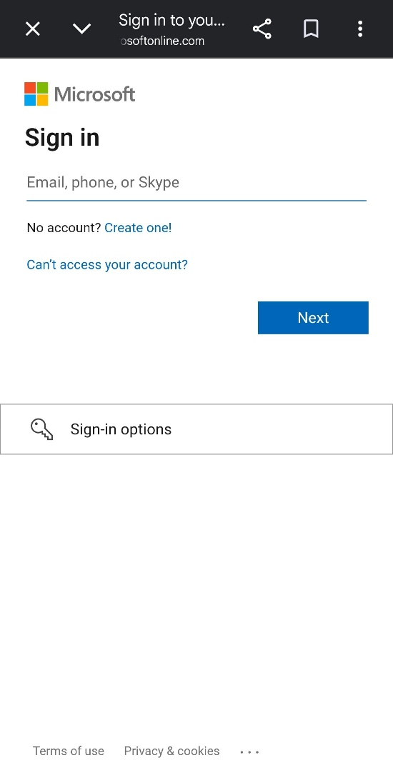
Enter your username@student.parkhall.org
For example: 26jdoe@student.parkhall.org
Click Next
The password you should enter, will be whatever password you use, when logging in to a school computer/laptop.
Note: Whilst you are present in school, the Synergy system should log you in without the need for an email or password, because it knows you are physically logged inside school.
This guide is only applicable when you are at home.
If your password is not accepted, you should speak to your teacher or a member of the IT team.
Please see page 2 for our Seneca Login guide.
Seneca Student login:
Using an internet browser, please visit the following website:
https://app.senecalearning.com/dashboard
Now please click Continue with Microsoft.
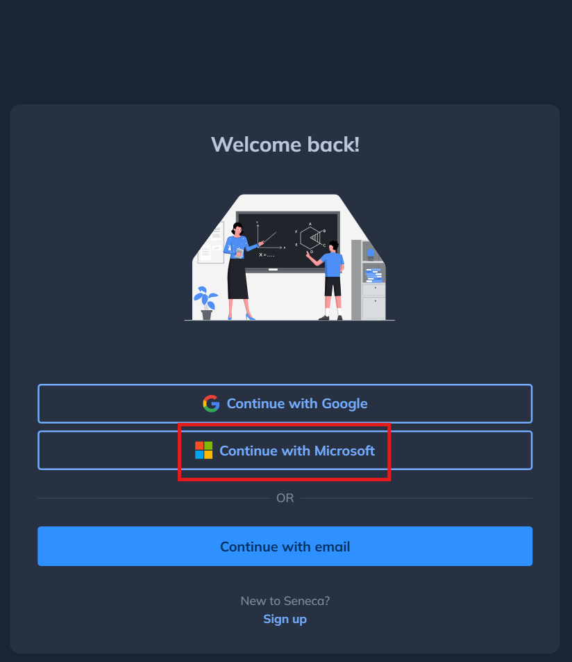 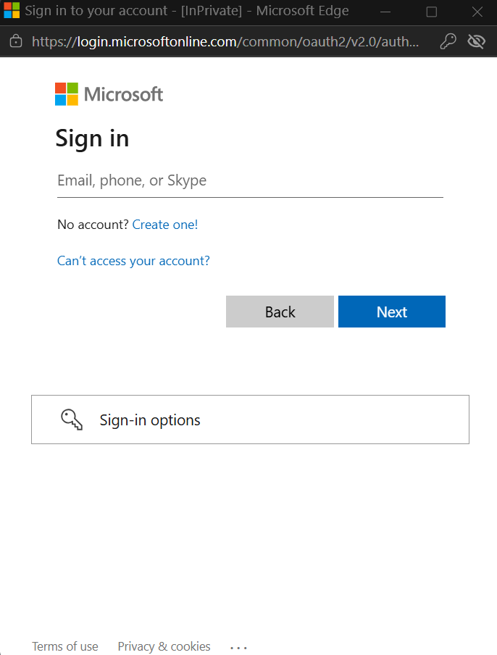
And now enter your @student.parkhall.org park hall email address, in the Microsoft sign-in box.
The password you should enter, will be whatever password you use, when logging in to a school computer/laptop.
Note: Whilst you are present in school, the Seneca system should log you in without the need for an email or password, because it knows you are physically logged inside school.
This guide is only applicable when you are at home.
If your password is not accepted, you should speak to your teacher or a member of the IT team.

