Introduction to Edexcel A-Level Politics
Park Hall Academy
Miss C Bartlett, Mr S Smith
2020
Specification
Exam Board: Edexcel
Link: https://qualifications.pearson.com/en/qualifications/edexcel-a-levels/politics-2017.html
This is a linear course, meaning that you will study the full A Level Specification over Year 12 and 13. You will then sit the three A Level exams at the end of Year 13. However, at the end of Year 12, you will take two papers – 1 for Component 1 and the other for Component 2. They DO NOT count towards your final grade at the end of Year 13 – but inform us of your suitability to carry on.
Year 12 | Year 13
Component 1 UK Politics  - Democracy and Participation  - Political Parties  - Electoral Systems  - Voting Behaviour and the Media  Component 2 UK Government  - Constitution  - Parliament  - The Prime Minister & Executive  - Relationships between the Branches | Political Ideas:  - Conservatism  - Liberalism  - Socialism  - & any one of the following – anarchism, ecologism, feminism, multiculturalism, nationalism.  Comparative Politics US Government  - US Constitution  - US Congress  - US Democracy and Participation  - US Presidency  - US Supreme Court and Civil Rights
Your Final Year Exams
Component 1 (2 hours) – UK Politics & 3 Core Political Ideas
Component 2 (2 hours) – UK Government & final Non-Core Political Idea
Component 3 (2 hours) – Comparative Politics

The link below will take you to a website. You should answer the questions honestly and truthfully. They will indicate where you would sit on the ‘political compass’. https://www.politicalcompass.org/test

Preparation for Your A-Level Course
What you will need:
- Two folders for Year 12 – one for UK Politics and one for UK Government
- Dividers for each folder
- Plastic wallets
- Lined paper
- Highlighters – minimum of four
Link: https://qualifications.pearson.com/en/qualifications/edexcel-a-levels/politics-2017.html
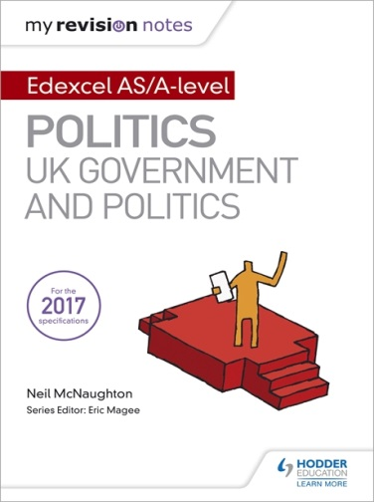
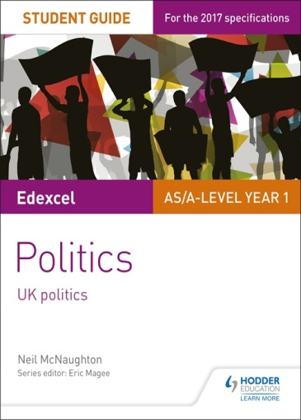
Suggested Books
- My Revision Notes: Edexcel AS/A Level Politics: UK Government and Politics
- Edexcel AS/A Level Politics Student Guide 1: UK Politics
- Edexcel AS/A Level Politics Student Guide 2: UK Government

The Economist and/or New Statesman are also great periodicals for this course – there are student subscriptions available. You may even wish to ask for a subscription as a birthday or Christmas prezzie!!

Summer Tasks
Over the summer, in preparation for studying A Level Politics, you should ensure you regularly (at least 3 times a week) watch the news and read newspapers (online editions are acceptable, but paper copies are much more fun!). Different newspapers will give you different political views – can you work out the views of each of the big national daily papers? Fill in a summary of News in the boxes below.

Topic 1: Democracy and Participation (SMT)
Research the definitions of the following Key Terms:
Key Term | Definition | Drawing/Logo for Representation
Legitimacy
Direct Democracy
Representative Democracy
Pluralist Democracy
Democratic Deficit
Participation Crisis
Franchise/Suffrage
Think Tanks
Lobbyists

Watch the following clip: https://www.youtube.com/watch?v=GsAZyYBiC70 .
Identify the features of a Representative Democracy
Identify the features of a Direct Democracy
Explain the difference between Direct and Representative Democracy
Key Milestones in ‘Widening the Franchise’
The Great Reform Act 1832
Research the key milestones of widening the franchise.

1948

1918

1884
Rural Householders
1928
1969
1867
Borough Householders
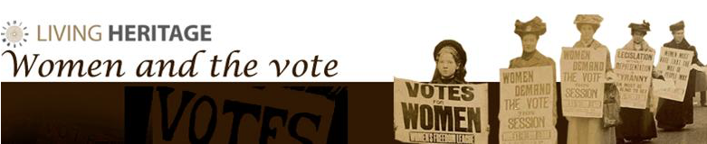
https://www.parliament.uk/about/living-heritage/transformingsociety/electionsvoting/womenvote/overview/campaign/ - Read through the different pages,
Using the link above, you should consider the term suffrage and the work of the suffragettes.
- When did the right to vote for women began?

- NUWSS let key suffrage movements. What does NUWSS stand for? What do they do?

- Who was Millicent Fawcett? What did she do?

- How did lobbying help the suffragettes?

- How did the use of Petitions help?

- The Start of the Suffragette movement began with the WSPU. What was this? What was their motto?

- What the WSPU do?

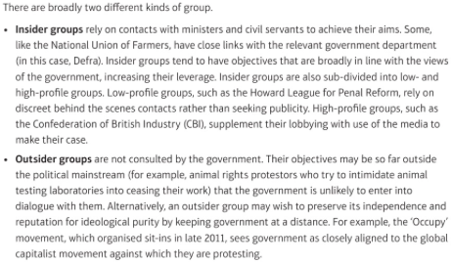
Pressure Groups
There are lots of different Pressure Groups in action today.
Research ONE pressure group. Consider what they do and who they support.
Recent Failures of this Pressure Groups
Recent Successes of this Pressure Groups
What tactics do they use?
What is their aim?

Are they an insider or outsider pressure group?
Who do they represent and help?
Pressure Group:
Topic 1: Political Parties (CBA)
Research the definitions of the following Key Terms:
Key Term | Definition | Drawing/Logo for Representation
Old Labour
New Labour
One Nation
New Right
Classical Liberals
Modern Liberals
Party Systems
Left Wing
Right Wing
Read the following notes: https://revisionworld.com/a2-level-level-revision/politics/political-parties-uk
Rank the functions of a Political Party in order of personal importance.
Explain the difference between a Political Party and a Pressure Group.
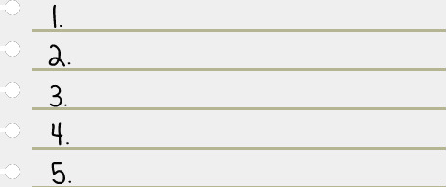
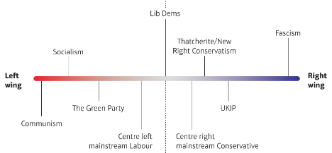
Research the Three Major Parties in the UK
https://www.businessinsider.com/uk-political-parties-manifestos-compared-2019-uk-general-election-2019-11?r=US&IR=T
https://www.parliament.uk/about/mps-and-lords/members/parties/

Political Party and  Current Leader | Conservative Party | Labour Party | Liberal Democrat Party
How many MPs do they have in Parliament?
Core Values of the Party (Key Beliefs)
Key Policy Stance: Education

Key Policy Stance: Health

Key Policy Stance: Economy
General Knowledge
Start an organised ‘scrapbook’, of articles you come across to do with the following – please ensure that you read them!
- Voting participation
- Electoral reform
- Changing Party Policies
- Pressure groups and protests
- Constitutional change
- The House of Commons or the House of Lords
- Relationships between the Prime Minister and the Cabinet
- The European Union
Try to get at least one story for each of these themes. They will provide the real-life examples you can use. In essence, you need to keep you to date with current affairs, so that you are able to become conversant with the world of government and politics. The more that you know about what’s going on around us every day, the more you will be able to make links with, and understand, the role that government and politics play in your lives and the better your exam essays will be.

