Area of Trapezium
To find the area of a trapezium we use the following formula: $Area= \frac{a+b}{2}×h$
A and b are the two lengths that are opposite and parallel. H is the height between these two.
Model example:
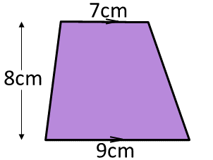
In this shape the two sides that are opposite and parallel are 7cm and 9cm. Therefore they are a and b. The height between them is 8, so h is 8.
So Area = $\frac{7+9}{2}×8=\frac{16}{2}×8=8×8=64{cm}^{2}$

Task 1: Watch the below video:
https://www.youtube.com/watch?v=jWX9KNToIcA

Task 2: Complete the below Questions
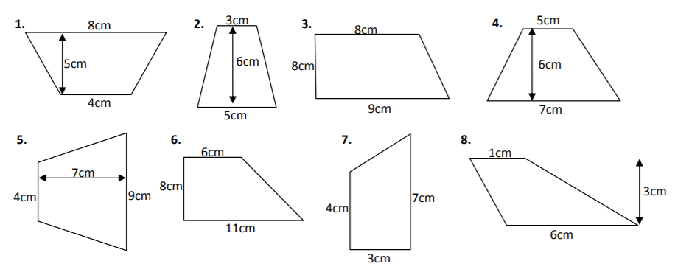

Task 3 (Stretch- Optional) Complete the below questions:

