Adding Decimals:
When we add numbers that go into decimals, we use the column method. It is important to line up the numbers with their correct place value. To make sure we are doing this the decimal points are in line.
Read the following webpage for help: https://www.mathsisfun.com/adding-decimals.html

Attempt two sections

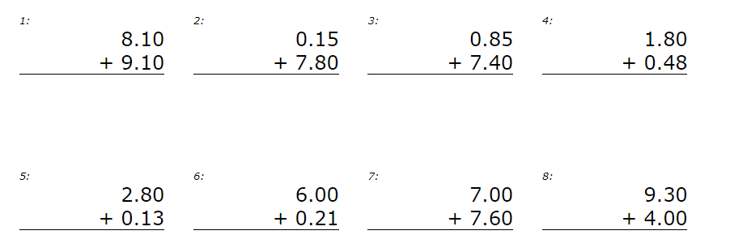
Bronze:
Silver:
- 7.32+ 6.24
- 1.32 + 5.2
- 1.01+2.31
- 5.85 x 2
- 4.65 + 3.21
- 5.65+ 3.23
- 1.23+8.77
- 5.71+8.85
Gold:
